Earthquake Scenario Ground Motion Hazard Maps
for the San Francisco Bay Region

Final Technical Report
USGS Grant Award 98-HQ-GR-1004

Prepared by

John F. Schneider (PI)
Impact Forecasting
230 W. Monroe Street, 9th Floor
Chicago, IL 60606

Walter J. Silva
Pacific Engineering & Analysis
311 Pomona Avenue
El Cerrito, CA 94025

Douglas Wright
URS Greiner-Woodward Clyde
500 12th Street Suite 200
Oakland, CA 94607

31 May 2000
Table of Contents
1. Technical Abstract 7
2. Introduction 8
2.1 Earthquake Scenarios 8
2.2 Ground Motion Modeling Approach 9
3. Ground Motion Modeling on Hard Rock 15
3.1 Scenario Specifications 15
3.2 Stochastic Fault Simulations 16
3.3 Empirical Attenuation Relations 19
3.4 Comparisons of Rock Motions 20
4. Site Amplification 27
4.1 Soil Amplification Categories 28
4.2 Geology Based Amplification Factors 31
5. Hazard Maps 56
5.1 Development of Maps 56
5.2 Hazard Maps for Median Rock Motions 57
5.3 Hazard Maps for Median Soil Motions 57
5.4 Hazard Maps for Effects of Uncertainty 58
6. Conclusions 97
7. References 98

Table of Figures
Figure 2.1. Map of San Francisco Bay Area Counties and Key Cities 10
Figure 2.2. Map of San Francisco Bay Area Faults 11
Figure 2.3. Scenario Earthquakes and Associated Fault Segments 12
Figure 2.4. Map of Surface Geology for the San Francisco Bay Area 13
Figure 2.5. Map of Depth to Bedrock for the Southern San Francisco Bay Area 14
Figure 3.1. Cartesian Grid Used to Estimate Initial Rock Ground Motions for the M 7.1 Hayward Fault Scenario. 23
Figure 3.2. Model Comparisons of Median Rock Ground Motions for M 7.1 Hayward Fault Scenario at 0.0 sec (PGA) 24
Figure 3.3. Model Comparisons of Median Rock Ground Motions for M 7.1 Hayward Fault Scenario at 1.0 sec 24
Figure 3.4. Comparisons of Average Empirical Rock Motions to Franciscan Corrected Empirical and Stochastic Rock Motions for M 7.1 Hayward Fault Scenario at 0.0 sec (PGA) 25
Figure 3.5. Comparisons of Average Empirical Rock Motions to Franciscan Corrected Empirical and Stochastic Rock Motions for M 7.1 Hayward Fault Scenario at 1.0 sec 25
Figure 3.6. Comparisons of Average Empirical Rock Motions to Stochastic Rock Motions for M 7.1 Hayward Fault Scenario at 0.0 sec (PGA): Directivity Effects 26
Figure 3.7. Comparisons of Average Empirical Rock Motions to Stochastic Rock Motions for M 7.1 Hayward Fault Scenario at 1.0 sec: Directivity Effects 1
Figure 4.1. Effects of Near Surface Soil Conditions on 5% Damped Response Spectral Shapes (Source: Seed, Ugas, and Lysmor, 1976) 38
Figure 4.2. Effects of Hard (ENA) and Soft (WNA) Rock Site Conditions on 5% Damped Response Spectral Shapes for M ~ 6.5 (Upper) and M ~ 4.5 (Lower) Earthquakes (Source: Silva and Darragh, 1995) 39
Figure 4.3. Median Shear-Wave Velocity Profiles Classified by Surface Surface Geology in the San Francisco Bay Area 40
Figure 4.4. Median and +-1 Sigma Shear-Wave Velocity Profiles for the Franciscan Surface Geologic Unit (Kjf) in the San Francisco Bay Area 41
Figure 4.5. Median and +-1 Sigma Shear-Wave Velocity Profiles for the Tertiary Surface Geologic Unit (TMzs) in the San Francisco Bay Area 42
Figure 4.6. Median and +-1 Sigma Shear-Wave Velocity Profiles for the Quaternary-Tertiary Surface Geologic Unit (QTs) in the San Francisco Bay Area 43
Figure 4.7. Median and +-1 Sigma Shear-Wave Velocity Profiles for the Quaternary Surface Geologic Unit in the San Francisco Bay Area 44
Figure 4.8. Median and +-1 Sigma Shear-Wave Velocity Profiles for the Bay Mud Surface Geologic Unit (Qm) in the San Francisco Bay Area 46
Figure 4.9. Map of Soil Amplification Categories for Combined Surface Geology and Depth to Bedrock 47
Figure 4.10. Median and +-1 Sigma Soil Amplification Factors for the Tertiary Surface Geologic Unit (TMzs) in the San Francisco Bay Area 48
Figure 4.11. Median and +-1 Sigma Soil Amplification Factors for the Quaternary-Tertiary Surface Geologic Unit (QTs) at Depths of 10 - 140 m (30 - 450 ft) 49
Figure 4.12. Median and +-1 Sigma Soil Amplification Factors for the Quaternary-Tertiary Surface Geologic Unit (QTs) at Depths of 105 - 200 m (350 - 650 ft) 50
Figure 4.13. Median and +-1 Sigma Soil Amplification Factors for the Quaternary Surface Geologic Unit at Depths of 10 - 140 m (30 - 450 ft) 51
Figure 4.14. Median and +-1 Sigma Soil Amplification Factors for the Quaternary Surface Geologic Unit at Depths of 105 - 200 m (350 - 650 ft) 52
Figure 4.15. Median and +-1 Sigma Soil Amplification Factors for the Quaternary Surface Geologic Unit at Depths of 150 - 300 m (500 - 1000 ft) 53
Figure 4.16. Median and +-1 Sigma Soil Amplification Factors for the Bay Mud Surface Geologic Unit (Qm) at Depths of 10 - 140 m (30 - 450 ft) 54
Figure 4.17. Median and +-1 Sigma Soil Amplification Factors for the Bay Mud Surface Geologic Unit (Qm) at Depths of 105 - 200 m (350 - 650 ft) 55
Figure 5.1. Hazard Map for Hayward Fault M7.1, 5% Damped Spectral Acceleration: Median at 0 sec (PGA) on Rock 60
Figure 5.2. Hazard Map for Hayward Fault M7.1, 5% Damped Spectral Acceleration: Median at 0.2 sec on Rock 61
Figure 5.3. Hazard Map for Hayward Fault M7.1, 5% Damped Spectral Acceleration: Median at 0.3 sec on Rock 62
Figure 5.4. Hazard Map for Hayward Fault M7.1, 5% Damped Spectral Acceleration: Median at 1.0 sec on Rock 63
Figure 5.5. Hazard Map for Hayward Fault M7.1, 5% Damped Spectral Acceleration: Median at 3.0 sec on Rock 64
Figure 5.6. Hazard Map for San Andreas Fault M7.9, 5% Damped Spectral Acceleration: Median at 0 sec (PGA) on Rock 65
Figure 5.7. Hazard Map for San Andreas Fault M7.9, 5% Damped Spectral Acceleration: Median at 0.2 sec on Rock 66
Figure 5.8. Hazard Map for San Andreas Fault M7.9, 5% Damped Spectral Acceleration: Median at 0.3 sec on Rock 67
Figure 5.9. Hazard Map for San Andreas Fault M7.9, 5% Damped Spectral Acceleration: Median at 1.0 sec on Rock 68
Figure 5.10. Hazard Map for San Andreas Fault M7.9, 5% Damped Spectral Acceleration: Median at 3.0 sec on Rock 69
Figure 5.11. Hazard Map for Hayward Fault M7.1, 5% Damped Spectral Acceleration: Median at 0 sec (PGA) on Soil 70
Figure 5.12. Hazard Map for Hayward Fault M7.1, 5% Damped Spectral Acceleration: Median at 0.2 sec on Soil 71
Figure 5.13. Hazard Map for Hayward Fault M7.1, 5% Damped Spectral Acceleration: Median at 0.3 sec on Soil 72
Figure 5.14. Hazard Map for Hayward Fault M7.1, 5% Damped Spectral Acceleration: Median at 1.0 sec on Soil 73
Figure 5.15. Hazard Map for Hayward Fault M7.1, 5% Damped Spectral Acceleration: Median at 3.0 sec on Soil 74
Figure 5.16. Hazard Map for San Andreas Fault M7.9, 5% Damped Spectral Acceleration: Median at 0 sec (PGA) on Soil 75
Figure 5.17. Hazard Map for San Andreas Fault M7.9, 5% Damped Spectral Acceleration: Median at 0.2 sec on Soil 76
Figure 5.18. Hazard Map for San Andreas Fault M7.9, 5% Damped Spectral Acceleration: Median at 0.3 sec on Soil 77
Figure 5.19. Hazard Map for San Andreas Fault M7.9, 5% Damped Spectral Acceleration: Median at 1.0 sec on Soil 78
Figure 5.20. Hazard Map for San Andreas Fault M7.9, 5% Damped Spectral Acceleration: Median at 3.0 sec on Soil 79
Figure 5.21. Hazard Map for Hayward Fault M7.1, 5% Damped Spectral Acceleration: Soil/Rock Amplification Factor at 0 sec (PGA) 80
Figure 5.22. Hazard Map for Hayward Fault M7.1, 5% Damped Spectral Acceleration: Soil/Rock Amplification Factor at 0.3 sec 81
Figure 5.23. Hazard Map for Hayward Fault M7.1, 5% Damped Spectral Acceleration: Soil/Rock Amplification Factor at 1.0 sec 82
Figure 5.24. Hazard Map for Hayward Fault M7.1, 5% Damped Spectral Acceleration: Soil/Rock Amplification Factor at 3.0 sec 83
Figure 5.25. Hazard Map for San Andreas Fault M7.9, 5% Damped Spectral Acceleration: Soil/Rock Amplification Factor at 0 sec (PGA) 84
Figure 5.26. Hazard Map for San Andreas Fault M7.9, 5% Damped Spectral Acceleration: Soil/Rock Amplification Factor at 0.3 sec 85
Figure 5.27. Hazard Map for San Andreas Fault M7.9, 5% Damped Spectral Acceleration: Soil/Rock Amplification Factor at 1.0 sec 86
Figure 5.28. Hazard Map for San Andreas Fault M7.9, 5% Damped Spectral Acceleration: Soil/Rock Amplification Factor at 3.0 sec 87
Figure 5.29. Hazard Map for Hayward Fault M7.1: Sigma of Natural Log Spectral Acceleration at 0 sec (PGA) on Rock for Stochastic Ground Motion Model 88
Figure 5.30. Hazard Map for Hayward Fault M7.1: Sigma of Natural Log Spectral Acceleration at 0 sec (PGA) on Soil (all models) 89
Figure 5.31. Hazard Map for Hayward Fault M7.1, 5% Damped Spectral Acceleration: 1 Sigma (84th Percentile) at 0 sec (PGA) on Soil (all models) 90
Figure 5.32. Hazard Map for Hayward Fault M7.1: Sigma of Natural Log Spectral Acceleration at 0.3 sec on Rock for Stochastic Ground Motion Model 91
Figure 5.33. Hazard Map for Hayward Fault M7.1: Sigma of Natural Log Spectral Acceleration at 0.3 sec on Soil (all models) 92
Figure 5.34. Hazard Map for Hayward Fault M7.1, 5% Damped Spectral Acceleration: 1 Sigma (84th Percentile) at 0.3 sec on Soil (all models) 93
Figure 5.35. Hazard Map for Hayward Fault M7.1: Sigma of Natural Log Spectral Acceleration at 3.0 sec on Rock for Stochastic Ground Motion Model 94
Figure 5.36. Hazard Map for Hayward Fault M7.1: Sigma of Natural Log Spectral Acceleration at 3.0 sec on Soil (all models) 95
Figure 5.37. Hazard Map for Hayward Fault M7.1, 5% Damped Spectral Acceleration: 1 Sigma (84th Percentile) at 3.0 sec on Soil (all models) 96

Table of Tables
Table 3.1. Segmentation Parameters for Hayward the San Andreas Fault* 16
Table 3.2. Characteristics of San Francisco Bay Area Earthquake Scenarios. 16
Table 3.3. Source and Path Parameters Used in the Stochastic Simulation Model 19
Table 3.4 Key Assumptions for Empirical Ground Motion Relations 19
Table 3.5. Sigma Values for M7.1 Hayward Scenario 20
Table 3.6. Empirical Sigma Values for M7.9 San Andreas Scenario 20
Table 4.1. Surface Geology Based Profiles, Site Classes, and Dynamic Material Properties. 35
Table 4.2. Comparisons of Site Classifications 35
Table 4.3. Relationships between Building Code Classifications 36
Table 4.4. Loma Prieta Crustal Model* 36
Table 4.5. Franciscan Reference Ground Motion Parameters 36
Table 4.6. Depth Categories and Depth Ranges 37

Technical Abstract
This report describes the development of seismic hazard maps for two major earthquake scenarios in the San Francisco Bay Region (10 counties). The maps incorporate the effects of source rupture directivity, crustal wave propagation and near-surface soil respognse, as well as the associated uncertainty. The maps will be useful to a broad audience of earthquake risk analysts to provide improved estimates of ground motion hazard for input to probable maximum loss analysis, structural designs and building codes, and urban disaster planning.
The scenario hazard maps present estimates of ground motion hazard for two key earthquakes identified by the US Geological Survey’s Working Group on California Earthquake Probabilities: a M 7.9 rupturing the four northern segments of the San Andreas (repeat of 1906); and a M 7.1 on the northern and southern segments of the Hayward fault. To generate rock motions, the approach combines the results of a numerical ground motion simulation model with empirical attenuation relations. In the numerical simulation model, the earthquake rupture and crustal wave propagation are represented using a stochastic finite-fault simulation method with random vibration theory (RVT) to generate suites of response spectra for each scenario. Four alternative empirical attenuation models were used that are appropriate and commonly used to estimate ground motions in California. To accommodate the effects of near-surface amplification in soil (or soft rock), frequency- and amplitude dependent amplification factors were developed. These factors take into account depth to bedrock (for alluvial sites), soil type (based on near-surface geology), and nonlinear amplification effects at high strains. The amplification factors are applied to rock motions across a dense geographic grid, then averaged across models at several discrete spectral periods. The results are contoured to yield hazard maps for 5% damped response spectra at five periods (0, 0.2, 0.3, 1.0 and 3.0 sec) and for median and 1-sigma levels.
The results show that while predicted ground motions are on average similar to those predicted by empirical relations alone, there is significantly more variability due to the combination of source, path and site effects modeled in this study. The largest median peak ground accelerations are nearly 1 g for the Hayward fault scenario and ~1.2 g for the San Andreas, with 1 sigma motions ranging from 50% to 120% higher than median motions. Due to source slip and directivity effects, median motions are lower at the ends of the fault relative to sites located elsewhere at similar fault distances, but show significantly greater variability (higher sigma). While crustal propagation is dominated by the general decay of ground motion with distance, post-critical Moho reflections do contribute to slight increases in median and 1 sigma motions at 50-80 km distance. Variations in soil amplification contribute significant variability in ground motions at all periods (e.g., Figures 5.21-5.24). Soft soils (especially Bay mud) show strong relative de-amplification at short periods and close distances (Fig. 5.21-5.22). The range of soil depths modeled clearly shows that amplification significantly increases with period as soil depth increases.

Introduction

Earthquake Scenarios
The US Geological Survey (Working Group on California Earthquake Probabilities [WGCEP]) recently completed a comprehensive review of the probabilities of occurrence of major earthquakes in the San Francisco Bay area. Their report, “Earthquake Probabilities in the San Francisco Bay Region”, concludes that the probability of occurrence of a major earthquake (M 6.7 or greater) in the region is about 70% over the next 30 years (WGCEP, 1999). Although the overall probability of occurrence estimates have not appreciably changed since the last official USGS report (WGCEP, 1990), probabilities for individual earthquake scenarios do differ. In addition, the 1999 report includes many more combinations of ruptures on individual or combined fault segments, as well as random (or floating) earthquakes. This report represents the most recent consensus of expert opinion on the magnitudes, locations and probabilities of occurrence of earthquakes in this area.
The area of interest to this study is shown in Figure 2.1, which covers a 10-county region surrounding San Francisco. The counties are Alameda, Contra Costa, Marin, Napa, San Francisco, San Mateo, Santa Clara, Santa Cruz, Solano, and Sonoma. The major population centers are shown relative to active faults in the area. Names of the most significant faults are identified in Figure 2.2.
The study focuses on key scenario events identified from the WGCEP (1999) report. Two scenarios were chosen among several earthquakes that are considered possible over the 30-year time period: 1) a moment magnitude 7.9 on the San Andreas fault, and 2) a moment magnitude 7.1 earthquake on the Hayward fault. A map showing the scenario fault segments is given in Figure 2.3. Details of the rupture scenarios are presented in Section 3.1. The San Andreas Fault earthquake represents a rupture of the four northern segments of the fault, along a 475-km (~300 miles) length from just north of Santa Cruz in the south, to Petrolia (south of Eureka) in the north. It is essentially a repeat of the M 7.9 1906 earthquake. The Hayward Fault earthquake involves a break along the northern and southern segments of the fault, for 87 km (~55 miles) from Fremont in the south, to the northern end of San Pablo Bay in the north. The last major earthquake on the Hayward fault was a M 6.9 in 1868 that ruptured the Southern segment.
The two scenario events chosen are widely believed to be the most significant to consider for disaster planning and for the design of major structures in this area. The WGCEP (1999) report cites that the San Andreas and Hayward-Rogers Creek faults have probabilities of at least one M ≥ 6.7 earthquake of 0.21 and 0.32, respectively before 2030, the highest probabilities among all faults in the area. Of the possible M ≥ 6.7 earthquakes on the San Andreas fault, a combined rupture of the four northern segments has a mean return period of 361 years, the shortest time interval of all possible event scenarios. For the Hayward-Rogers Creek system, individual segment ruptures of the Southern Hayward, Northern Hayward and Rogers Creek have mean return periods of 371, 387, and 286 years, respectively. A combined rupture of the Southern and Northern Hayward is estimated to occur on average every 523 years, not an appreciably longer interval than the return periods for individual segments and a much shorter interval than that of any other multiple-segment rupture. Thus, this scenario is considered as a key event in this study due to its relatively high probability of occurrence, combined with its potential for substantially large impact on the metropolitan San Francisco Bay Region.

Ground Motion Modeling Approach
This section provides a brief overview of the approach to modeling ground motion and creating scenario hazard maps. The process is divided into three main steps: 1) generation of ground motions for rock, 2) application of soil amplification factors, and 3) creation of ground motion hazard maps.
Based on the locations and magnitudes of the earthquake scenarios, ground motions are first modeled for a uniform rock outcrop over a grid of points throughout the region. Rock motions are generated in terms of 5% damped response spectra at a suite of 5 periods from PGA (0 sec) to 3 sec (0, 0.2, 0.3, 1.0 and 3.0 sec). Two different modeling approaches are used to generate the rock motions (Section 3). In the first approach, a numerical simulation model is used to approximate the effects of the finite earthquake source rupture (Silva et al., 1990). Alternative rock ground motion estimates are determined from four different and widely accepted empirical ground motion relations (Section 3.3). For each scenario event then, ground motions are expressed across a geographic grid of points in terms of the mean and variance of the natural log of spectral acceleration for each of the five models (1 simulation and 4 empirical) at the five spectral periods of interest.
Amplification factors are then developed to accommodate the effects of near-surface variability in geologic properties of soils, and for their depths to bedrock (Section 4). A map of the soil classification based on geologic age is shown in Figure 2.4 (after Wentworth, 1997). A contour map of depth to bedrock is shown in Figure 2.5. These two databases, together with available seismic and geotechnical soils data provide the bases for the development of a set of ground motion amplification factors for the SFBR for a wide range of input (rock) ground motion levels and spectral periods. The amplification factors are then applied to each set of rock motions based on the appropriate combination of surface geology, depth to bedrock, period of motion and rock peak ground acceleration input level.
The resulting ground motions are combined in Section 5 to generate dense spatial grids of ground motions for each scenario. Results are expressed in terms of the mean and variance of 5% damped spectral acceleration (Sa) at five spectral periods for the M7.1 Hayward and M7.9 San Andreas events. In the final analysis, empirical motions are combined with the stochastic simulations with weights of 0.4 (0.1 each) and 0.6 respectively (Section 5.2). The larger weight for the simulations (0.6) is intended to reflect an emphasis on region-specific attributes such as static stress drop, Q(f) model, and crustal structure. The final results are provided as a series of scenario hazard maps for median (50th percentile) and median + 1 standard deviation (84th percentile) ground motions.

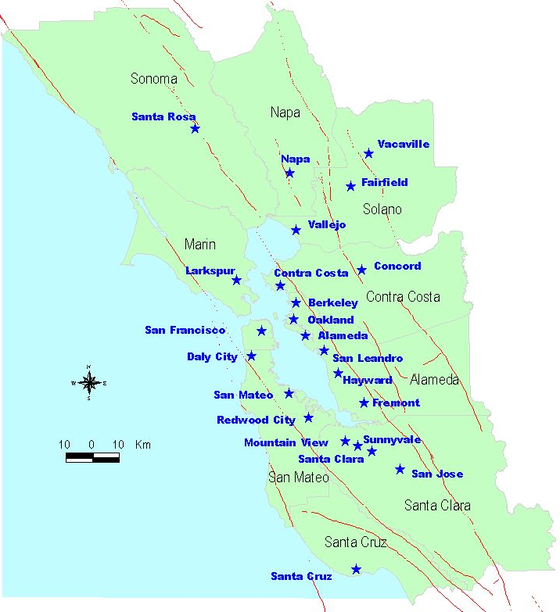

Figure 2.1. Map of San Francisco Bay Area Counties and Key Cities

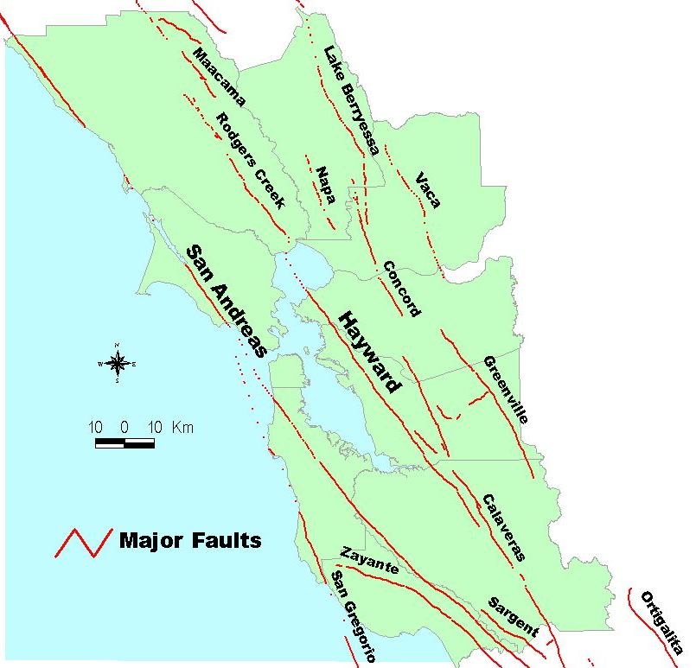

Figure 2.2. Map of San Francisco Bay Area Faults

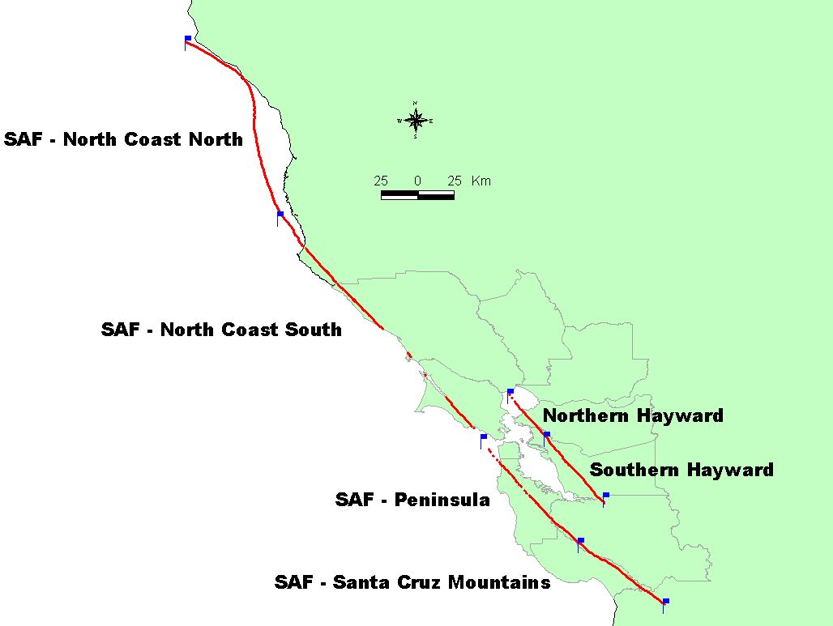

Figure 2.3. Scenario Earthquakes and Associated Fault Segments

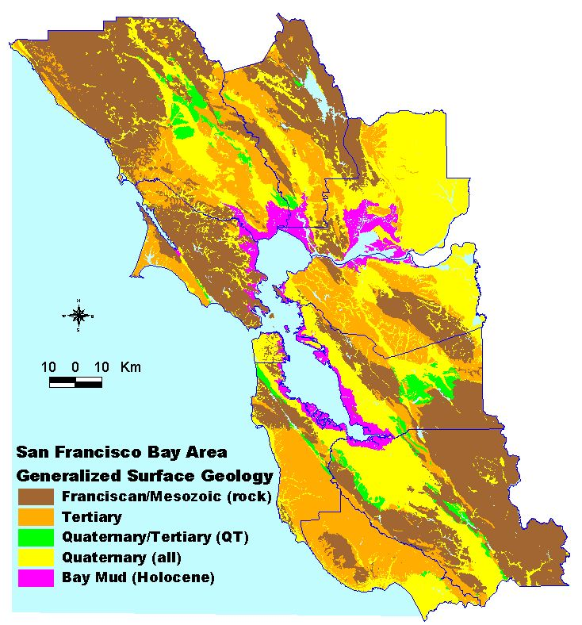

Figure 2.4. Map of Surface Geology for the San Francisco Bay Area

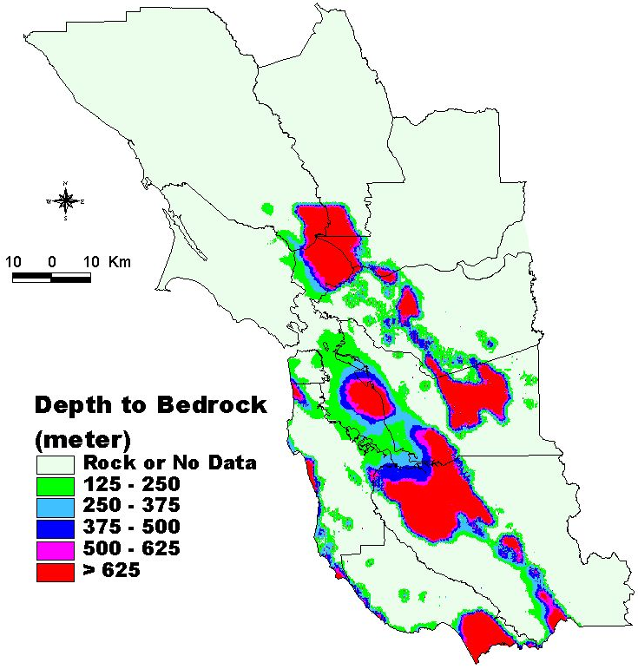

Figure 2.5. Map of Depth to Bedrock for the Southern San Francisco Bay Area

Ground Motion Modeling on Hard Rock

Scenario Specifications
The pattern of ground motion during an earthquake is the result of a complex process initiated by rupture of the fault and followed by the propagation of seismic waves through the earth. In order to compute or estimate ground motion, it is convenient to separate the process into three components: 1) the generation of seismic waves during fault rupture (source effects); 2) the propagation of waves through the earth’s crust (path effects); and 3) the local amplification of ground motion resulting from variation in near-surface soils (site effects). In this context, outcrop rock motions are the result of the combination of source and path effects; while soil motions result from the addition of site effects. This section of the report presents a discussion of the ground motion models used to generate rock motions that form the basis for the scenario hazard maps. The generation of soil motions is presented in Section 4.
Dimensions and locations for individual fault segments are provided by WGCEP (1999) and presented in Table 3.1. For the purposes of modeling the ground motion, the locations and dimensions of each scenario are defined by the single plane rectangular area that best satisfies the linear combination of segments. A single plane approximation is quite adequate given the small deviations in azimuth of the fault. The model values are summarized in Table 3.2. The scenario length is given simply by the sum of segment lengths, and the width is given by the average value that preserves total fault area and seismic moment: Avg Width = sum(L x W)/sum(L). For the San Andreas, the average width over the four segments is 11.88 km, but the average width within the San Francisco Bay Area is ~ 13 km, a value that preserves area and seismic moment within the area of interest for our ground motion calculations. Both planes are assumed to be vertical, and the mechanisms are assumed to be right-lateral strike-slip.
The equivalent circular rupture Brune stress drops (Δσ) are also listed in Table 4.2. For the San Andreas fault rupture, the area and magnitude result in a stress drop of 40 bars, considerably larger than the approximately 30 bars implied by the Wells and Coppersmith (1994) empirical magnitude/rupture area relation. The larger stress drops imply higher than median ground motions, based on empirical attenuation relations, which is reflected in the finite-fault modeling. Interestingly, the M 6.9 1989 Loma Prieta earthquake did not generally show anomalous (above median) motions for sites located within about 70 km of the rupture, with the expected exception of a few very soft sites.
In order to accommodate the uncertainty in source and path properties, the ground motion hazard maps developed in this study are derived from a combination of empirical and stochastic simulation approaches. The stochastic model incorporates the effects of rupture propagation along the fault as well as wave propagation from the fault to each site. This model can be used to generate ground motion time histories and 5% damped response spectra. A summary of the stochastic modeling approach is provided in Section 3.2 and a complete description is given in Appendix A The empirical models used are regressions of observed ground motion from earthquakes in California and similar tectonic regions. Model results are expressed in terms of 5% damped response spectra. Section 3.3 provides a summary of the empirical models. Section 5.1 presents the details of developing final model-weighted rock and soil motions and preparing final results in terms of hazard maps.
For each scenario and ground motion model, ground motions in terms of 5% damped spectral acceleration were generated over a grid of points centered about the fault trace. As an example, the grid of 658 points used for the Hayward scenario is shown in Figure 3.6. The grid points were chosen with intervals ranging from 1 to 20 km, depending on distance from the fault and proximity to the fault endpoints.
Table 3.1. Segmentation Parameters for Hayward the San Andreas Fault*
Fault segment | North Lat | North Lon | South Lat | South Lon | Length  (km) | Seismic Width  (km)
SAF - North Coast North | 40.245 | -124.405 | 39.171 | -123.842 | 137 | 11
SAF - North Coast South | 39.171 | -123.842 | 37.810 | -122.597 | 190 | 11
SAF - Peninsula | 37.810 | -122.597 | 37.176 | -122.004 | 85 | 13
SAF - Santa Cruz Mountains | 37.176 | -122.004 | 36.807 | -121.483 | 62 | 15
Northern Hayward | 38.087 | -122.434 | 37.828 | -122.210 | 35 | 12
Southern Hayward | 37.828 | -122.210 | 37.454 | -121.849 | 52 | 12
*Source: USGS WGCEP (1999)
Table 3.2. Characteristics of San Francisco Bay Area Earthquake Scenarios.
Fault Rupture | Segments | Fault type | Length  (km) | Avg Seismic Width (km) | Modeled Width (km) | M | Δσ  (Bars)
Hayward | North and South | right-lateral strike-slip | 87 | 12 | 12 | 7.1 | 36
San Andreas | Santa Cruz Mountains, Peninsula, Southern North Coast, Northern North Coast | right-lateral strike-slip | 474 | 11.88 | 13 | 7.9 | 40

Stochastic Fault Simulations

Simulation Procedure

The effects of a large finite source including rupture propagation, directivity, and source receiver geometry can profoundly influence strong ground motions in terms of frequency content and duration. These effects can not be properly accounted for using empirical methods. To accommodate these effects, a methodology that combines the aspects of finite earthquake source modeling techniques (Hartzell, 1978) with the stochastic point source ground motion model has been developed to produce response spectra as well as time histories appropriate for engineering design (Silva et al., 1990; Silva and Stark, 1993; Schneider et al., 1993). The approach is similar to the empirical Green function methodology introduced by Hartzell (1978) and Irikura (1983). In this case however, the stochastic point source is substituted for the empirical Green function and peak amplitudes; PGA, PGV, and response spectra (when time histories are not produced) are estimated using random vibration theory (RVT). The stochastic finite-fault model has been used in practice since about 1990 and a validation exercise using the Loma Prieta earthquake is discussed in Schneider et al., (1993). The model has recently been validated using about fifteen earthquakes and about 500 sites (Silva et al., 1997). A brief description of the method is presented here; and a detailed description of the method and results of model validation are provided in Appendix A.
In this approach, the slip distribution on the fault is represented by a series of stochastic point sources, which are initiated in turn as the rupture front is propagated across the fault. Waves are propagated from each point source to the sites of interest and their amplitudes are summed with the appropriate time delays to generate time histories of motion or response spectra. The locations of hypocenters and distributions of slip on the fault are varied to produce a representative sample of possible rupture scenarios. In this manner, the ground motion variability that can be attributed to uncertainty in the fault rupture process can be realistically modeled.
Use of the stochastic point source as a Green function is motivated by its demonstrated success in modeling ground motions in general and, strong ground motions in particular (Boore, 1983, 1986; Silva and Stark, 1993; Silva et al., 1997), and the desire to have a model that is truly site and region specific. The model can accommodate a region-specific crustal Q(f), Green function sources of arbitrary moment or stress drop, and site-specific kappa values (Anderson and Hough, 1984). This approach obviates the necessity of regional and site-specific recordings or the modification of empirical Green functions.
For the finite source characterization, a rectangular fault is discretized to provide the locations of the number of sub-faults (NS) of moment M^{s}₀. The empirical relationship
log A = -4.0 + M (Eq 3-1)
is used to assign areas to both the target earthquake (if its rupture surface is not fixed) as well as to the sub-faults. The sub-event magnitude M^{s} is generally taken as 5.0. The value of NS is determined as the ratio of the target event area to the sub-fault area. To constrain the proper moment, the total number of events summed (N) is given by the ratio of the target event moment to the sub-event moment. The sub-event and modeled event rise times are determined by the equation
log τ = 0.33 log M_{o} - 8.62 (Eq 3-2)
which is from a fit to M₀ - rise time results of modeling 15 large earthquakes (Silva et al., 1997). Heterogeneity of the earthquake source process is modeled by randomizing the location of the sub-events within each sub-fault (Hartzell, 1978) as well as the sub-event rise time. The stress drop of the stochastic point source Green function is taken as
Δσ = 7/16 (M_{s}/R_{e}³) (Eq 3-3)
where R_{e} is the equivalent circular radius of the rectangular sub-event.
Different values of slip are assigned to each sub-fault as relative weights so that asperities or non-uniform slip can be incorporated into the methodology. The rupture velocity is taken as depth independent at a value of 0.8 times the shear wave velocity, generally at the half-depth of the slip surface. A random component (20%) is added to the rupture velocity in order to avoid unrealistic spectral peaks and troughs in the resulting ground motion spectra. The radiation pattern is computed for each sub-fault, a random component is added, and the root-mean-square is applied to the motions computed at the site.
The response of the earth’s crust is accommodated by using vertically propagating shear waves through a vertically heterogenous crustal structure. Propagation path damping is modeled using a Q(f) model, which is a function of the source-site distance. Near-surface damping in the crust is incorporated through the kappa operator (e.g., Anderson and Hough, 1984). The path effects associated with variations in crustral structure are modeled via the method of Ou and Herrmann (1990), which models direct arrays and post critical reflections. The distance-dependencies associated with the Q and crustal-structure models are applied separately to the distance from each sub-fault element to each site.

Stochastic Scenario Models
Each earthquake scenario represents a combination of source ruptures, representing the range of uncertainty associated with future events. Accordingly, source ruptures for each scenario are randomly initiated at hypocenters along the length of the fault, representing scenarios ranging from unilateral ruptures in opposite directions, with various bilateral ruptures in between. The hypocenters are randomized within a nucleation zone (rectangle) which comprises the bottom half and to within 10% of the ends of the rupture surface. The sample distribution of hypocenters is used to model potential variations in source directivity. To represent other random effects of the rupture process, each scenario is generated from a suite of randomly selected slip distributions. The random slip models are generated using a simulation scheme that preserves asperity statistics such as size and number, given a rupture area. The statistics are based on slip models derived from modeling strong ground motions (Abrahamson et al., 1994). The combined randomization of hypocenter locations and slip distributions results in a total of 30 source scenario combinations for the entire grid of site locations.
For both scenario events modeled, the depth to the top of the fault is assumed to be 2.0 km below the earth’s surface, the nominal depth to the top of the seismogenic zone. The magnitude, fault dimensions, orientation and mechanism are given in Table 3.2. Additional source and path parameters used to constrain the ground motion estimates for the scenarios are provided in Table 3.3. The path parameters used are specific to the San Francisco Bay area, and have been determined from inversions of ground motion recordings from the Loma Prieta, Coyote Lake, and Morgan Hill earthquakes (Silva et al., 1997) (see also Appendix A). The path damping, Q(f), and kappa value are also randomized (Table 4.3) based on distributions from inversions (EPRI, 1993).
For the SFBR, the rock outcrop motions are determined using a shear-wave velocity profile appropriate for Franciscan (Mesozoic) rock. This is the same profile (Figure 4.16) used to develop the site amplification factors (Section 4). The profile is modeled using an RVT based equivalent-linear approach (Appendix A). Generic rock G/Gmax and hysteretic damping curves are used (Silva et al., 1997) to a depth corresponding to a shear-wave velocity of 3,000 ft/sec. The profile is assumed linear beyond and is merged into the Wald et al. (1991) crust. The total small-strain kappa value is constrained to 0.04 sec (Silva and Darragh, 1995). These motions are later amplified by soil amplification factors relative to the same Franciscan outcrop reference seismic velocity structure (Section 4).
Table 3.3. Source and Path Parameters Used in the Stochastic Simulation Model
Q_{o} | σ_{lnQo} | η | σ_{η} | κ (sec) | σ_{lnκ}
176 | 0.4 | 0.6 | 0 | 0.03 | 0.3

Empirical Attenuation Relations
Four empirical attenuation relations are combined to provide representative estimates of ground motions for the scenario events. The four relations, cited in Table 3.4, are all widely accepted models applicable to estimating earthquake ground motions in California. As with the stochastic model, the magnitude, fault dimensions, orientation and mechanism are implemented as given in Table 3.2. Table 3.4 also lists additional assumptions made in implementing each of the models.
Table 3.4 Key Assumptions for Empirical Ground Motion Relations
Relations | Distance Measure | Depth of top of fault (km) | Parameters for “Rock”
Boore et al (1997) | To surface projection of rupture (R_{JB}) | 0 | V_{s}30 = 511.10 m/s (Geomatrix A/B category)
Abrahamson and Silva (1997) | To rupture surface (R_{rup}) | 0 | Coefficients for “rock”
Campbell (1997) | To top of rupture surface (R_{seismo}) | 3 | Coefficients for “soft rock”
Sadigh et al (1997) | To rupture surface (R_{rup}) | 0 | Coefficients for “rock”

For each empirical relation, regression parameters or coefficients were chosen as appropriate for a rock outcrop, or, when available, for a “soft-rock” outcrop. The average shear-wave velocity to 30 m depth for typical soft rock in California is 511.10 m/s (Wills and Silva, 1998). This velocity is consistent with the Geomatrix category A/B used by Sadigh (1997) and Abrahamson and Silva (1997) for rock motions; and is consistent with the “soft-rock” coefficients for Campbell (1997). Differences between Franciscan and soft-rock outcrop motions are investigated in Section 3.4.

Comparisons of Rock Motions
Figure 3.7 presents a comparison of median peak ground accelerations (PGA) on rock (i.e., soft rock) for the four empirical attenuation relations and the stochastic ground motion model as a function of fault distance. Similar differences occur at other spectral periods as shown in Figure 3.3 for ground motions at 1 sec period. For the stochastic model, data points are site-specific median values determined from the suite of simulations with randomized slip distributions and hypocenter locations. The variation in scatter with distance is largely a function of directivity and crustal wave propagation effects. Table 3.5 and Table 3.6 present standard deviations {i.e., Sigma[Ln(Sa)]} for scenario ground motions for each of the models. Values are presented as a function of spectral period for the 5 periods used to develop hazard maps. For the stochastic finite-fault model, the modeling uncertainty shown in Table 3.5 and Table 3.6 is large because it is based on modeling 15 earthquakes (including central and eastern United States) at about 500 sites for distances out to about 500 km (Appendix A). Since neither kappa values nor crustal structures, including shallow profiles, were optimized in the modeling, the corresponding modeling uncertainty accommodates their uncertainties for future simulations. However, to incorporate site specific uncertainty in the shallow Franciscan rock profile (Section 4.4.2), nonlinear properties and kappa values are all randomized along with the Q(f) model (Table 3.3), as are the source parameters of nucleation point and slip model. As a result, some of the uncertainty is being double-counted in the simulations. This was done primarily to generate smooth estimates of response spectra at each site location, and, since the interest is primarily in median estimates, the increased uncertainty is not considered to be a significant issue. In all cases, the standard deviations for the empirical and stochastic model are independent of distance to the fault.
Table 3.5. Sigma Values for M7.1 Hayward Scenario
Empirical Relation | Sigma (Ln Sa)
 | PGA | 0.2 sec | 0.3 sec | 1.0 sec | 3.0 sec
Abrahamson & Silva (1997) | 0.430 | 0.495 | 0.510 | 0.589 | 0.672
Boore et al (1997) | 0.469 | 0.435 | 0.443 | 0.520 | 0.594
Campbell (1997) | 0.481 | 0.481 | 0.481 | 0.481 | 0.481
Sadigh et al (1997) | 0.400 | 0.440 | 0.460 | 0.540 | 0.504
Average (Variance Weighted) | 0.446 | 0.464 | 0.474 | 0.534 | 0.576
Stochastic | 0.516 | 0.596 | 0.607 | 0.692 | 0.853

Table 3.6. Empirical Sigma Values for M7.9 San Andreas Scenario
Empirical Relation | Sigma (Ln Sa)
 | PGA | 0.2 sec | 0.3 sec | 1.0 sec | 3.0 sec
Abrahamson & Silva (1997) | 0.430 | 0.495 | 0.510 | 0.589 | 0.672
Boore et al (1997) | 0.469 | 0.435 | 0.443 | 0.520 | 0.594
Campbell (1997) | 0.466 | 0.466 | 0.466 | 0.466 | 0.466
Sadigh et al (1997) | 0.380 | 0.420 | 0.440 | 0.520 | 0.520
Average (Variance Weighted) | 0.438 | 0.455 | 0.466 | 0.526 | 0.568
Stochastic* | 0.516 | 0.596 | 0.607 | 0.692 | 0.853

It is important to note that the Franciscan rock category used for the stochastic model is likely significantly stiffer than the “rock” or “soft-rock” definitions for these empirical attenuation relations (Abrahamson and Shedlock, 1997). Therefore, as the “soil” amplification factors (developed in Section 4) are provided relative to Franciscan rock, they may not be strictly appropriate to the empirical rock motions specified here. Therefore, Silva et al (1999) developed separate amplification factors for a “soft rock” site category (Geomatrix A and B) relative to Franciscan rock to assess potential differences in response. These factors can also be used to provide an adjustment to the soil factors as appropriate to the base rock condition used to define the input motions.
Figures 3.4 and 3.5 show the impact of adjusting the empirical motions shown in Figures 3.2 and 3.3 to Franciscan outcrop. Three sets of rock motions are shown: 1) averaged median empirical rock motions 2) average Franciscan motions determined by applying “Franciscan/Geomatrix A/B” amplification factors to the empirical motions (Silva et al, 1999); and 3) the stochastic ground motions. The combined ground motions were determined by assigning weights of 0.1 to each of the empirical models (soft-rock assumed), and 0.6 to the stochastic model. As can be seen in these figures, the differencces between the two sets of empirical motions is not particularly significant, although the corrected values do provide a slightly better fit to the 1 sec stochastic motions.
In Figures 3.6 and 3.7 the average empirical motions are compared again to the stochasic ground motions; but in this case, the stochastic motions are separated into three geographic bins. Points identified as being north, south or in the center, correspond to the their locations relative to the fault rupture when projected perpendicularly onto the fault trace.
As demonstrated at 0.0 and 1.0 sec in Figures 3.2 to 3.7, the results show a number of significant features:
- Differences between average empirical motions for the two rock-site conditions (soft rock vs Franciscan) are generally much less than the differences in the median among the four relations (e.g., Figure 3.7) at all five spectral periods and at all distances.
- The combined stochastic motions are generally unbiased relative to the mean of the empirical motions for soft rock (Geomatrix A/B) at periods shorter than 1.0 sec, and biased slightly low at periods of 1 sec and greater.
- The median combined motions show significant variability at any given distance for those sites that project onto the fault between the endpoints. This variability is attributable to the sensitivity of the stochastic model to locations of sites relative to hypocenters and distributions of slip on the fault.
- The median combined motions are generally less at any given distance for those sites that project beyond the endpoints of the fault (i.e., north or south). This difference is attributed largely to geometrical effects such that given the same closest distance to the fault, sites off the ends of the fault are further away from the average asperity locations than are sites along the rupture segments.
- The median combined motions show a distinct increase in ground motion in the range 50-80 km. This inflection is due to post-critical reflections from within and at the base (Moho Discontinuity) of the crust as modeled by the stochastic ground motion model.
The results indicate that the models are reasonably consistent in providing estimates of median ground motions, and that the combined motions are unbiased across a wide range of spectral periods. Furthermore, based on items 1 and 2 above, the differences between “soft-rock” and “Franciscan” motions are considered to be sufficiently small that no corrections are made to the soft-rock empirical motions for input to the hazard maps presented in Section 5.
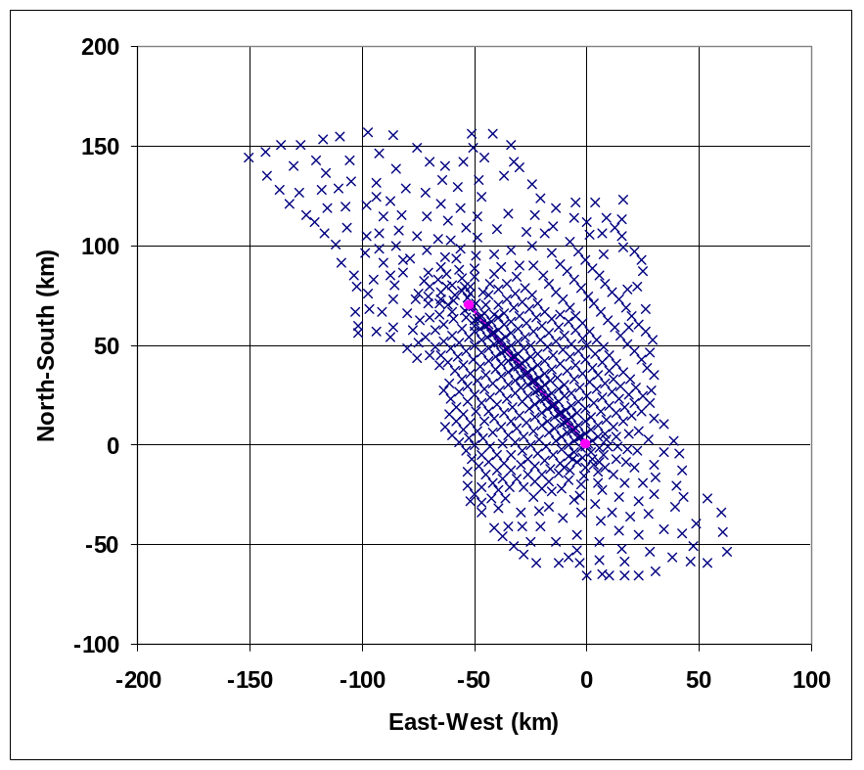

Figure 3.6. Cartesian Grid Used to Estimate Initial Rock Ground Motions for the M 7.1 Hayward Fault Scenario.

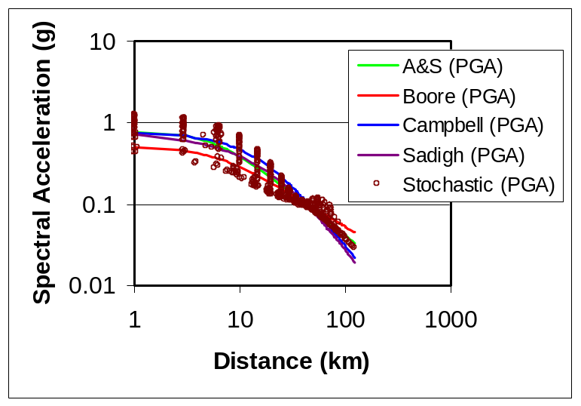
Figure 3.7. Model Comparisons of Median Rock Ground Motions for M 7.1 Hayward Fault Scenario at 0.0 sec (PGA)

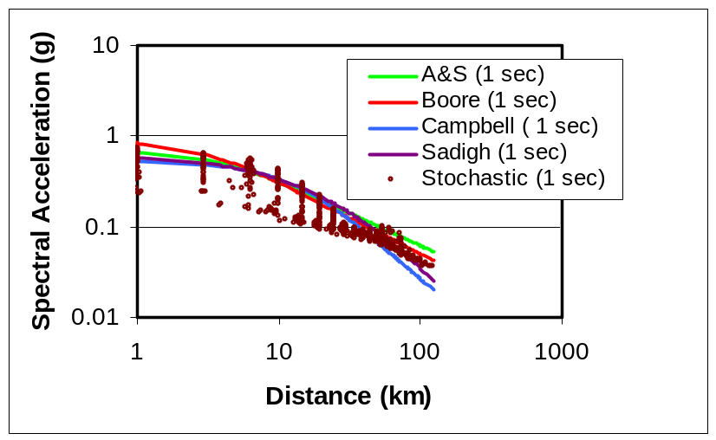
Figure 3.8. Model Comparisons of Median Rock Ground Motions for M 7.1 Hayward Fault Scenario at 1.0 sec

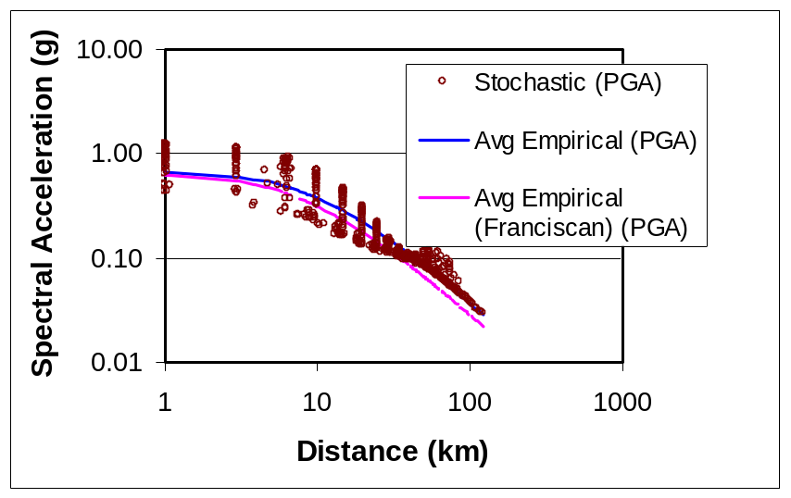
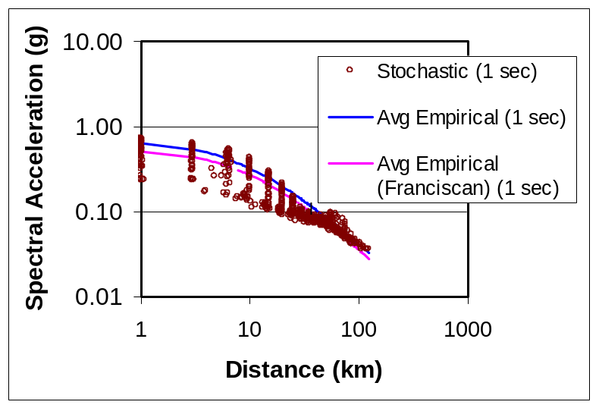Figure 3.9. Comparisons of Average Empirical Rock Motions to Franciscan Corrected Empirical and Stochastic Rock Motions for M 7.1 Hayward Fault Scenario at 0.0 sec (PGA)

Figure 3.10. Comparisons of Average Empirical Rock Motions to Franciscan Corrected Empirical and Stochastic Rock Motions for M 7.1 Hayward Fault Scenario at 1.0 sec

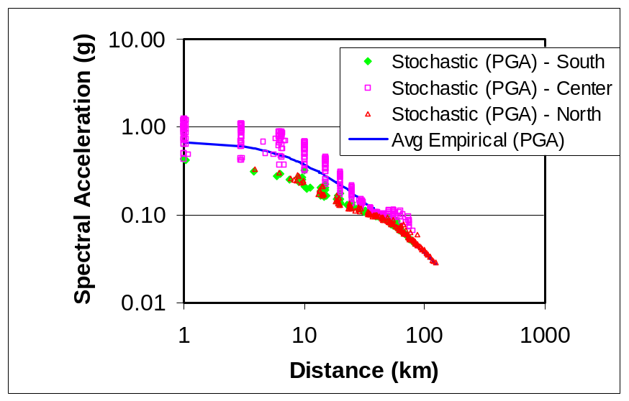
Figure 3.11. Comparisons of Average Empirical Rock Motions to Stochastic Rock Motions for M 7.1 Hayward Fault Scenario at 0.0 sec (PGA): Directivity Effects
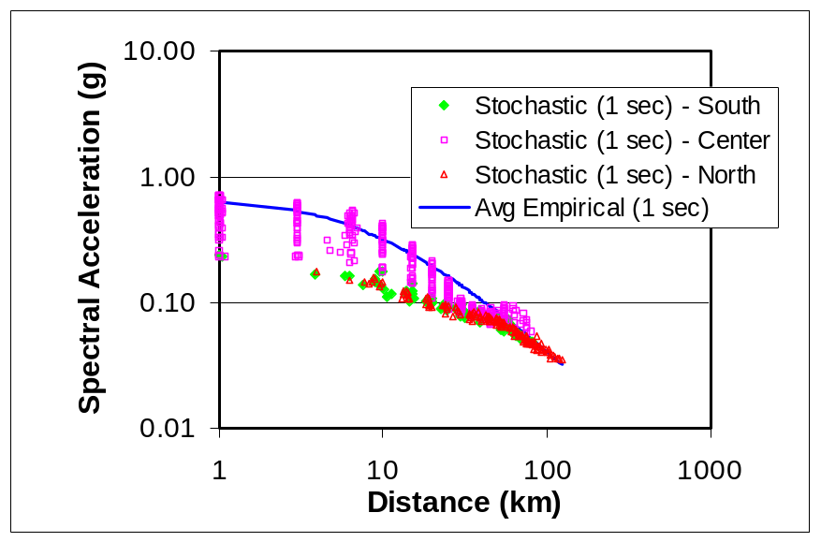
Figure 3.12. Comparisons of Average Empirical Rock Motions to Stochastic Rock Motions for M 7.1 Hayward Fault Scenario at 1.0 sec: Directivity Effects

Site Amplification
Wood (1908) and Reid (1910), using apparent intensity of shaking and distribution of damage in the San Francisco Bay area during the 1906 earthquake, gave evidence that the severity of shaking can be substantially affected by the local geology and soil conditions. Gutenberg (1927, 1957) developed amplification factors representing different site geology by examining recordings of microseisms and earthquakes from instruments located on various types of ground. Borcherdt (1970) was the first to develop a model for ground motion intensity in the SFBR based on surface geologic categories. Figure 4.13 shows average spectral shapes (response spectral acceleration divided by peak acceleration) computed from recordings made on rock and soil sites at close distances to earthquakes in the magnitude range of about M 6 to 7. The differences in spectral shapes are significant and depend strongly upon the general site classifications. These variations in spectral content represent average site dependent ground motion characteristics and result from vertical variations in soil material properties (Hayashi et al., 1971; Mohraz, 1976; Seed et al., 1976). Due primarily to the limited number of records from earthquakes of different magnitudes, spectral content in terms of response spectral shapes was for some time interpreted not to depend upon magnitude nor distance, but primarily on the stiffness and depth of the local soil profile. However, with an increase in the strong motion database, it has become apparent that spectral shapes depend strongly upon magnitude as well as site conditions (Joyner and Boore, 1982, Idriss, 1985; Silva and Green, 1989), and distance (Silva and Green, 1989), and that site effects extend to rock sites as well (Boatwright and Astrue, 1983; Campbell 1981, 1985, 1988; Cranswick et al., 1985; Silva and Darragh, 1995).
Examples of differences in spectral content largely attributable to one-dimensional site effects at rock sites can be seen in comparisons of response spectral shapes computed from motions recorded in both active and stable tectonic regions (Silva and Darragh, 1995). Figure 4.14 shows average spectral shapes (Sa/amax) computed from recordings made on rock at close distances to large and small earthquakes. For both magnitudes (moment magnitude M 6.4 and 4.0), the motions recorded in Eastern North America (ENA), a stable tectonic region, show a dramatic shift in the maximum spectral amplification toward higher frequencies compared to the Western North American (WNA) motions. These differences in spectral content are significant and are interpreted as primarily resulting from differences in the shear-wave velocity and damping in the rocks directly beneath the site (Boore and Atkinson, 1987; Toro and McGuire, 1987; Silva and Green, 1989; Silva and Darragh, 1995). Also evident in Figure 4.14 is the strong magnitude dependency of the response spectral shapes. The smaller earthquakes show a much narrower bandwidth. This is a consequence of higher corner frequencies for smaller magnitude earthquakes (Boore, 1983; Silva and Green, 1989; Silva and Darragh, 1995).
The difference in spectral content due to soil site effects, as shown in Figure 4.13, and due to rock site effects, as shown in Figure 4.14, are dramatic and illustrate the degree to which one-dimensional site conditions (vertical variations in dynamic material properties) control strong ground motions. In order to capture these geologically controlled differences in ground motions, site amplification factors are developed in a manner that is appropriate for San Francisco Bay Region soil and rock sites. For wide applicability, both the rock and soil conditions are based upon mapped surface geology with appropriate shear-wave velocity profiles developed for each geologic type. The amplification factors are developed for 5% damped response spectra (values at 100 Hz apply to peak acceleration) and are relative to a generic Franciscan rock site appropriate for this area. The factors accommodate nonlinear soil/rock response and are produced as a function of expected Franciscan rock peak acceleration values. Because of this, they may be applied to any size earthquake at any distance with knowledge only of the expected rock peak acceleration. The factors are considered appropriate for rock outcrop peak accelerations up to 1.25g and over the frequency range of 0.1 to 100.0 Hz.
It is important to note that these amplification factors do not explicitly incorporate basin (3D) effects. As a result, some may believe that the model will underpredict long period (> 2 sec) deep soil motions for earthquake sources located outside (laterally) the SFBR basin. However, for the ground motion periods considered here, most of the ground motion variability in the SFBR should be well-approximated by a local one-dimensional soil structure. In particular, with possible exception of the deep Santa Clara basin (south of the southern end of the San Francisco Bay in Figure 2.5), the Southern SFBR between the San Andreas and Hayward faults is a very shallow and wide basin, not generally susceptible to significant three-dimensional ground motion effects. Further, the sources considered here are basin margin faults, which would result in much less excitation of surface waves in the basin relative to more distant events. Additionally, source, path, and rock and soil site modeling of 48 Bay area sites which recorded the Loma Prieta, Coyote Lake, and Morgan Hill earthquakes using a one-dimensional soil model showed no bias associated with deep soil sites (Schneider et al., 1993; Silva et al., 1997). Interestingly, Hartzell et al (1999) compare one-dimensional and thre-dimensional source, path, and site modeling for sites in the Los Angeles basin that recorded the Northridge earthquake and show no difference in accuracy for response and Fourier amplitude spectra over the frequency range of 0.1 to 20 Hz. As a result, we conclude that neglecting potential basin effects will not result in a stable and serious underprediction of long period motions.

Soil Amplification Categories
This section describes the development of soil amplification categories based on the vertical variation in shear-wave velocity ascribed to different surface geologic units in the San Francisco Bay area by Wills and Silva (1998). The categories developed are assigned within the 10-county San Francisco Bay Region based on mapped surface geology (Wentworth, 1997) (Figure 2.4), and depth to bedrock, described in Section 4.1.3.

Definition of Geologic Categories by Vertical Velocity Profiles
The soil amplification factors are based on the separation of rock units into Franciscan and Tertiary units. Soil units consist of Quaternary-Tertiary, Quaternary and Older Alluvium (generic Quaternary), and Bay Mud (Figure 2.4). Table 4.1 lists the geology types, average shear-wave velocity to 30m, the corresponding USGS and NEHRP site categories (Table 4.2), and number of shear-wave velocity profiles currently in each category. Figure 4.15 shows the median shear-wave velocity profiles for each geologic unit. With the exception of the Quaternary Alluvium (Q_{al}) and Older Alluvium (Q_{oa}), each unit has a distinct median profile. Distinct NEHRP categories include Franciscan (K_{jf}, NEHRP B), Tertiary Bedrock (TM_{ZS}, C) and Quaternary/Tertiary Rock (QT_{S}, C) and the stiff to firm soils (all NEHRP category D). Unfortunately, the median Bay Mud profile (Q_{m}), with its 30m average shear-wave velocity of about 188m/sec, is placed in NEHRP Category C, with the firm to stiff soils (Table 4.2).
The soil profiles show several features of interest. For the rock classes, Franciscan and Tertiary, a significant difference exists with the Tertiary profile being much softer (NEHRP site class C) than the Franciscan and resembling a stiff soil (Older Alluvium) at shallow depths. The Franciscan is considered soft rock but is stiff enough (NEHRP site class B) to form the basis for the San Francisco area amplification factors. Thus the site amplification factors computed in this study are determined relative to Franciscan rock outcropping as defined by the Franciscan profile in Figure 4.16. The velocity profile for the Quaternary-Tertiary unit can also be differentiated relative to both the Tertiary and Quaternary units
For the alluvium, little difference in stiffness is seen between the Old Quaternary and Young Quaternary Alluvium profiles, as noted in earlier studies by Wills and Silva (1998) and Silva et al (1999). Silva et al (1999) have in fact shown that there are no statistically significant differences in the amplification factors computed with these two profiles. Therefore, the Older Quaternary and Quaternary profiles are combined into a single class for development of amplification factors. Based on a subset of the same soil profile dataset, a similar classification scheme was also adopted by Schneider et al (1998) in the development of soil amplification factors for California.
The Bay Mud profile shows a shallow low velocity zone with higher shear-wave velocities at the surface than at a depth of about 20 ft. This velocity reversal is likely due to the presence of fill material which is a common occurrence in the built environment near San Francisco Bay. This profile is not unexpected since velocity measurements (boreholes) are generally associated with structures of some kind. Because such features can have a strong effect on ground motions at high levels of loading, they are most appropriately addressed on a site-specific basis. The base case profile was smoothed through this feature. The amplification factors for Bay Mud surface geology should then be considered to have higher uncertainty at higher loading levels (expected Franciscan PGA ≥ 40%g) and at short periods (≤ 0.2 sec).

Smooth Velocity Profiles for Site Response Analyses
Smooth profiles were drawn through the median values and, where necessary, extrapolated to deeper depths to develop profiles for computing strong ground motions (PGA, PGV, PGD, and 5% damped response spectra). The resulting variation with depth in median and ±1 sigma values of shear-wave velocity are shown in Figures 4.4 to 4.8 for each of the geologic soil classes. Both median and ± 1 σ surface geology based profiles as well as smooth and extrapolated versions for site response calculations are shown. For source-to-site modeling, the shallow profiles are merged with the regional “Loma Prieta” model for the earth’s crust of Wald et al. (1991) (Table 4.4). For the Franciscan rock unit, the bottom of the shallow Franciscan profile is merged with the second layer of the Wald et al. (1991) crust (Figure 4.21). The remaining geologic unit profiles are simply placed on top of the Wald crust, which has a shear-wave velocity of 3,281 ft/sec in the top layer (Table 4.4).

Depth to Bedrock
A depth to bedrock map was developed for this study based on constraints provided by Revision 1 of the South San Francisco Bay Area 3-D Velocity Model (Jachens, personal communication, 1999). The depth-to-bedrock map shown in Figure 2.5 forms the basis for defining divisions of soil amplification categories by depth ranges.
The spatial extent of the model covers the region from just north of San Pablo Bay in the north, to Monterey which lies just to the south of the study area. The velocity model is constrained by available compilations of depths to bedrock from boreholes, seismic refraction studies and gravity measurements throughout the area. The surface layer densities are tied to the geologic units of the San Francisco Bay Region digital geologic map of Wentworth (1997), shown in Figure 2.4. These data were used by Jachens in a nonlinear inversion process to optimize seismic velocities (Vp and Vs) and densities as a function of geographic location and depth for a dense three-dimensional grid. The model results are given in three depth ranges for three sets of blocks corresponding to the lower, middle and upper portions of the crust. For the purposes of our study, data from only the upper-crustal block were used, corresponding to depths up to 625 meters. The ground motion responses for spectral periods in the range of interest to this study are generally insensitive to variations in depth to bedrock below this depth.
In the upper-crustal block, grid points are defined in three dimensions (latitude, longitude and depth) from the surface to 625 meters over a uniform 3-D grid at 125 m intervals. Further, for our application, the data in the upper-crustal block were reduced to 250-m intervals in the horizontal plane. Upon review of the assumptions and constraints on the inversion, it was concluded that the variation in density with depth provided the best constraints to resolve depth-to-bedrock. The density corresponding to all basement rock (Franciscan and Salinian) in this area was assumed to be 2.67 grams/cm³. Therefore, for our purposes, depth to bedrock was defined to lie between the shallowest layer with a density of at least 2.67, and the layer above it, i.e., within a 125-m depth range.
Figure 2.5 presents the resulting interpreted depths contoured at the 125-meter resolution of the layered model. Depths to bedrock compare very well with contoured depths developed by previous investigators in the greater Oakland-Alameda area (Rogers and Figuers, 1991), and in San Mateo, Santa Clara and Alameda Counties (Hazelwood, 1976; Hensolt and Brabb, 1990). Depths are also consistent with available bedrock depths from seismic well logs (Joyner and Fumal, 1984; Fumal, 1991; Gibbs et al, 1992; Thiel and Schneider, 1993), in the southern San Francisco Bay Region. The 125-meter depth contour, which lies at or below the limit of nearly all borings, is the best constrained. In addition, in the San Francisco-Oakland area, the Franciscan basement is overlain entirely by Quaternary sediments (Helley and Lajoie, 1979; Rogers and Figuers, 1991), which provides a very distinct velocity and density contrast at the bedrock interface in this area. On the other hand, bedrock depths greater than 375 meters, such as in the South Bay and Santa Clara Valley (in the vicinity of San Jose) are poorly constrained. In this area, the Mesozoic is generally overlain by Upper and Lower Tertiary deposits (e.g., Helley and Lajoie, 1979). Thus profiles in these deeper alluvial areas are probably not marked by distinctive changes in seismic impedance, even at the Tertiary-Mesozoic interface; rather, the profiles tend to show more gradual increases in velocity consistent with more gradual changes in geologic age.

Mapped Soil Categories by Depth and Surface Geology
The combined variation in velocity profiles for each distinct surface-geologic unit and resolution of depth to bedrock provides the basis for the final breakdown of soil categories (Figure 4.21). Due to limitations in the mapped depth resolution (125-m intervals), and uncertainties in these depths, only a few depth ranges are warranted. Further, beyond several hundred meters depth, the variation in amplification in the spectral period range of interest (i.e., above 3 sec) does not warrant the definition of multiple categories at these depths. Based on these considerations, depth categories were assigned for shallow (10-140 m), intermediate (140-200 m) and deep (>200 m) ranges in depth to bedrock. For locations that lie outside the area for which depths are constrained (e.g., mainly north of San Pablo Bay), all soil units were assigned to the shallow depth class. This was done recognizing that most of the areas concern consist of generally narrow alluvial valleys, which are assumed to be relatively shallow. In addition, in the event the depth is unknown, application of the shallow depth class provides a measure of conservatism with respect to the hazard of interest to most of the built environment, as it is most susceptible to amplification for spectral periods shorter than 1 sec.
The Franciscan and Tertiary rock units are each assigned to a unique category, obviously without any applicable depth variation. The Quaternary-Tertiary and Bay Mud geologic units subdivide into two categories: shallow (10-140 m) and intermediate-depth (140-200 m). The Quaternary geologic unit, which covers the broadest range of depths, is subdivided into three depth categories, with the addition of a deep range for all sites with depths greater than 200 m.

Geology Based Amplification Factors
In this section we describe the development of site amplification factors based on near surface geology and depth to bedrock. First is a description of the ground response model for estimation of ground motion in soil, followed by the development of nonlinear soil properties, the generation of soil and rock ground motions, and then the development of soil amplification factors.

Equivalent-Linear Ground Response Model
In this analysis, site response is modeled assuming the vertical propagation of plane shear waves. In this approach, departures of site response from a linear constitutive relation are treated in an approximate manner through the use of an equivalent-linear approach (Seed and Idriss, 1970). This scheme is a particular application of the general equivalent linear theory introduced by Iwan (1967), and later formalized into the computational program SHAKE (Schnabel et al., 1972). In this approach, a linear equation is used to approximate a second order nonlinear equation, over a limited range of its variables. Formally this is done in such a way that an average of the difference between the two systems is minimized. In this process, an effective strain of 65% of the peak time-domain strain at the midpoint of each layer is assumed to exist for the duration of the excitation. Modulus and damping curves are then used to define new parameters for each layer based on the effective strain computations. The linear response calculation is repeated, new effective strains evaluated, and iterations performed until the changes in parameters are below some tolerance level. Generally a few iterations are sufficient to achieve a strain-compatible linear solution.
While the assumptions of vertically propagating shear waves and equivalent-linear soil response certainly represent approximations to actual conditions, their combination has achieved demonstrated success in modeling observations of site effects (Schnabel et al., 1972; Silva et al., 1988; Schneider et al., 1993; EPRI, 1993).
The computational scheme employed here utilizes a stochastic model to generate the power spectral density and spectral acceleration of the rock or control motion (Silva and Lee, 1987). This motion or power spectrum is then propagated through the one-dimensional soil profile using the plane-wave (SH) propagators of Silva (1976). Arbitrary angles of incidence may be specified but normal incidence is used throughout the present analyses.
Random Vibration Theory (RVT) is used to predict peak time domain values of shear strain based upon the shear strain power spectrum, rather than in the time domain as is required using the program SHAKE. The purely frequency-domain approach obviates a time domain control motion and, perhaps just as significant, eliminates the need for a suite of analyses based on different input motions. This arises because each time domain analysis represents only one realization of a random process; thus, several realizations must be sampled to provide a statistically stable estimate of site response. In the case of the frequency domain approach the estimates of peak shear strain as well as oscillator response are, as a result of the random process theory, fundamentally probabilistic in nature. Stable estimates of site response can then be computed by forming the ratio of spectral acceleration predicted at the surface of a soil profile to the spectral acceleration predicted for the control motion.
The procedure of generating the point-source stochastic power spectrum, computing the equivalent-linear layered-soil response, and estimating peak time domain values has been incorporated into a single computational code termed RASCALS (Schneider et al., 1993).

G/Gmax and Hysteretic Damping Curves
Two sets of parameters control the variation in site response as a function of shear strain in the soil. The first is the shear modulus (G), which decreases as a function of increasing strain, and is expressed relative to its maximum (low-strain) value as G/Gmax. The second is the hysteretic damping, which increases with increasing shear strain. The net result is that the peak ground response shifts to lower frequency (longer period) with increasing levels of input ground motion, and, except in the case of very shallow soils, the overall level of ground motion is reduced due to increased soil damping.
In this study, three sets of G/Gmax and hysteretic damping curves are used: Franciscan and Tertiary rock are represented by curves developed for generic rocks, Plio-Pleistocene (Quaternary-Tertiary) and Quaternary soils are represented by cohesionless soils, and Bay Mud is represented by cohesive soils (Q_{m}) (Table 4.1).
- Generic rock curves are based on point-source modeling of the rock-site empirical attenuation relation of Abrahamson and Silva (1997) for a range in magnitudes and distances using a generic rock profile (Geomatrix A and B) (Silva et al., 1997).
- For cohesionless soils, which represent gravels, sands, and low plasticity-index clays, the recent EPRI (1993) G/Gmax and hysteretic damping curves are used. Quaternary/Tertiary rocks (QT_{S}) are also included in this grouping, consistent with their near-surface shear-wave velocity (800 ft/sec) (Figure 4.6) and NEHRP site classification (C) (Table 4.1). The EPRI (1993) curves have recently been validated at 48 San Francisco Bay area cohesionless soil sites (Geomatrix site class C or D, Table 4.3) through modeling strong ground motions from the Coyote Lake, Morgan Hill, and Loma Prieta earthquakes (Silva et al., 1997).
- For the Bay Mud (Q_{m}) categories, generic sections of artificial fill (15 ft), young Bay Mud (50 ft) and old Bay Clay (30 ft) over Quaternary Alluvium (Q_{al}) are assumed. These generic zones are based on an examination of several CALTRANS boreholes located near highway bridges (Cliff Roblee, personal communication) and are used only to assign G/Gmax and hysteretic damping curves. For the fill material and the alluvium, EPRI (1993) curves are used. For the young Bay Muds and Old Bay Clay, the Vucetic and Dobry (1991) cohesive soil curves for a PI of 40%, an average value for these cohesive soils, are used.

Specification of Control Motions
As discussed above, the amplified ground motions are computed by propagating ground motions vertically upward from an assumed (reference) rock surface at the base of the soil profile. Since time histories are not required for the RVT based equivalent-linear site response analyses, the input rock motions are computed using the stochastic point-source ground motion model. The Franciscan (K_{jf}) profiles (Figure 4.21), which represent the stiffest suite of geologically based profiles, are used as the reference (rock) site geology (Table 4.1) (see also Borcherdt and Glasssmoyer, 1992).
To generate the motions, a M 6.5 earthquake is used with the distance (epicentral) varied to produce a suite of six distinct peak acceleration values at the surface of the reference rock unit (Table 4.4). The same source and path parameters are then used in conjunction with the other soil profiles. Then for a given magnitude-distance combination, the ratio of soil-to-rock response spectra represents an estimate of the frequency-dependent amplification factor for the given soil class. The same source and path parameters are then used for the other soil classes to generate a suite of amplification factors as a function of the reference rock outcrop peak acceleration values (EPRI, 1993; Toro et al., 1992). For the point-source, a stress drop of 60 bars (Silva et al., 1997) and a small strain total kappa (damping) value of 0.04 sec are used for all the profiles, provided this depth is ≤ 500 ft. The Q(f) model for the crust in the San Francisco Bay area is 176 f^{0.6} (Table 3.3), as determined from parameter inversions of northern California earthquakes Loma Prieta, Coyote Lake, and Morgan Hill. These events were recorded at about 90 sites over the fault distance range of about 12 to 90 km (Silva et al., 1997).
Soil profile depths range from 30 to 1,500 ft, depending upon soil category depth (Table 4.7). All soils are constrained to be linear in response below 500 ft. To generate a realistic range of motions for each soil category, multiple realizations of the profiles are created. The statistical distribution of velocity with depth and its correlation between adjacent soil layers are used to generate suites of random profiles (EPRI, 1993; Silva et al., 1997).
To accommodate variability in the modulus reduction and damping curves on a generic basis, the curves were independently randomized about the base case values. A log normal distribution was used with a σ_{ln} of 0.35 at a cyclic shear strain of 3 x 10⁻²% with upper and lower bounds of 2σ. The truncation was necessary to prevent modulus reduction or damping models that are not physically possible. The distribution is based on analyses of G/Gmax and hysteretic damping curves from recent laboratory testing.

Development of Site Amplification Factors
Site amplification factors are computed as the ratio of 5% damping response spectral acceleration (Sa) computed at the surface of each site for each randomized profile to the median 5% damping response spectral acceleration (Sa) computed for the reference rock outcrop motion. The amplification factors were computed at approximately 90 frequencies from approximately 0.10 Hz to 100 Hz. In addition, peak acceleration, peak particle velocity, and peak particle displacement were computed for each site category. Levels of reference rock outcrop peak acceleration values of 0.05, 0.1, 0.2, 0.4, 0.75, 1.0, and 1.25g were used to accommodate the effects of material nonlinearity upon site response.

Table 4.5 shows the magnitude (M), distance (R), peak acceleration, peak particle velocity, and peak particle displacement computed for the outcrop motions. Categories based upon depth to basement were developed to be consistent with the resolution of current USGS model for depth to bedrock in the San Francisco Bay area. The categories reflect a mean depth and a range over which the amplification factors are considered applicable. Table 4.7 lists the categories, depth ranges, and the corresponding geologic units that are considered to have underlying basement material. The range in depth to basement material over which the amplification factors for each depth category are considered applicable are based on the randomization of depth over a uniform distribution.

The final set of amplification factors covering the complete range in Franciscan outcrop peak accelerations (0.05 to 1.25g) are shown in Figures 4-10 to 4-17. Each figure shows median and ± 1 σ amplification factors (5% damped response spectra) computed as functions of depth to basement rock and surface geology for the Bay Mud, Quaternary Alluvium, Quaternary/Tertiary, and Tertiary surface geologic units. Several observations can be made from the trends in these amplification curves.
The amplification of peak acceleration (100 Hz on the plots) is large, about a factor of 2 for the soil profiles at low levels of motions (Figures 4.15 to 4.17). At around 0.20 to 0.40g, the effects of nonlinearity become significant, reducing high frequency motions (f ≥ 10 Hz) and increasing low frequency (f ≤ 1 Hz) motions. These trends are, as expected, more pronounced as profile stiffness decreases (i.e., for Bay Mud and Quaternary categories), and are reflected in a change in shape of soil spectra with increasing loading levels. For the highest levels of motions (0.075g and 1.25g for outcropping Franciscan) the Quaternary Alluvium and Bay Mud profiles show extreme nonlinearity. These results must be viewed in the context of the equivalent-linear approximation and may be overdamped compared to appropriate equivalent fully nonlinear analyses. These levels of motions are beyond the current sampling in the empirical strong motion database, so a reasonable lower limit of 0.5 is placed on these factors, a value supported empirically for generic deep soil (Abrahamson and Silva, 1997).
The variable effects of depth to bedrock can be seen by comparing the amplification factors for different depth-to-bedrock categories (at comparable PGA input levels). The comparisons show a broadening and shifting of peak amplification to lower frequencies as depth to basement increases. There is also an accompanying decrease in high frequency amplification due to material damping. These results show that depth to basement material is a first order effect in amplification factors and should be accommodated in their development as well as implementation.
The amplification factors are designed to serve as a means of approximately accounting for the effects of surficial geology and depth to basement for seismic hazard estimation. Although detailed site specific results could produce results different from those predicted for these generalized categories, we believe that the results presented are appropriate and represent a useful tool for use in seismic hazard estimation for applications to the San Francisco Bay area. Linear interpolation is used to provide amplifications between specified frequency and reference rock peak acceleration values.

Table 4.7. Surface Geology Based Profiles, Site Classes, and Dynamic Material Properties.
Geology | Average Velocity over 30m (m/sec) | Site Classes |  | Number of Profiles | G/Gmax and Hysteretic Damping
Geology | Average Velocity over 30m (m/sec) | USGS | NEHRP | Number of Profiles | G/Gmax and Hysteretic Damping
Franciscan Bedrock (K_{jf}) | 771.44 | A | B | 30 | Generic rock
Tertiary (TM_{zs}) | 506.13 | B | C | 18 | Generic rock
Quaternary/Tertiary (QT_{s}) | 466.12 | B | C | 9 | EPRI
Quaternary Alluvium (Q_{al} + Q_{oa}) | 312.15 | C | D | 53 | EPRI
Bay mud (Q_{m}) | 187.87 | C | D | 60 | Vucetic/Dobry,EPRI

Table 4.8. Comparisons of Site Classifications
USGS Classification*  Vs (m/sec) | NEHRP 1994  Vs (m/sec)** | UBC 1997  Vs (ft/sec)**
A ≥ 750 m/sec | A ≥ 1,500 | > 5,000 ft/sec
B = 360 – 750 | B = 760 - 1,500 | 2,500 - 5,000 ft/sec
C = 180 – 360 | C = 360 – 760 | 1,200 - 2,500 ft/sec
D ≤ 180 m/sec | D = 180 - 360 | 600 - 1,200 ft/sec
 | E ≤ 180 | < 600 ft/sec
*(Boore et al., 1994); **Average shear-wave velocity to a depth of 30 m.
Table 4.9. Relationships between Building Code Classifications
UBC | USGS | NEHRP | GEOMATRIX
S1 | A + B | B + C | A + B
S2 | B + C | C + D | C + D
S3 | D | E | E
S4 | E

Table 4.10. Loma Prieta Crustal Model*
Thickness (km) | V_{s} (km/sec) | Density (cgs)
0.1 | 1.00 | 2.00
0.4 | 1.95 | 2.30
0.5 | 2.48 | 2.35
2.0 | 2.77 | 2.35
2.0 | 3.10 | 2.35
2.0 | 3.31 | 2.45
2.0 | 3.55 | 2.58
4.0 | 3.61 | 2.62
5.0 | 3.62 | 2.63
7.0 | 3.85 | 2.77
 | 4.62 | 3.28
*From Wald et al., 1991

Table 4.11. Franciscan Reference Ground Motion Parameters

Target Outcrop* PGA (g) | Median Outcrop* PGA (g) | Median Outcrop* PGV  (cm/sec) | Median  Outcrop* PGD  (cm) | Dist. (km) | Depth  (km) | M | Δσ  (bars) | Q(f)
0.05 | 0.05 | 5.08 | 2.30 | 42.00 | 8.00 | 6.5 | 60 | 176 f^{0.6}
0.10 | 0.11 | 10.16 | 4.45 | 22.00 | 8.00 | 6.5 | 60 | 176 f^{0.6}
0.20 | 0.20 | 17.46 | 7.51 | 11.80 | 8.00 | 6.5 | 60 | 176 f^{0.6}
0.40 | 0.39 | 33.03 | 14.00 | 0.00 | 7.80 | 6.5 | 60 | 176 f^{0.6}
0.75 | 0.74 | 65.22 | 28.80 | 0.00 | 4.50 | 6.5 | 60 | 176 f^{0.6}
1.25 | 1.30 | 122.25 | 52.93 | 0.00 | 2.54 | 6.5 | 60 | 176 f^{0.6}
*Top of Franciscan profile
Table 4.12. Depth Categories and Depth Ranges
Category | Geologic Units | Mean Depth (m) | Range* (m)
1 | Franciscan Bedrock (K_{jf}) | N/A | N/A
2 | Tertiary (TM_{zs}) | N/A | N/A
3a | Quaternary/Tertiary (QT_{s}) | 75 | 10 - 140
3b | Quaternary/Tertiary (QT_{s}) | 150 | 100 - 200
4a | Quaternary Alluvium (Q_{al} + Q_{oa}) | 75 | 10 -140
4b | Quaternary Alluvium (Q_{al} + Q_{oa}) | 150 | 100-200
4c | Quaternary Alluvium (Q_{al} + Q_{oa}) | 225 | 150 – 300
5a | Bay mud (Q_{m}) | 75 | 10 – 140
5b | Bay mud (Q_{m}) | 150 | 100 - 200

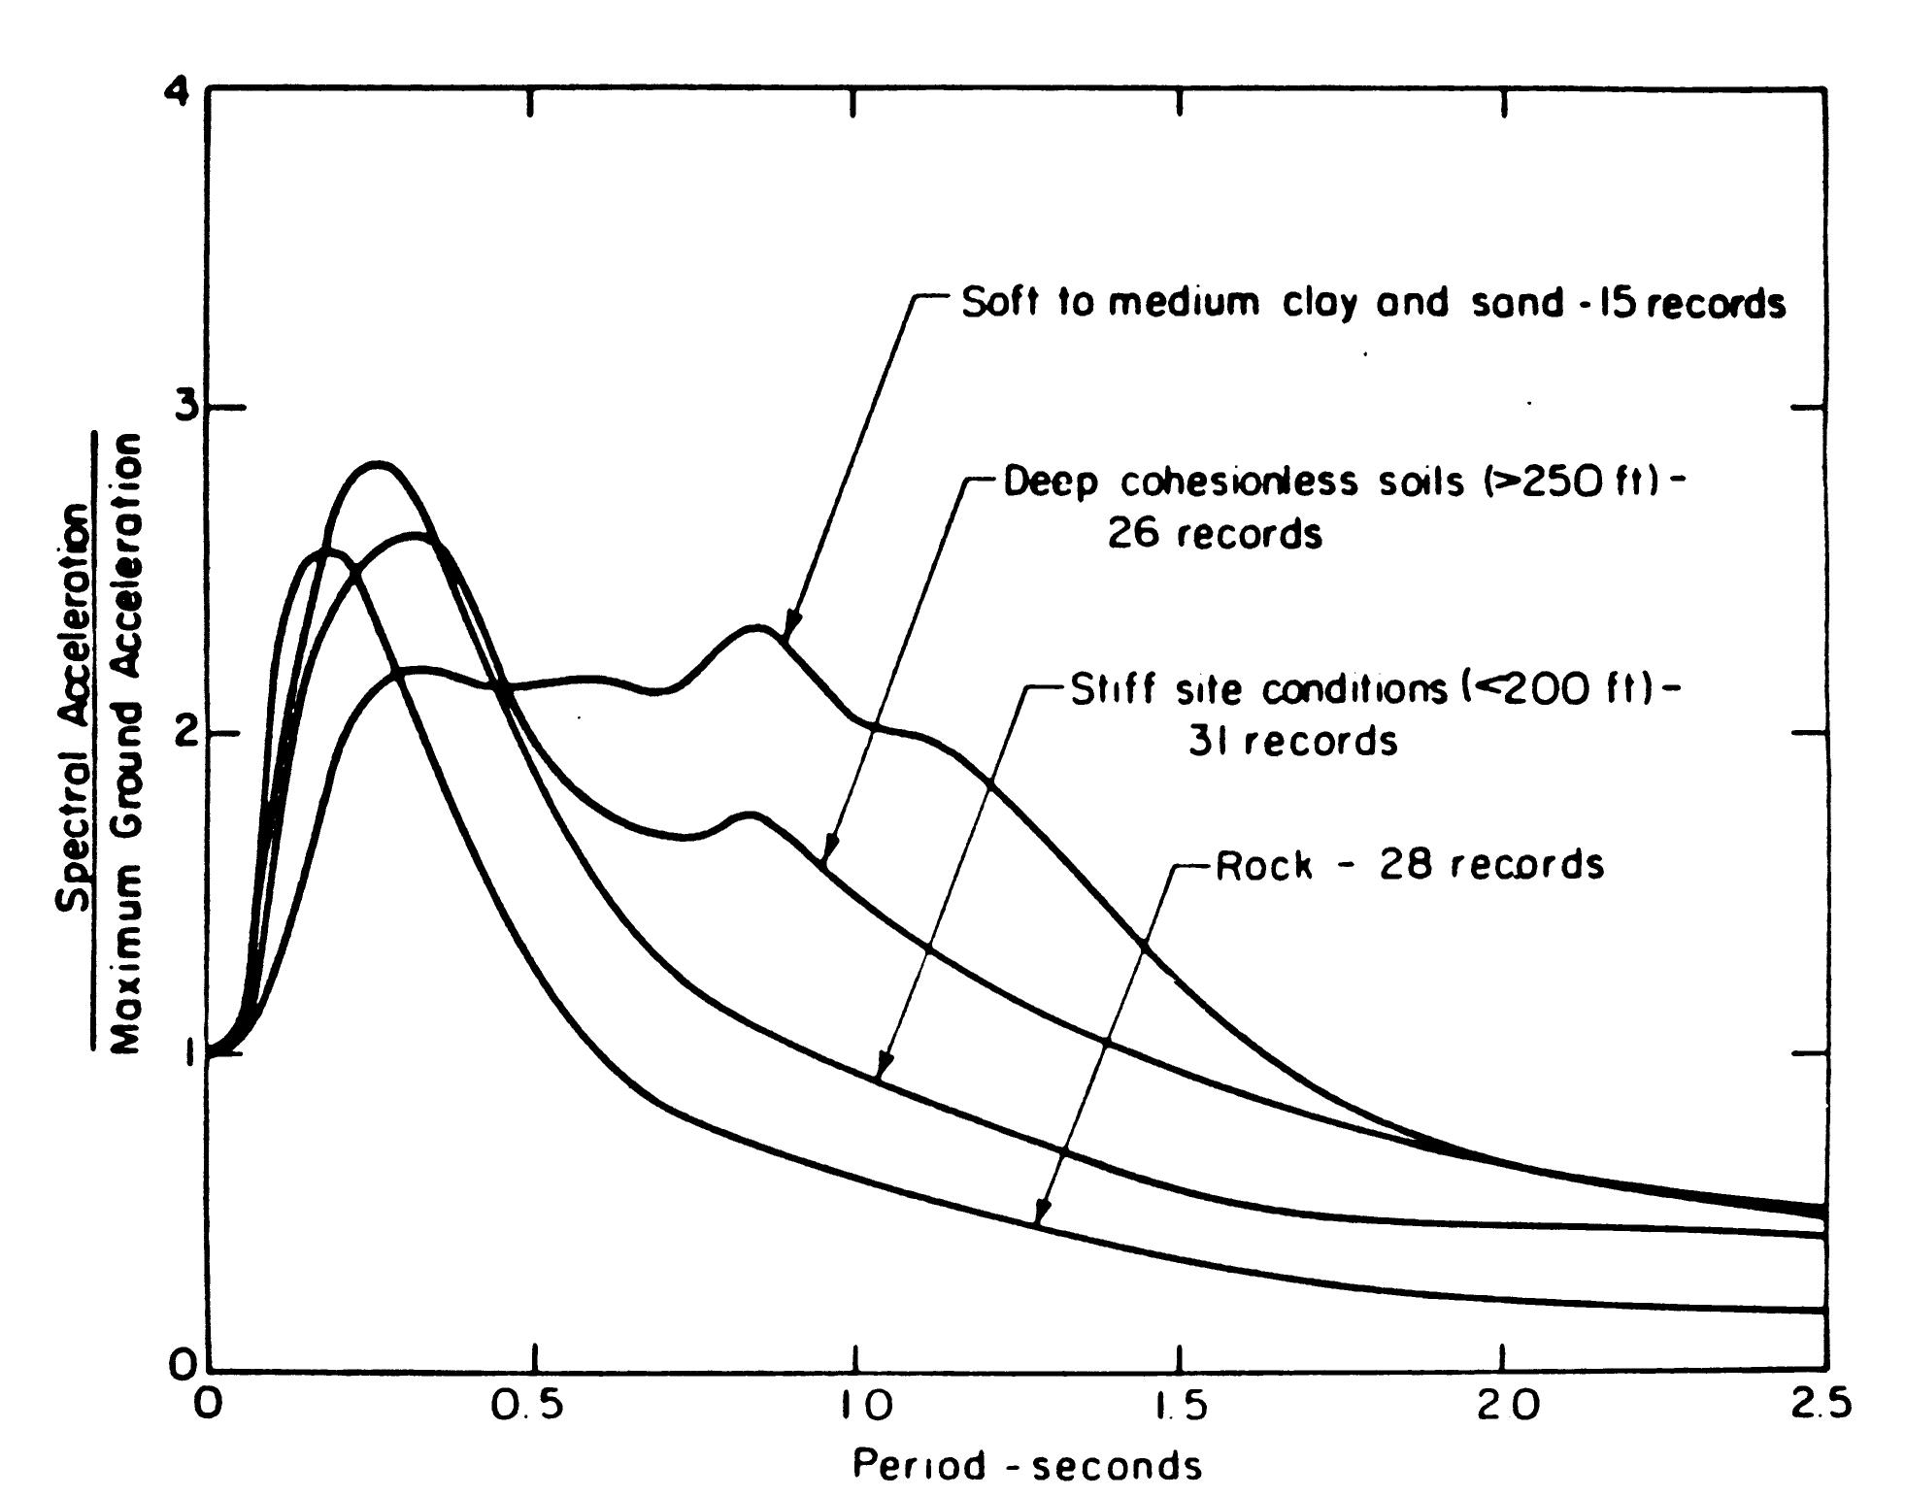

Figure 4.13. Effects of Near Surface Soil Conditions on 5% Damped Response Spectral Shapes (Source: Seed, Ugas, and Lysmor, 1976)
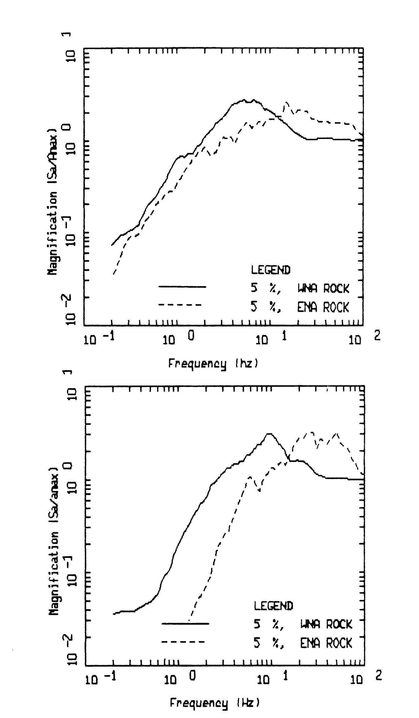

Figure 4.14. Effects of Hard (ENA) and Soft (WNA) Rock Site Conditions on 5% Damped Response Spectral Shapes for M ~ 6.5 (Upper) and M ~ 4.5 (Lower) Earthquakes (Source: Silva and Darragh, 1995)
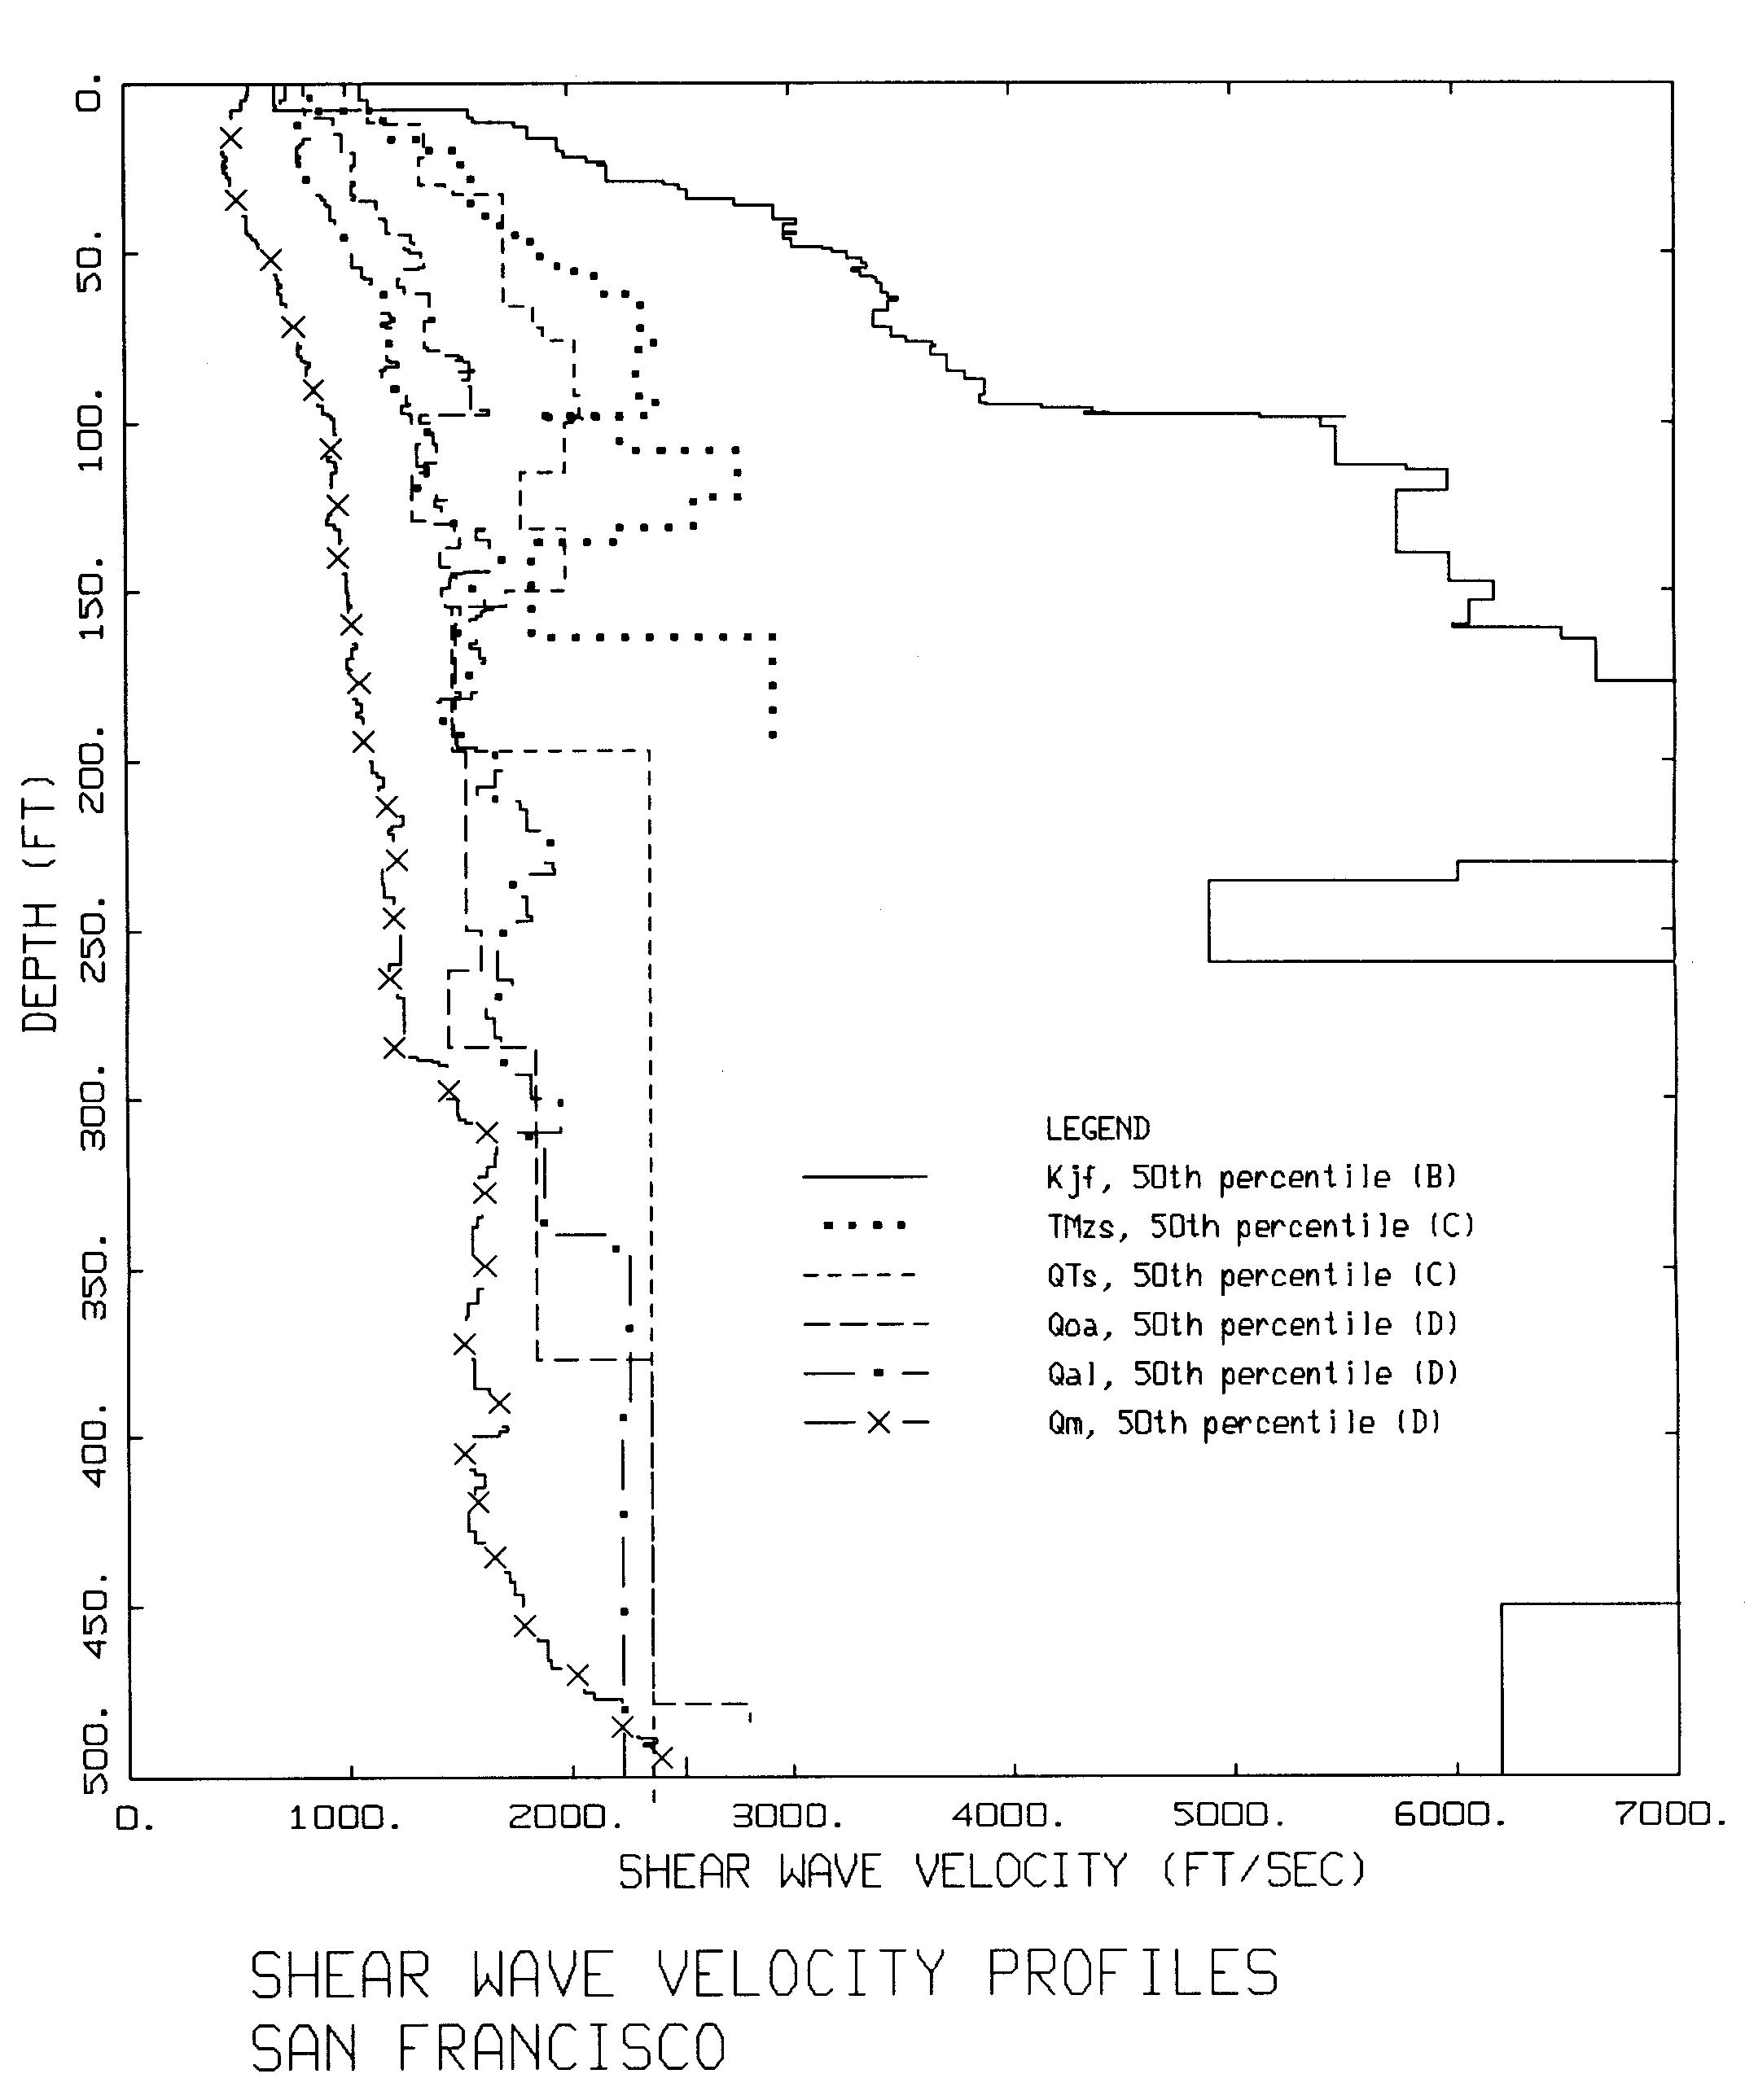

Figure 4.15. Median Shear-Wave Velocity Profiles Classified by Surface Surface Geology in the San Francisco Bay Area

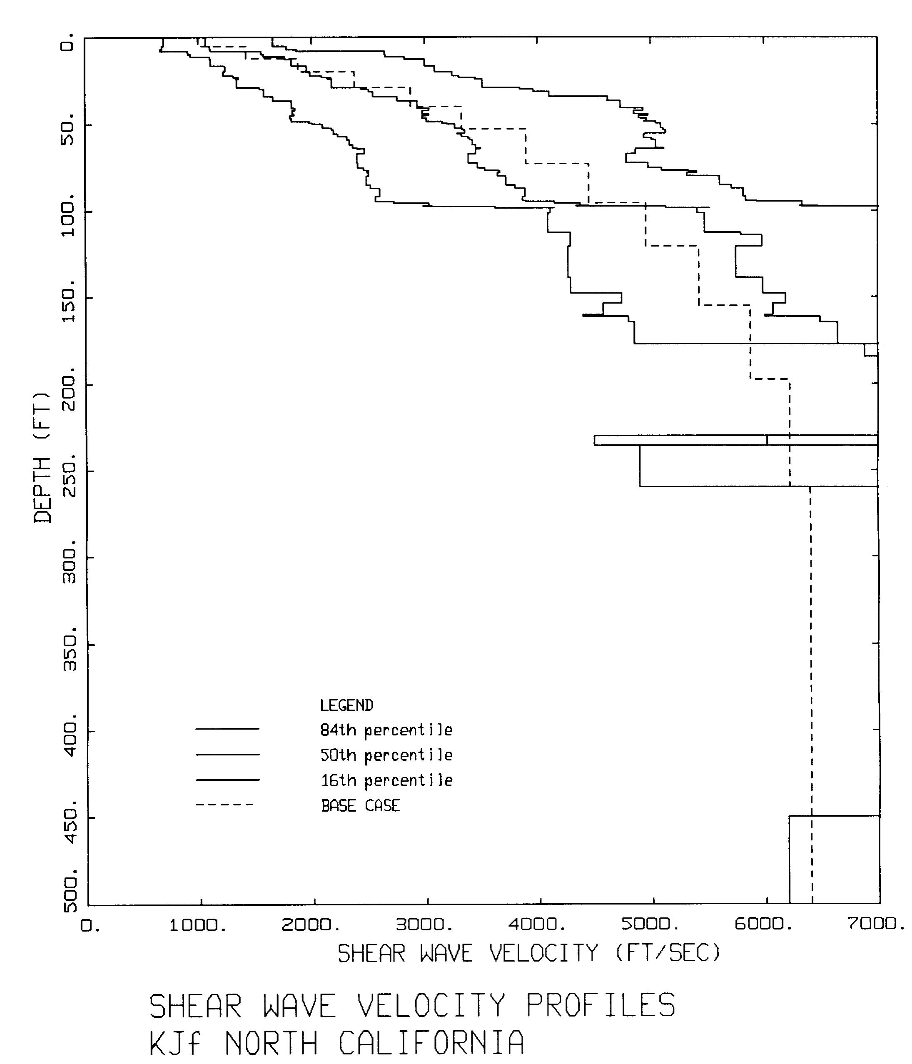

Figure 4.16. Median and +-1 Sigma Shear-Wave Velocity Profiles for the Franciscan Surface Geologic Unit (Kjf) in the San Francisco Bay Area
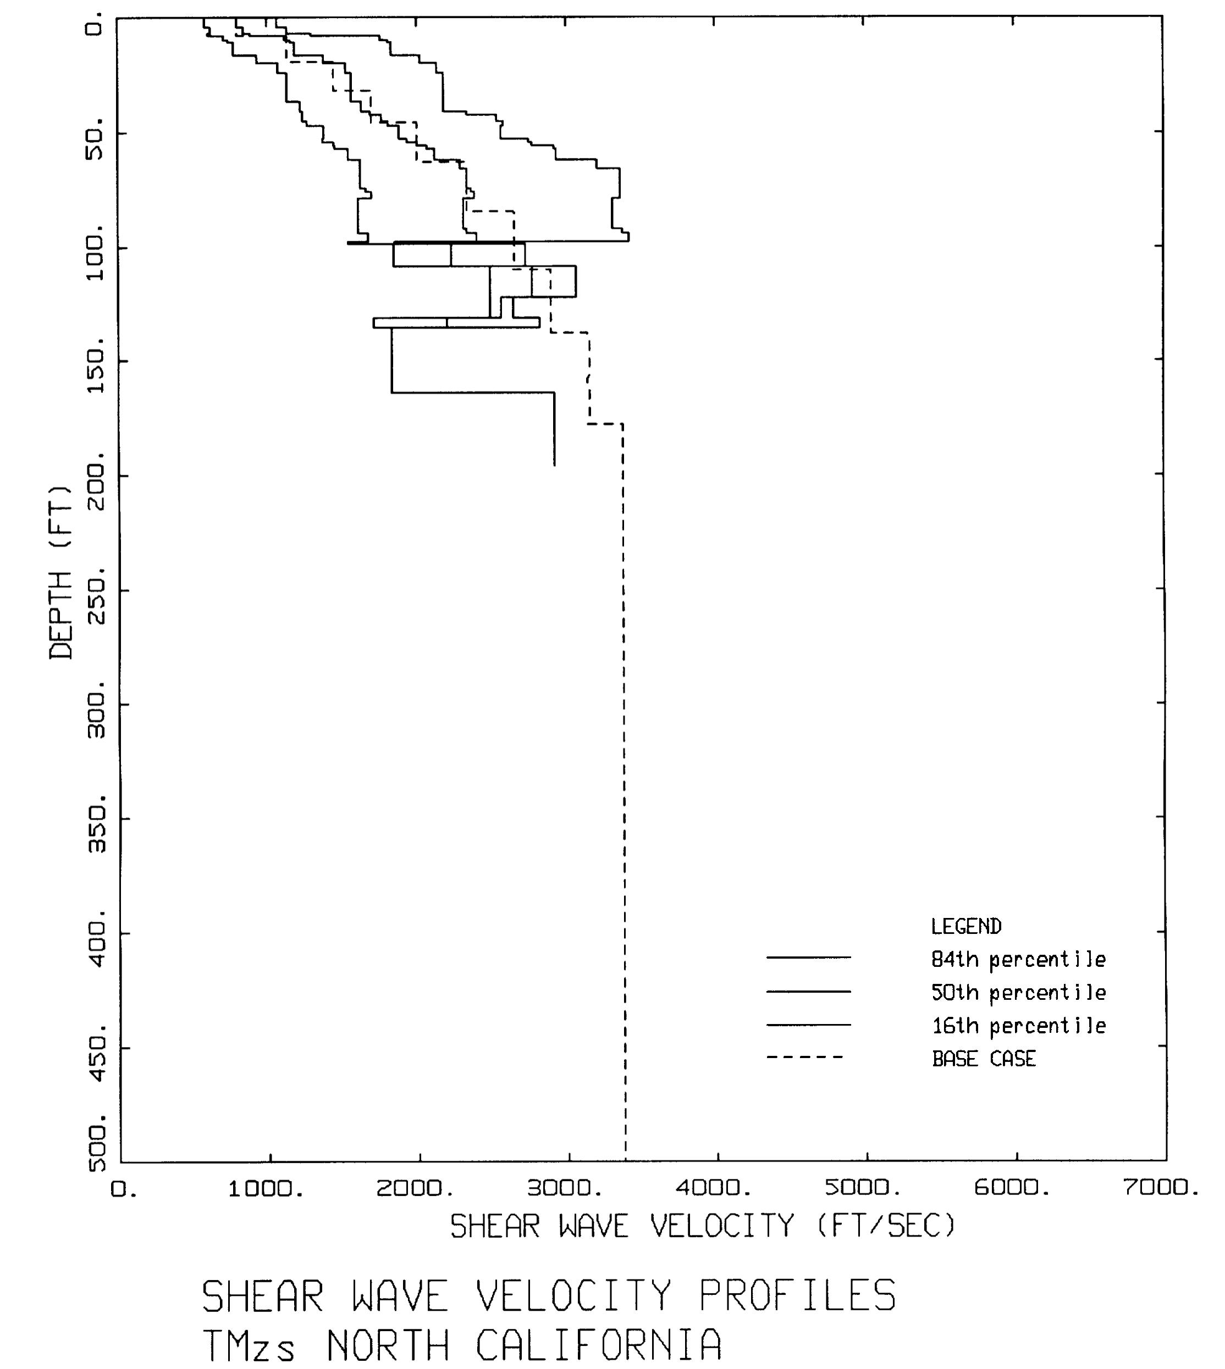

Figure 4.17. Median and +-1 Sigma Shear-Wave Velocity Profiles for the Tertiary Surface Geologic Unit (TMzs) in the San Francisco Bay Area

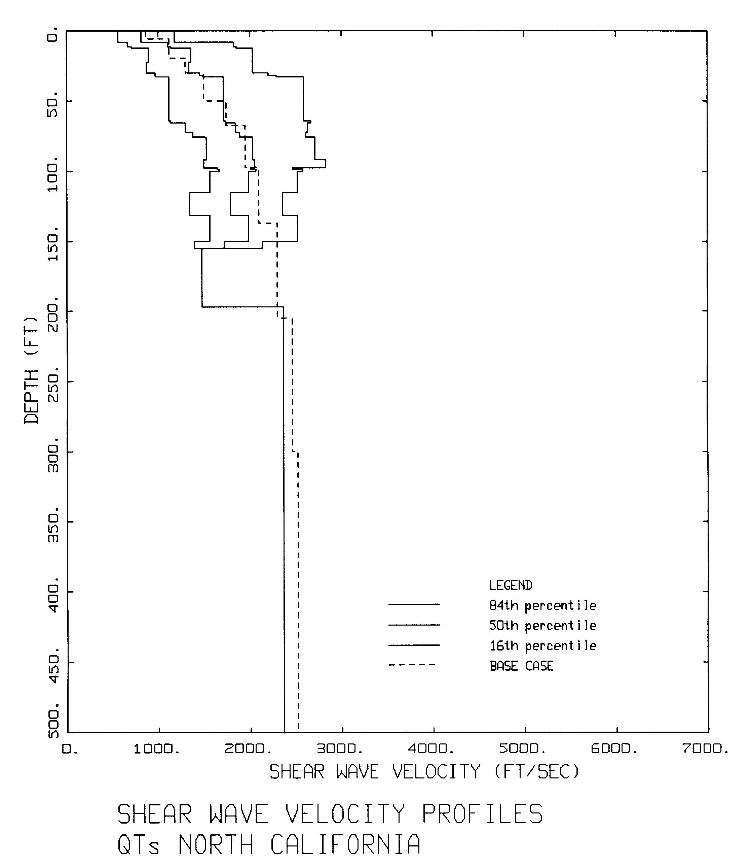

Figure 4.18. Median and +-1 Sigma Shear-Wave Velocity Profiles for the Quaternary-Tertiary Surface Geologic Unit (QTs) in the San Francisco Bay Area

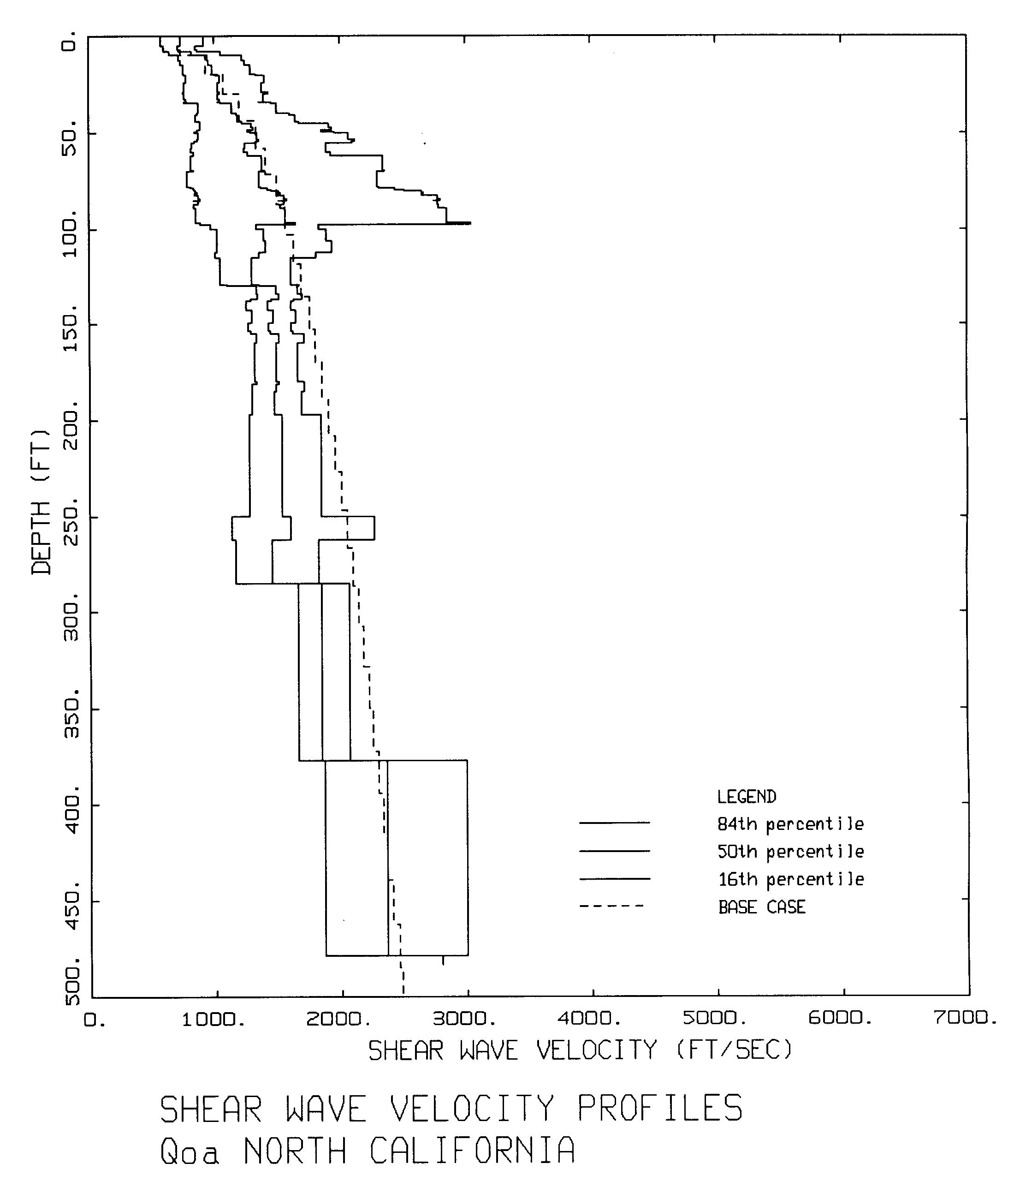

Figure 4.19a. Median and +-1 Sigma Shear-Wave Velocity Profiles for the Quaternary Surface Geologic Unit in the San Francisco Bay Area

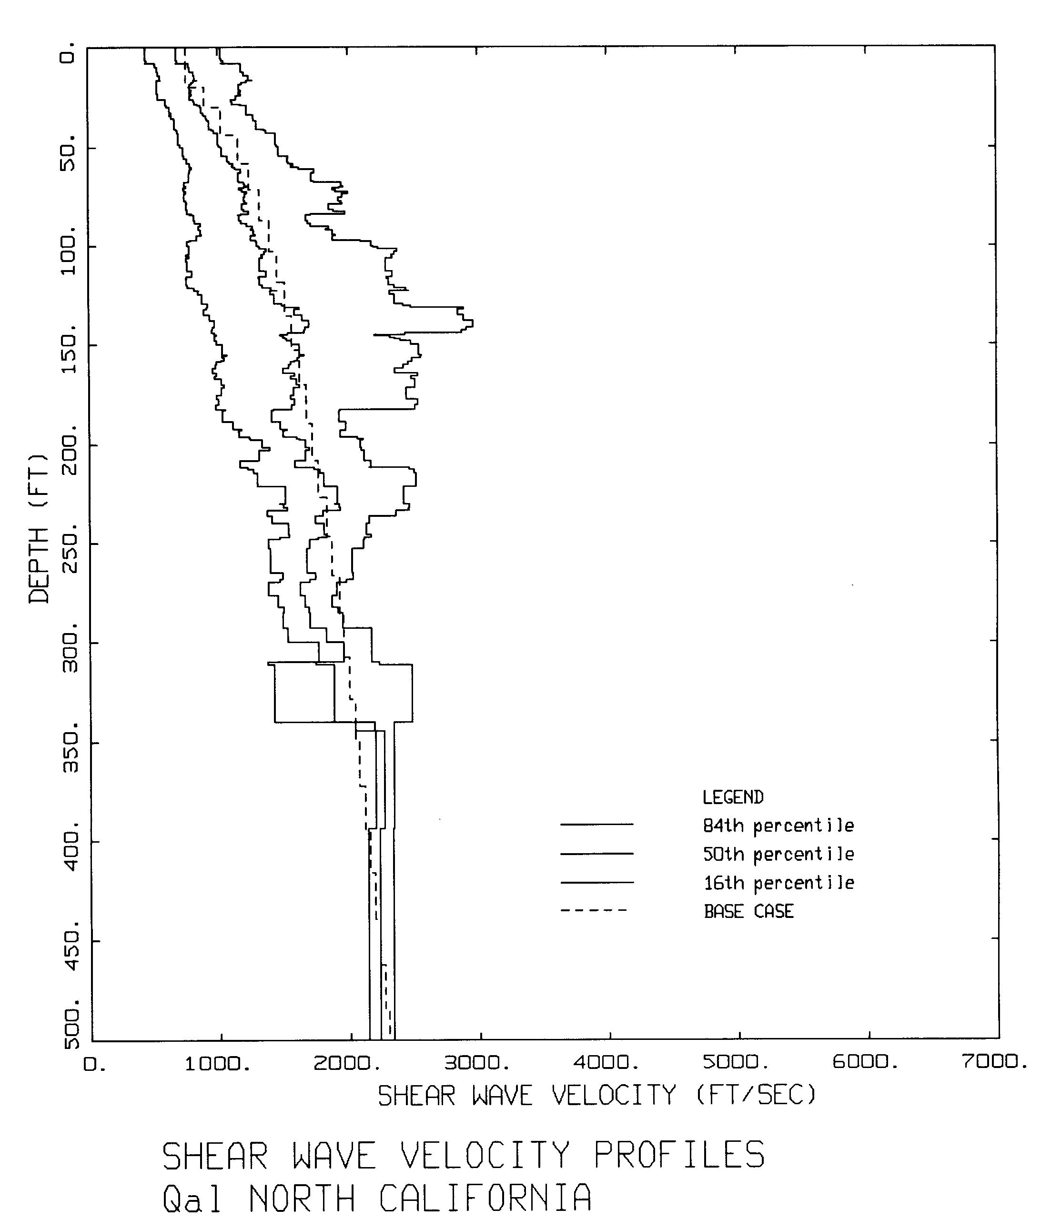
Figure 4.7b. Median and +-1 Sigma Shear-Wave Velocity Profiles for the Young Quaternary Surface Geologic Unit in the San Francisco Bay Area

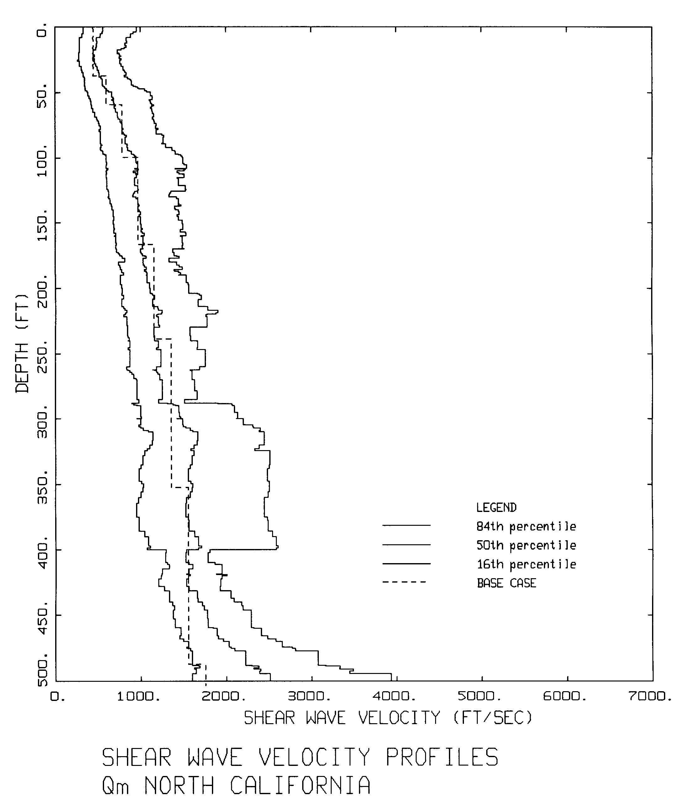

Figure 4.20. Median and +-1 Sigma Shear-Wave Velocity Profiles for the Bay Mud Surface Geologic Unit (Qm) in the San Francisco Bay Area

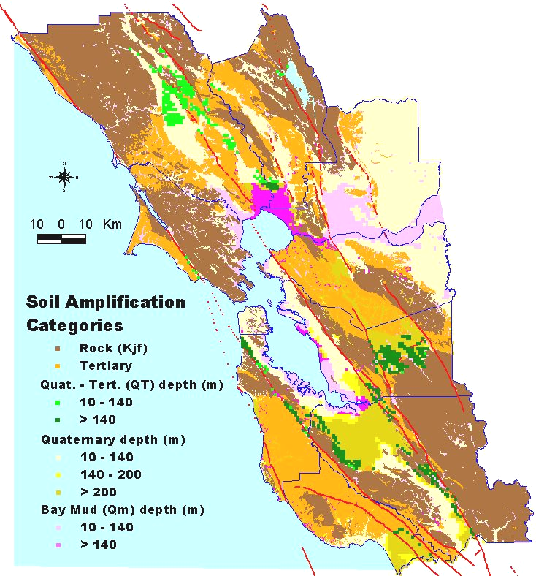

Figure 4.21. Map of Soil Amplification Categories for Combined Surface Geology and Depth to Bedrock

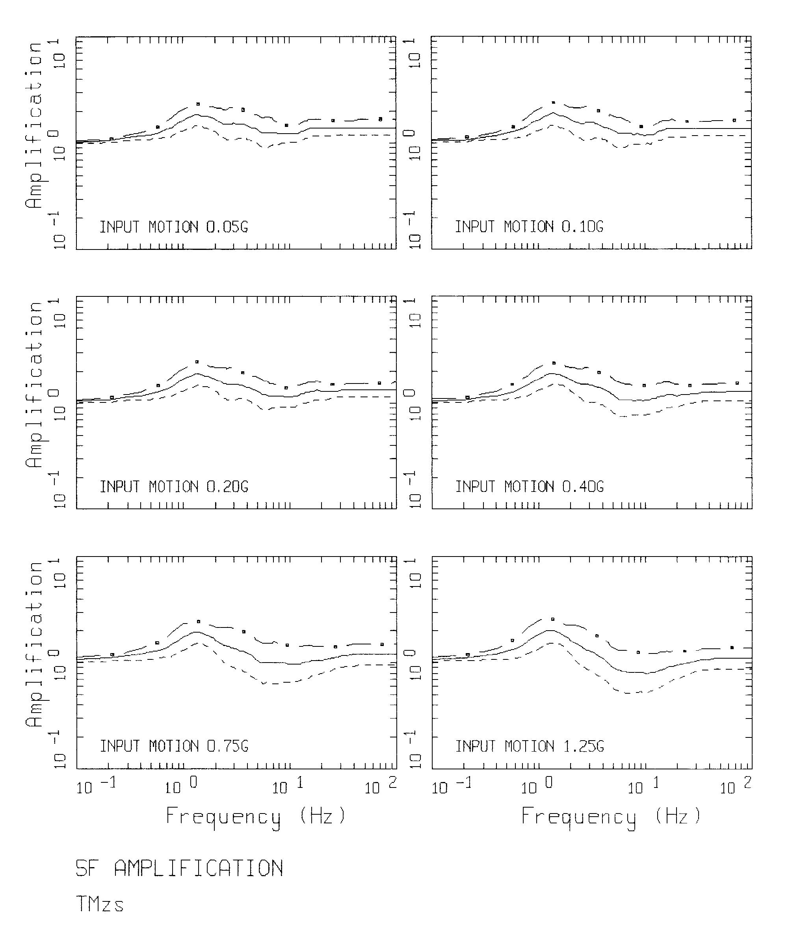

Figure 4.22. Median and +-1 Sigma Soil Amplification Factors for the Tertiary Surface Geologic Unit (TMzs) in the San Francisco Bay Area

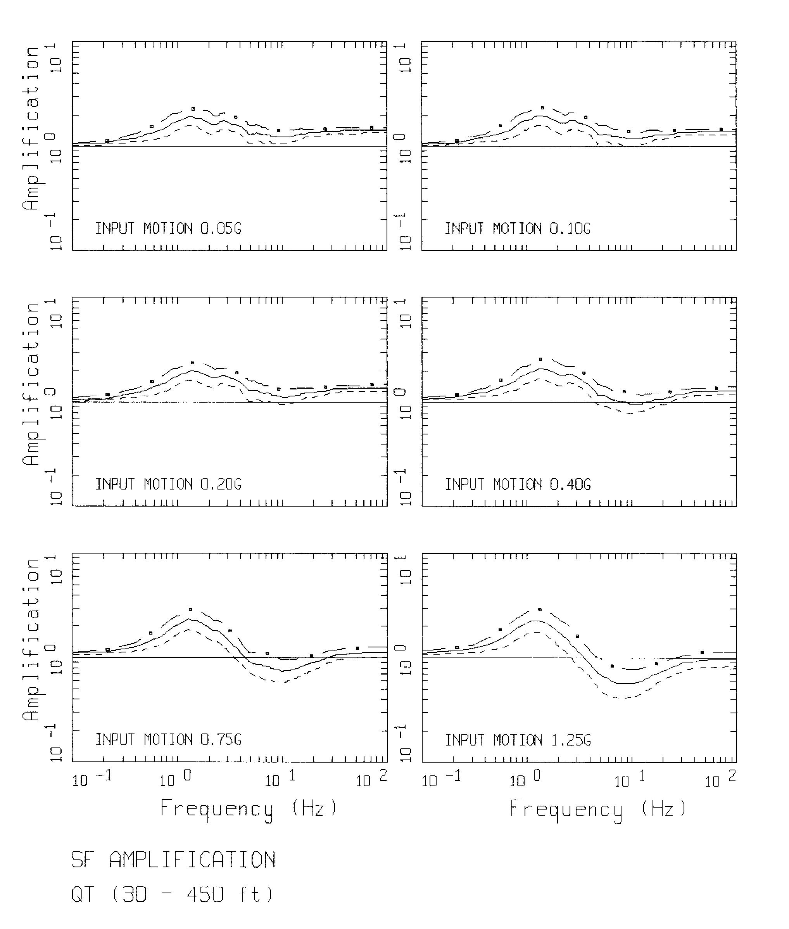

Figure 4.23. Median and +-1 Sigma Soil Amplification Factors for the Quaternary-Tertiary Surface Geologic Unit (QTs) at Depths of 10 - 140 m (30 - 450 ft)

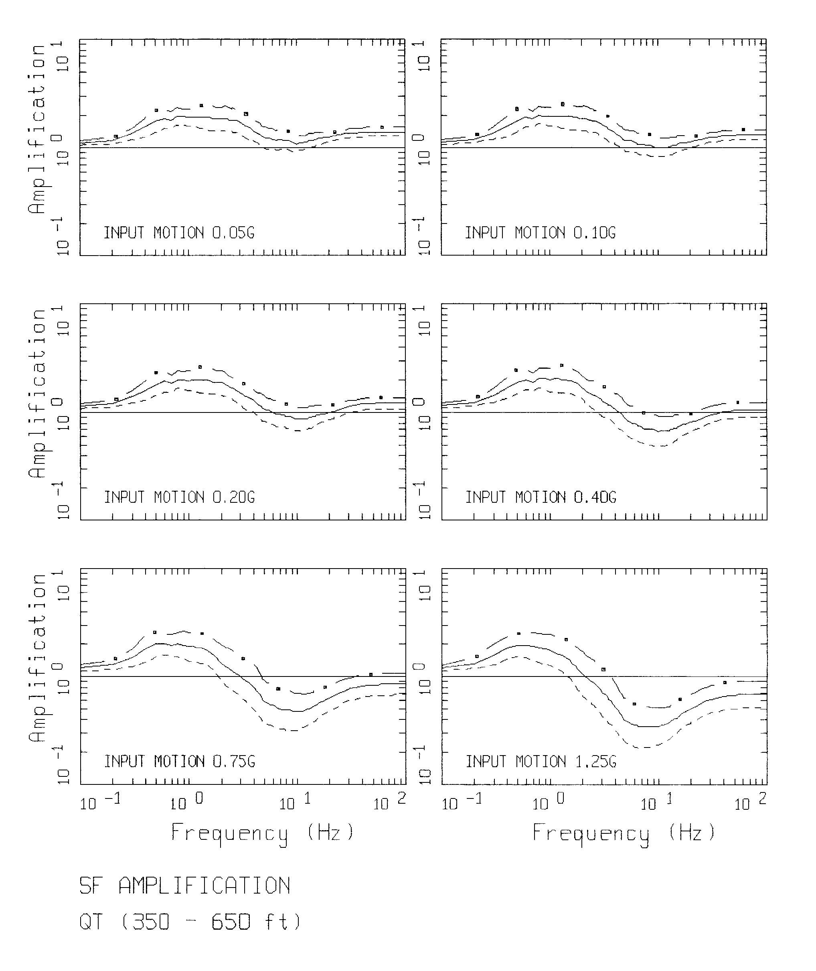

Figure 4.24. Median and +-1 Sigma Soil Amplification Factors for the Quaternary-Tertiary Surface Geologic Unit (QTs) at Depths of 105 - 200 m (350 - 650 ft)

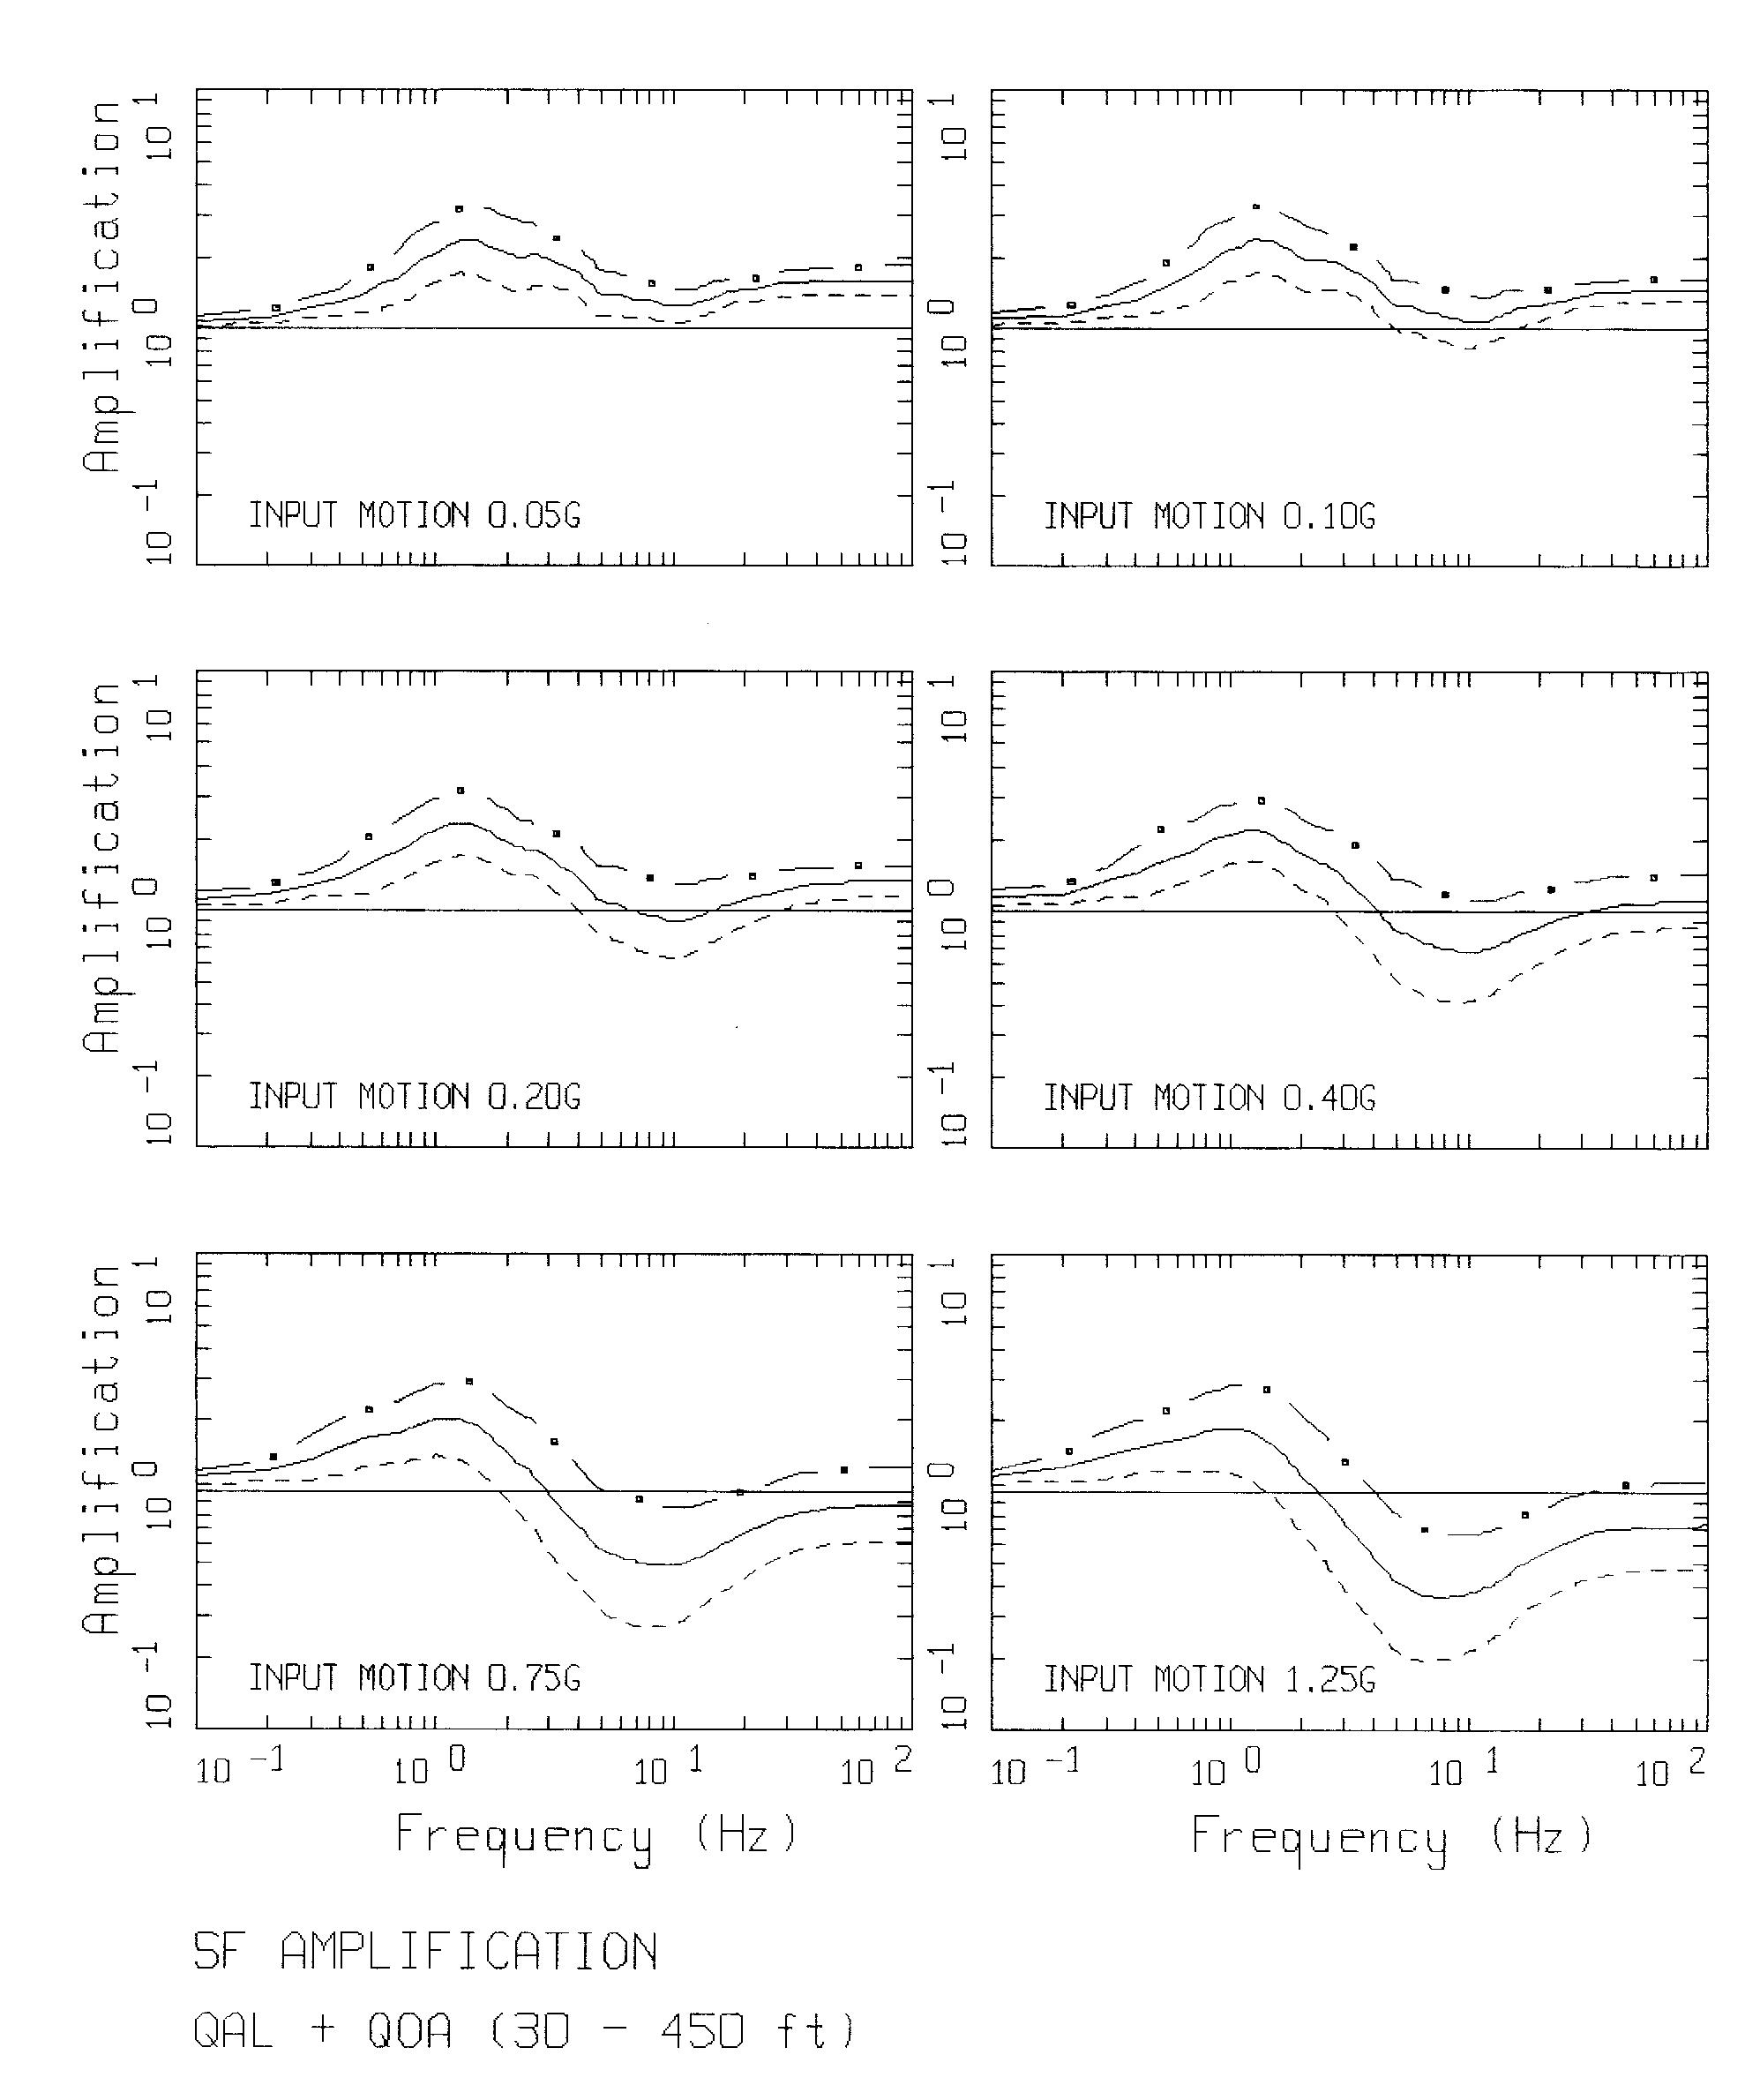

Figure 4.25. Median and +-1 Sigma Soil Amplification Factors for the Quaternary Surface Geologic Unit at Depths of 10 - 140 m (30 - 450 ft)

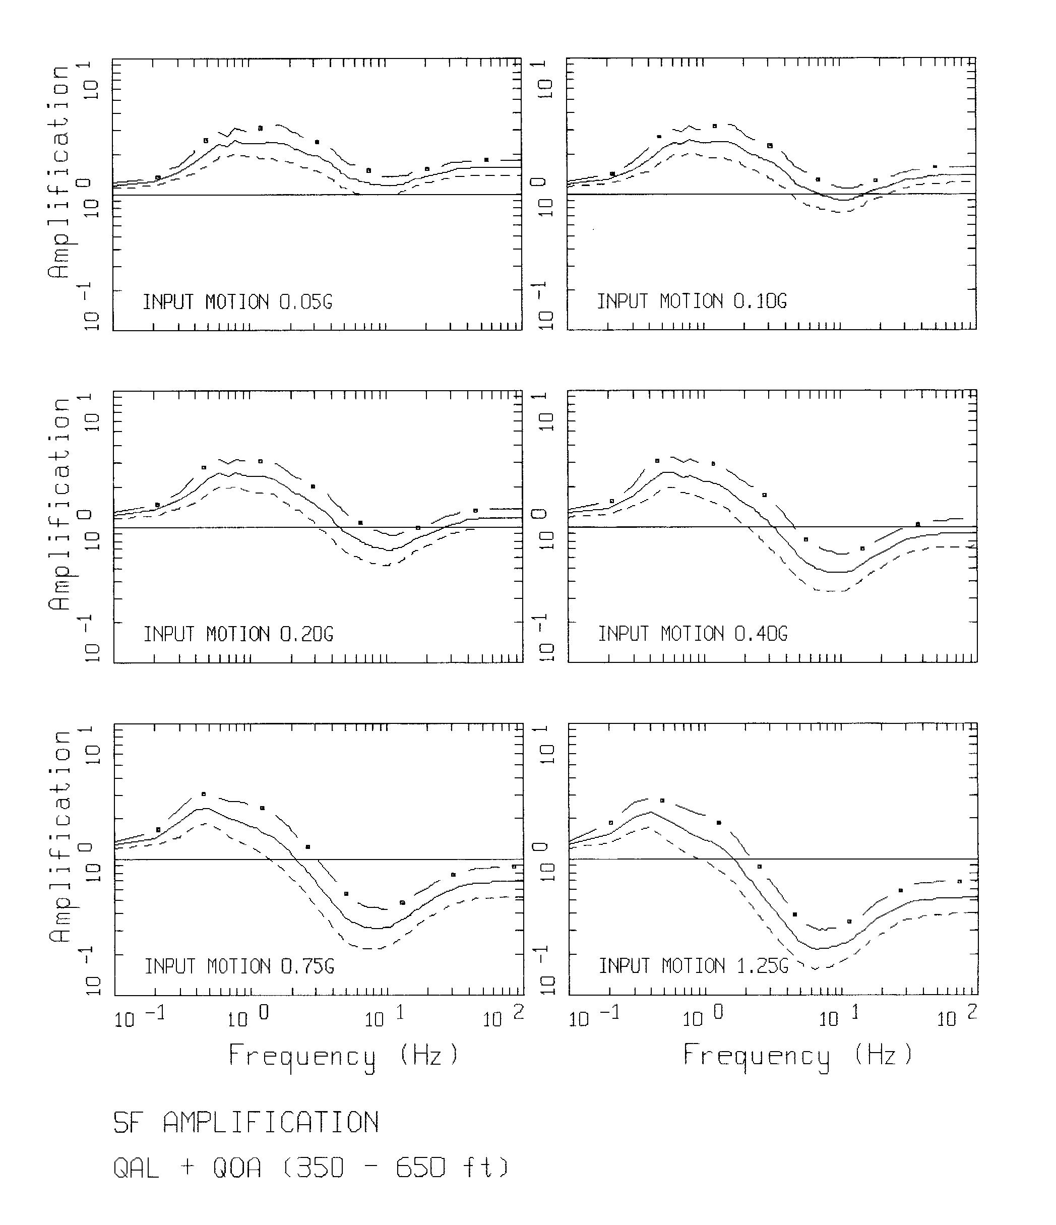

Figure 4.26. Median and +-1 Sigma Soil Amplification Factors for the Quaternary Surface Geologic Unit at Depths of 105 - 200 m (350 - 650 ft)

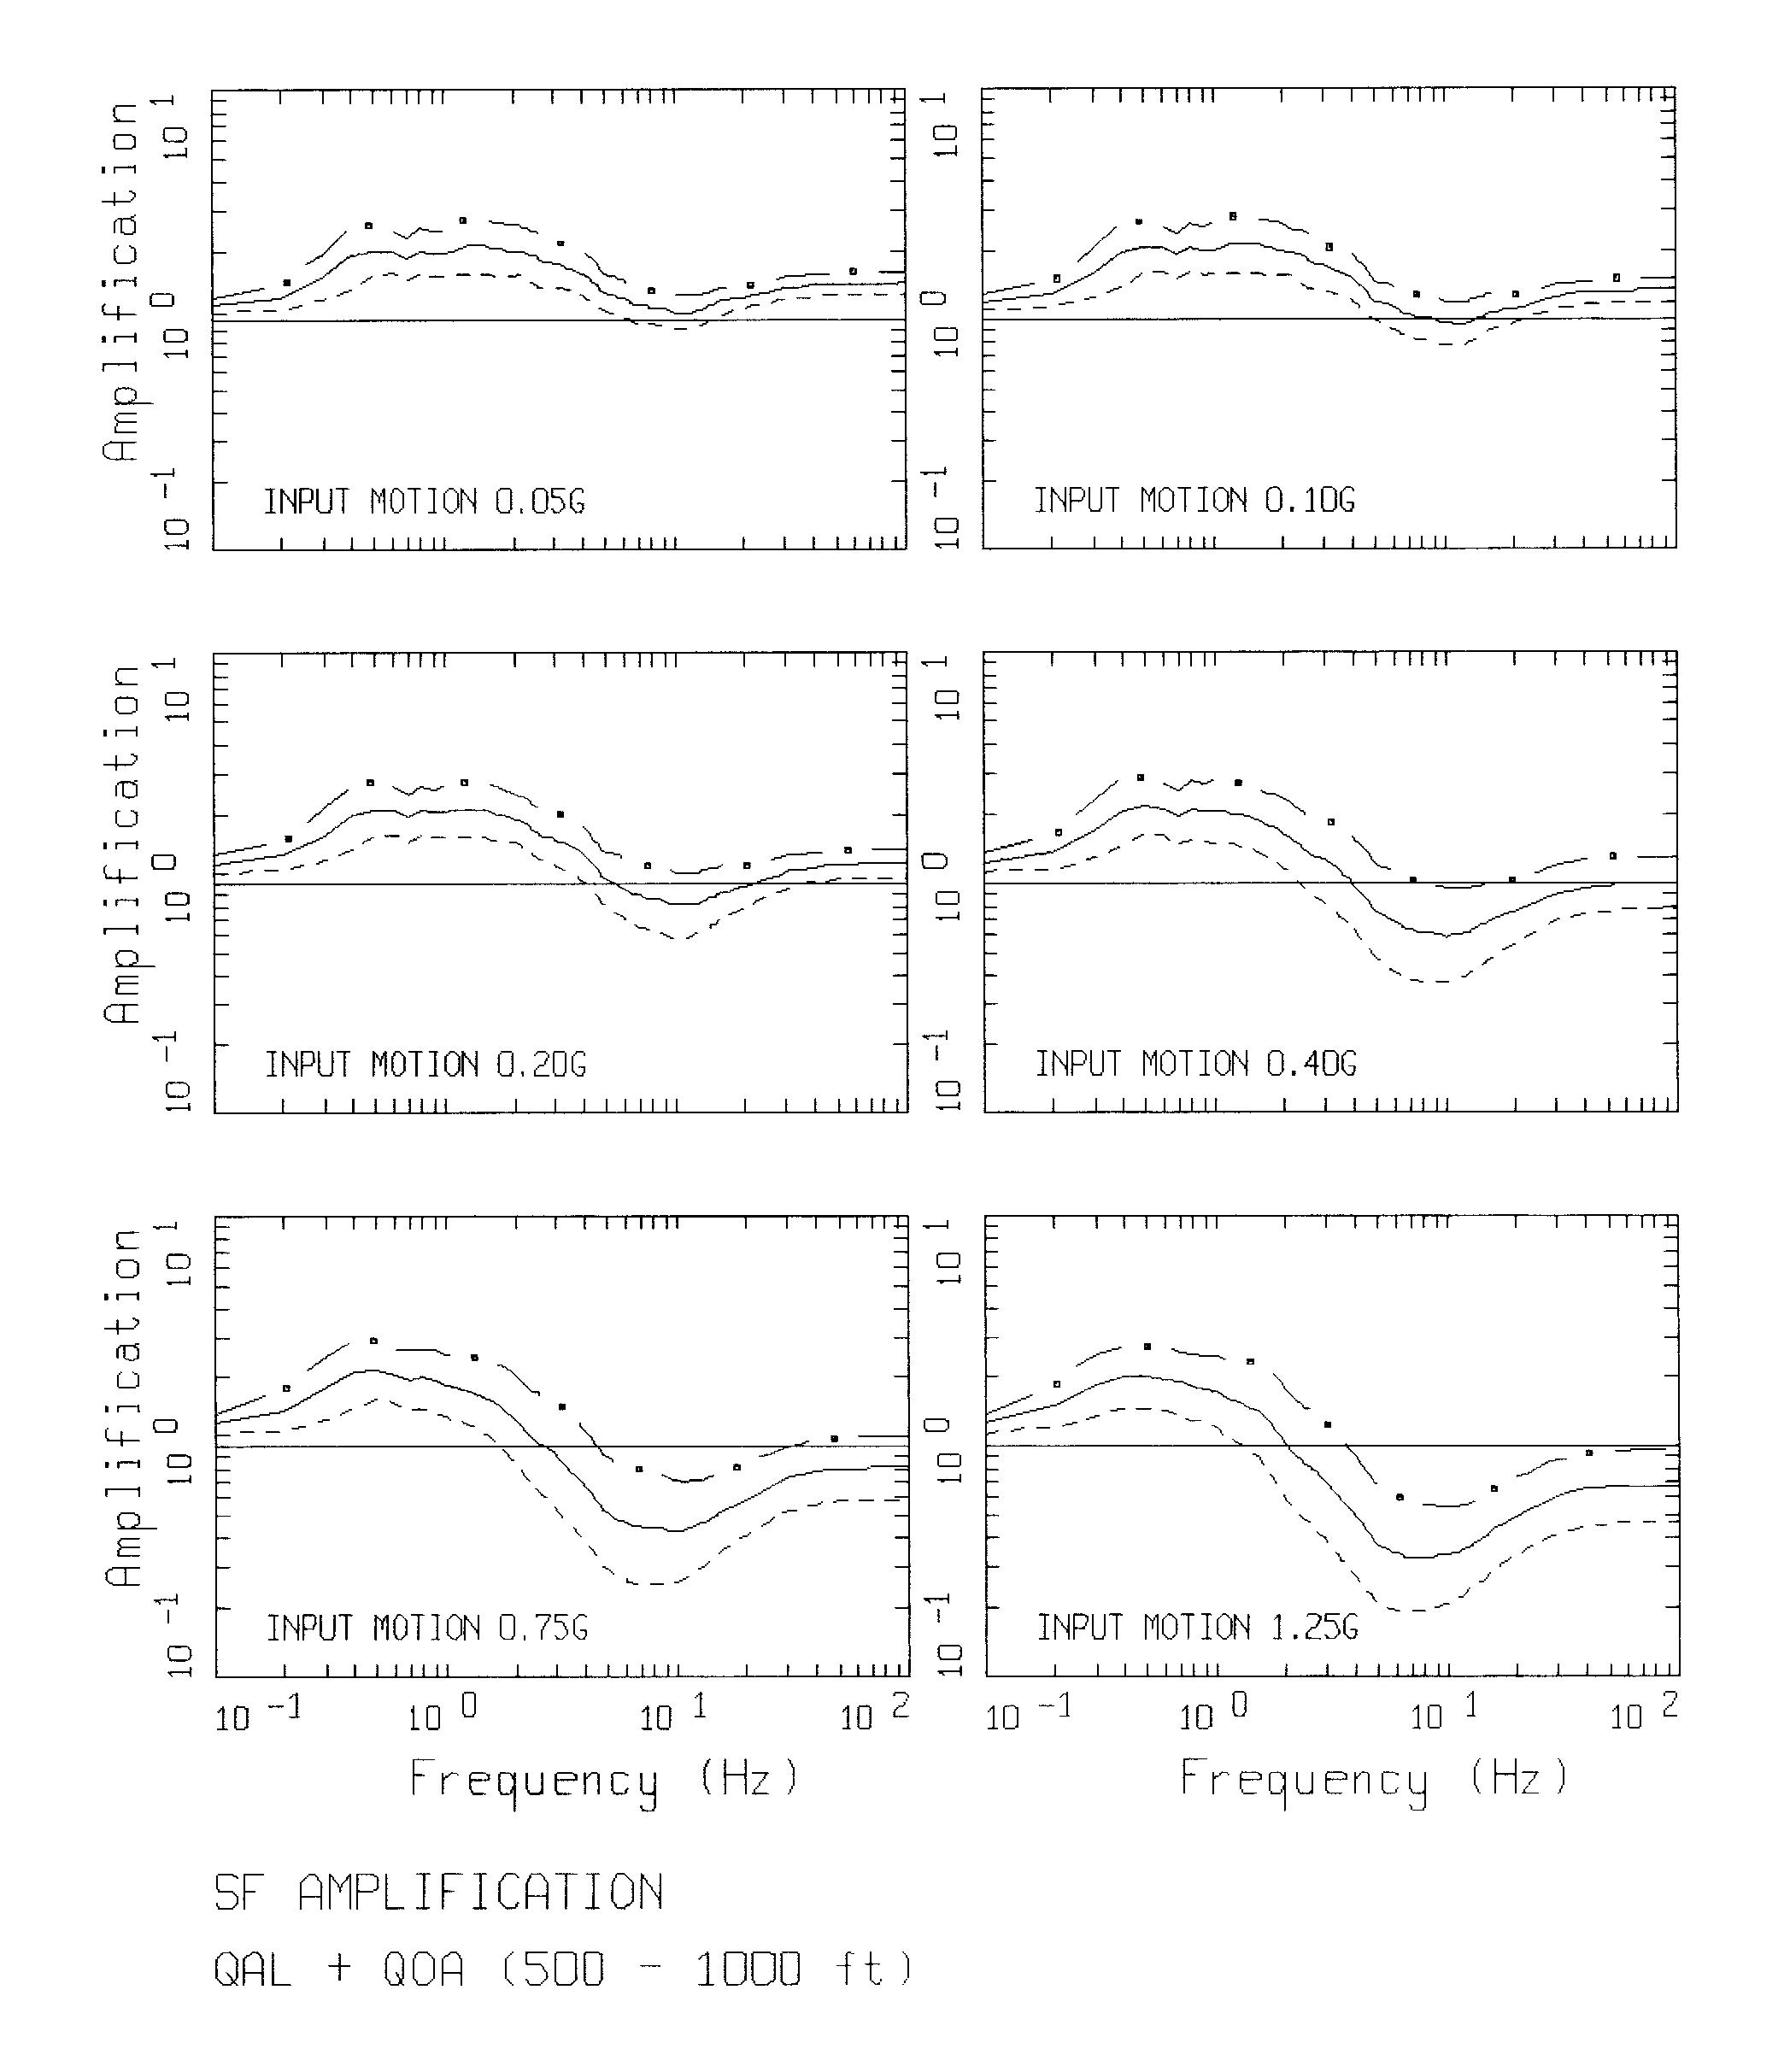

Figure 4.27. Median and +-1 Sigma Soil Amplification Factors for the Quaternary Surface Geologic Unit at Depths of 150 - 300 m (500 - 1000 ft)

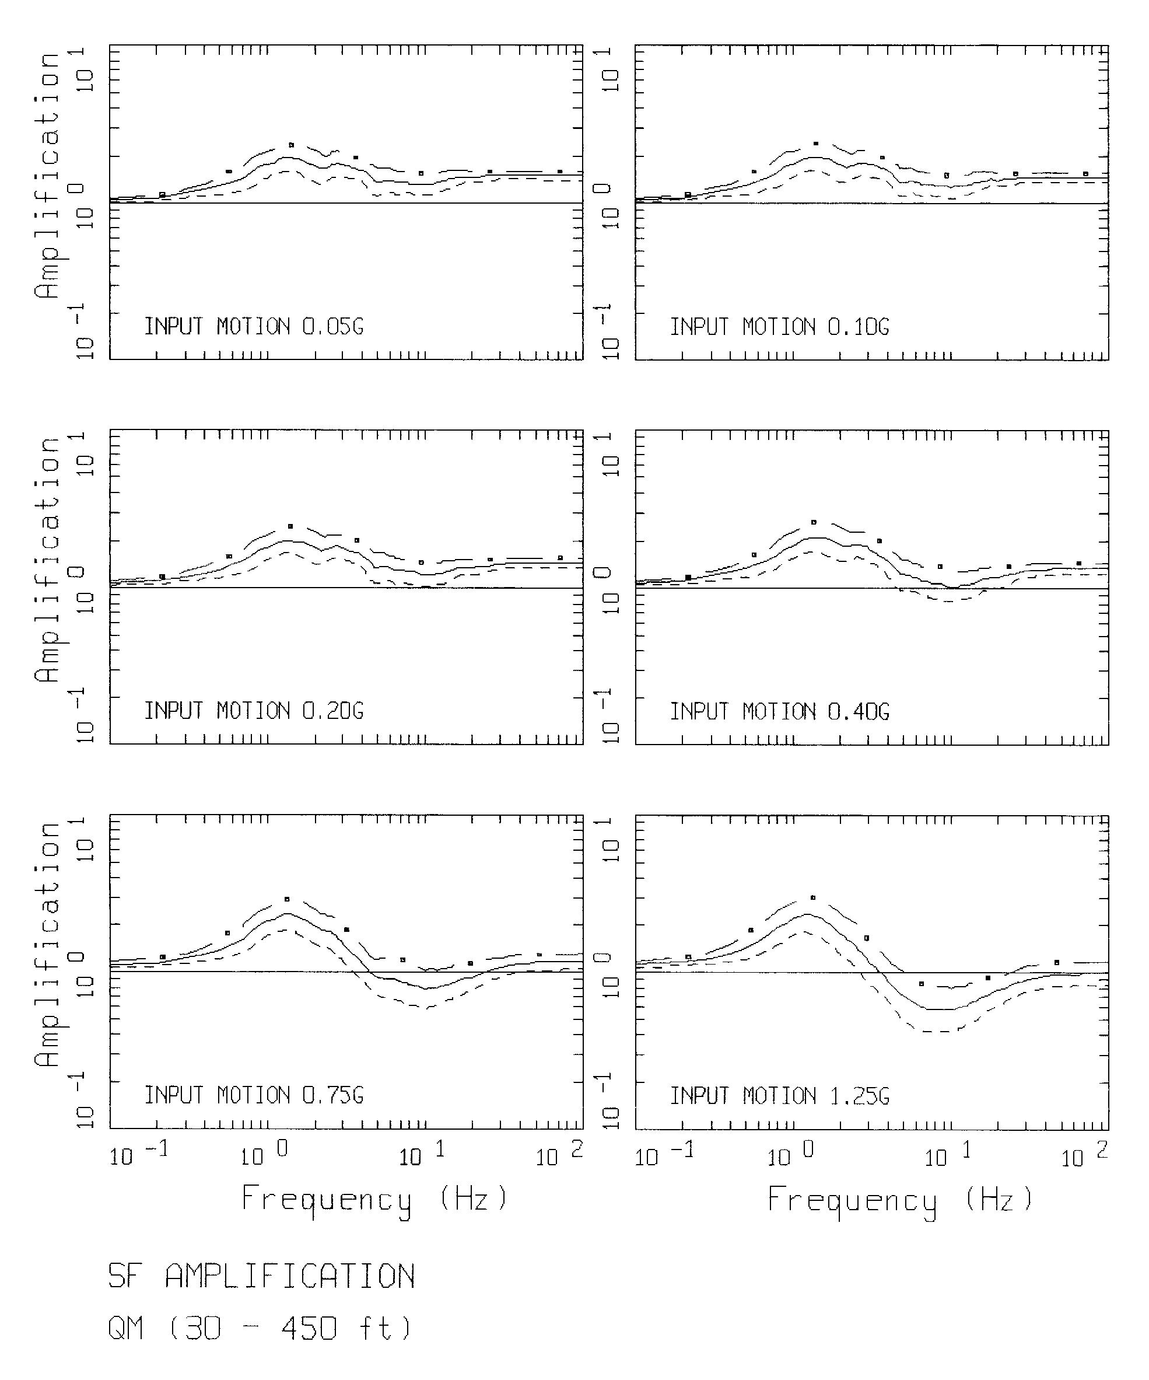

Figure 4.28. Median and +-1 Sigma Soil Amplification Factors for the Bay Mud Surface Geologic Unit (Qm) at Depths of 10 - 140 m (30 - 450 ft)

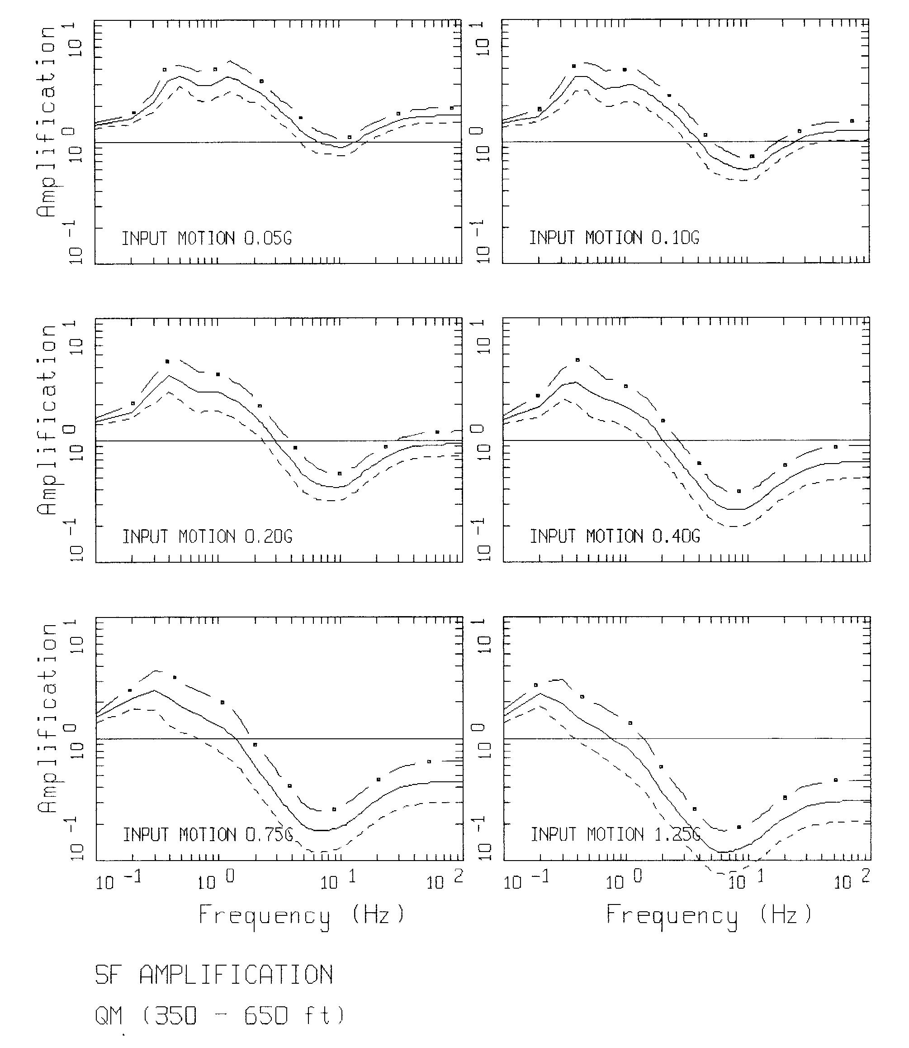

Figure 4.29. Median and +-1 Sigma Soil Amplification Factors for the Bay Mud Surface Geologic Unit (Qm) at Depths of 105 - 200 m (350 - 650 ft)

Hazard Maps
This section contains the results of the ground motion modeling in terms of scenario hazard maps. The maps are presented in terms of median and median-plus-sigma (84th percentile) 5% damped response spectral acceleration for the two earthquake scenarios at five spectral periods: 0 (PGA), 0.2, 0.3, 1.0, and 3.0 sec. Results are presented for rock outcrop motions and for the effects of soil amplification. Presented first is a summary of the preparation of maps, including the equations governing the combination of model results.

Development of Maps

Calculation of Mean and Variance
The median ground motions are given by the exp(mean[Ln(Sa)], where the Ln(Sa) is assumed to be lognormally distributed. Thus, the mean [μLn(Sa)] ground motions for each individual model are given by:
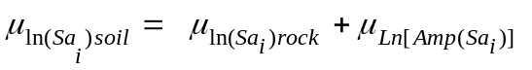 Eq. 5.1
The weighted average mean for the combination of all models is given by:
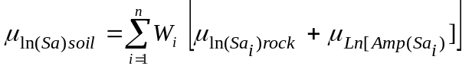 . Eq. 5.2
The standard deviation (sigma) for an individual model is calculated as the square root of the sum of the variances from rock and soil uncertainty, as follows:
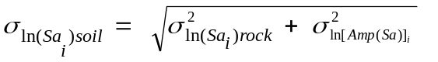. Eq. 5.3
The variance from the weighted combination of different models is computed as:
Eq. 5.4
This formulation of the variance does not include the additional variance contributed by the uncertainty between models, due to the difference in the mean between ground motion models (for rock). An expression including this additional source of uncertainty is given by:
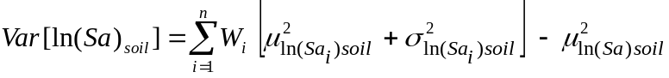 Eq. 5.5
For this study, the uncertainty is expressed using Eq. 5.4. As discussed in Section 3.4 the additional variance associated with Eq. 5.5 is not warranted as the variance contributed by the site has been included twice: once in the total variance for the rock motions and again in the variance associated with the amplification factors. Use of Eq. 5.5 really requires a correct partitioning of variances into source/path and site components, a very desirable objective, but given the present limitations of data and models, not something that can be done reliably.

Hazard Maps for Median Rock Motions
In order to generate hazard maps, the rock motions computed in Section 3 were interpolated over a dense grid on over 20,000 points covering the 10-county San Francisco Bay Region. The median rock motions were computed using Eq. 5.2, with a weight of 60% applied to the stochastic finite-fault simulations, and 10% applied to each of the four empirical models. Final results were then contoured by applying a kriging filter and plotted at the five spectral periods for each scenario. to Figure 5.34 present hazard maps for median values of 5% damped response spectra at periods 0, 0.2, 0.3, 1.0, and 3.0 sec (respectively) for the M 7.1 Hayward Fault scenario. Figure 5.35 to Figure 5.39 present hazard maps for median values of 5% damped response spectra at periods 0, 0.2, 0.3, 1.0, and 3.0 sec (respectively) for the M 7.9 San Andreas Fault scenario.
These hazard maps show smooth contours radiating away from the fault, with variations dominated by attenuation of ground motion with distance from the fault. The highest spectral accelerations are found at 0.2 sec for both scenarios. Peak ground accelerations have a maximum of 0.9 to 1.0 g for the Hayward scenario, and have a maximum of about 1.2 g for the San Andreas scenario. These values are larger than would be predicted by the average of the empirical relations alone. On the other hand, ground motions show a tendency to diminish toward the ends of the fault at all spectral periods. This trend is attributed to the fact that in the stochastic simulation model on average the hypocenter locations and largest sources of slip on the fault will tend to be closer to the middle of the fault than to either end. This trend is not an attribute of the empirical relations, as for these models the ground motion is estimated as a simple function of distance to the fault, without regard to proximity of a given site to the fault end points.
The ten rock motion hazard maps can be used for site-specific analyses by applying amplification factors specifically developed for a given site. They can also be used as the basis for applying the amplification factors developed here (and discussed in the next section) or generic amplification factors developed by others.

Hazard Maps for Median Soil Motions
The hazard maps for median soil motions were developed by applying the soil amplification factors developed in Section 5 to the rock motions computed in Section 3. Amplification factors were applied to each of the more than 20,000 points used for the base rock hazard maps (Section 6.2), using the formulations of Eq. 5.3 and 6.4. As with the rock motions, the soil motions were computed with a weight of 60% applied to the stochastic finite-fault simulations, and 10% applied to each of the four empirical models. Final results were then contoured by applying a kriging filter and plotted at the five spectral periods for each scenario.
Figure 5.40 to Figure 5.44 present hazard maps for median values of 5% damped response spectra at periods 0, 0.2, 0.3, 1.0, and 3.0 sec (respectively) for the M 7.1 Hayward Fault scenario. Figure 5.45 to Figure 5.49 present hazard maps for median values of 5% damped response spectra at periods 0, 0.2, 0.3, 1.0, and 3.0 sec (respectively) for the M 7.9 San Andreas Fault scenario.
Like the hazard maps for rock, the soil hazard maps show a similar trend in decreasing ground motion radiating away from the fault; variations tend also to be dominated by attenuation of ground motion with distance from the fault. The highest spectral accelerations are also found at 0.2 sec for both scenarios; and peak ground accelerations near the centers of the faults are similar to those for rock. In comparison to rock motions, however, the soil motions decay much less rapidly with distance from the fault and show localized variations of a factor of two or more which are attributable to differences in soil amplification.
Details of the differences between soil and rock motions can be seen in the maps of soil/rock amplification ratios in Figure 5.50 to Figure 5.53 for the Hayward scenario, and Figure 5.54 to Figure 5.57 for the San Andreas scenario. These maps provide the ratios at periods 0 (PGA), 0.2, 1.0, and 3.0 sec. Within each map one clearly sees the spatial variations in amplification at each period. Across maps, one can compare the variations in amplification at any given location at different periods and for different scenarios at the same period. For instance, at short periods (< 1 sec), there is significant deamplification of ground motion near the faults, particularly in the bay mud. The patter is slightly different for the Hayward and San Andreas scenarios, as the deamplification is greatest at close proximity to the rupture. At longer periods, the amplification is generally 1 or greater, with large depth-dependent amplification apparent is the alluvial valleys. In particular, the largest amplifications at 1.0 sec are in the intermediate-depth class (140-200 m), and shift at 3.0 sec to the deepest class (> 200 m).

Hazard Maps for Effects of Uncertainty
The effects of uncertainty in modeling ground motions are addressed in Figures 5.29 to 5.37. Maps are shown only for the Hayward fault scenario, as the results are quite similar for both modeled scenarios. The maps are provided in three groups for PGA, 0.3 and 3.0 sec in Figures 5.29-5.31, 5.32-5.34 and 5.35 to 5.37, respectively. The first figure in each group (Figures 5.29, 5.32, and 5.35) shows the uncertainty or variability in rock motions from the stochastic model. Uncertainty is expressed in terms of the standard deviation (sigma) in natural log PGA. For the stochastic model, sigma is expressed relative to the distribution of ground motion estimates at each individual location for all realizations of slip or rupture distributions and hypocenter locations. A similar plot is not shown for the empirical models, as the sigma values for these models are not a function of location or distance (only period). The second figure in each group (Figures 5.30, 5.33, and 5.36) shows the combined sigma for all five rock motion models plus the effects of soil (Eq. 5.4). Finally, the third figure in each group (Figures 5.31, 5.34, and 5.37) shows median +1 sigma (84th percentile) spectral accelerations for the combined model. In this case, the corresponding median hazard maps are Figures 5.11, 5.13, and 5.15, to which sigma values are added via Eq. 5.4. A discussion of signficant observations follows.
For the stochastic model results (Figures 5.29, 5.32 and 5.35) the increase in variability at the fault ends is due mainly to rupture directivity, with a corresponding minimum effect at the center of the fault. The higher sigma at 50-70 km distance to the NE and SW of the fault is due to variations in the location of post-critical reflections from the base of the crust (i.e., Moho bounce) relative to the location of slip on the fault. There also appears to be a slightly higher sigma to the SE of the fault relative to the SW, which is attributable to model bias in the randomization of the slip distributions and hypocenter locations. This bias, though not significant to the overall results, could be reduced or eliminated by performing and aggregating a larger number of fault simulations. The results show similar patterns at all periods modeled.
For the sigma variability for all models with soil (Figures 5.30, 5.33, and 5.36), the higher sigma values at the fault ends are still dominant. Sigma values are increased slightly, particularly along the west side of the fault, due to the additional variability in soil response. The variability is substantially higher at 1 and 3 sec periods, due to greater variation in soil amplification at these periods. This is due in part to nonlinear effects at shorter periods, which tend to reduce the variability in soil motions across the range of event realizations.
The 84th percentile motions (Figures 5.31, 5.34, and 5.37) show similar trends to the corresponding hazard maps for median values (Figures 5.11, 5.13, and 5.15), as the dominant trends are again the attenuation in ground motion with distance from the fault. 84th percentile PGA’s are over 1 g along the entire length of the fault.
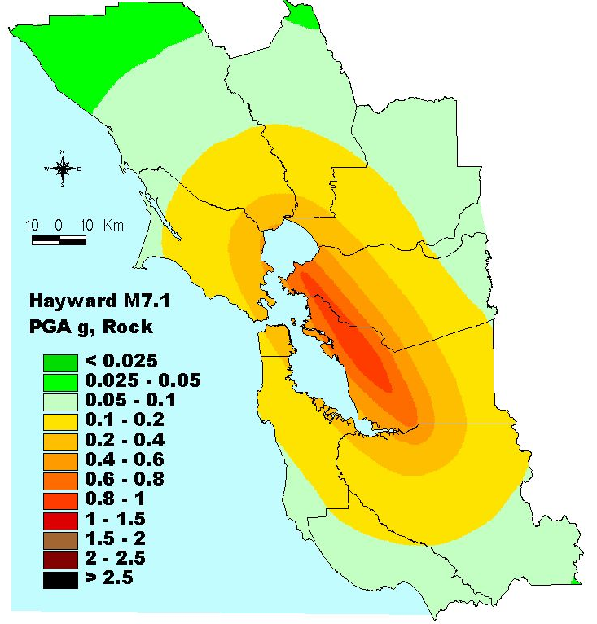

Figure 5.30. Hazard Map for Hayward Fault M7.1, 5% Damped Spectral Acceleration: Median at 0 sec (PGA) on Rock

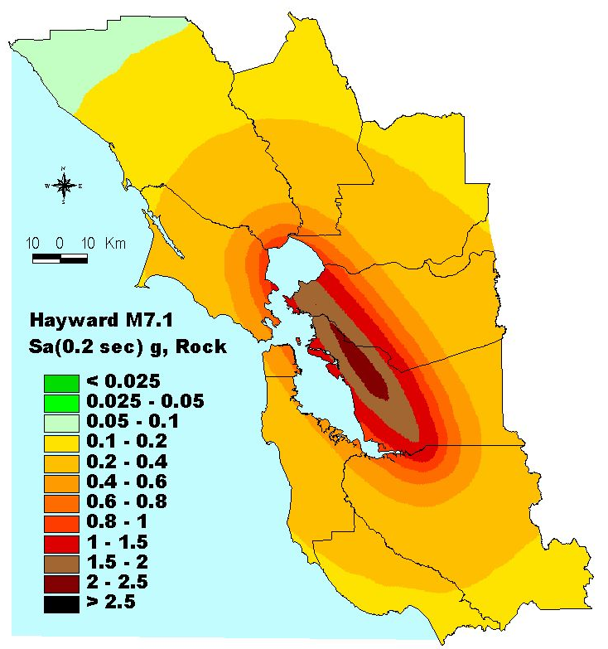

Figure 5.31. Hazard Map for Hayward Fault M7.1, 5% Damped Spectral Acceleration: Median at 0.2 sec on Rock

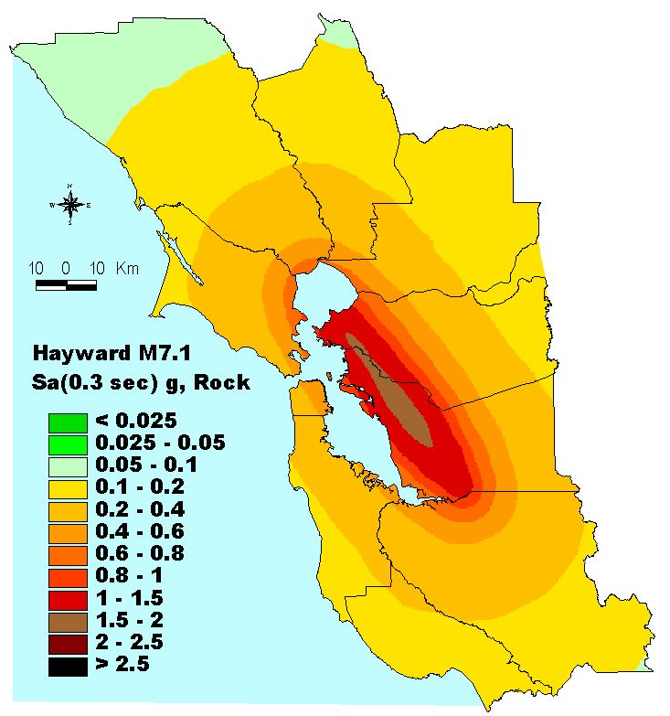
Figure 5.32. Hazard Map for Hayward Fault M7.1, 5% Damped Spectral Acceleration: Median at 0.3 sec on Rock

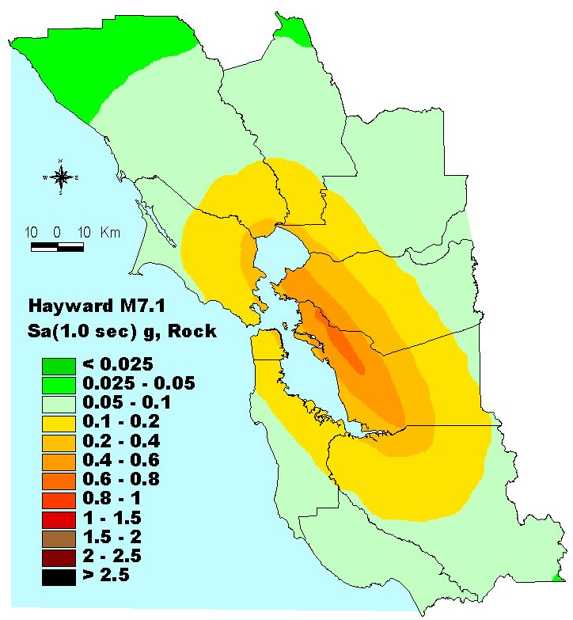

Figure 5.33. Hazard Map for Hayward Fault M7.1, 5% Damped Spectral Acceleration: Median at 1.0 sec on Rock

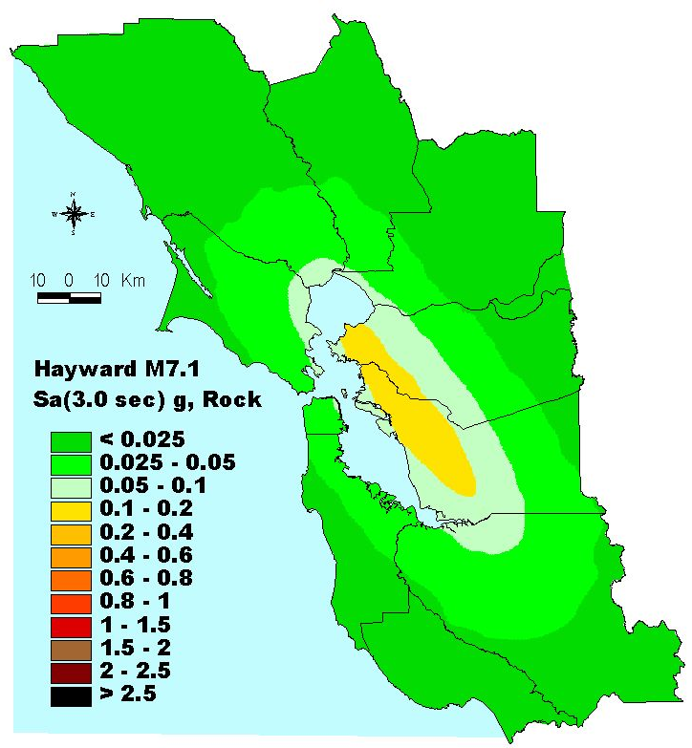

Figure 5.34. Hazard Map for Hayward Fault M7.1, 5% Damped Spectral Acceleration: Median at 3.0 sec on Rock

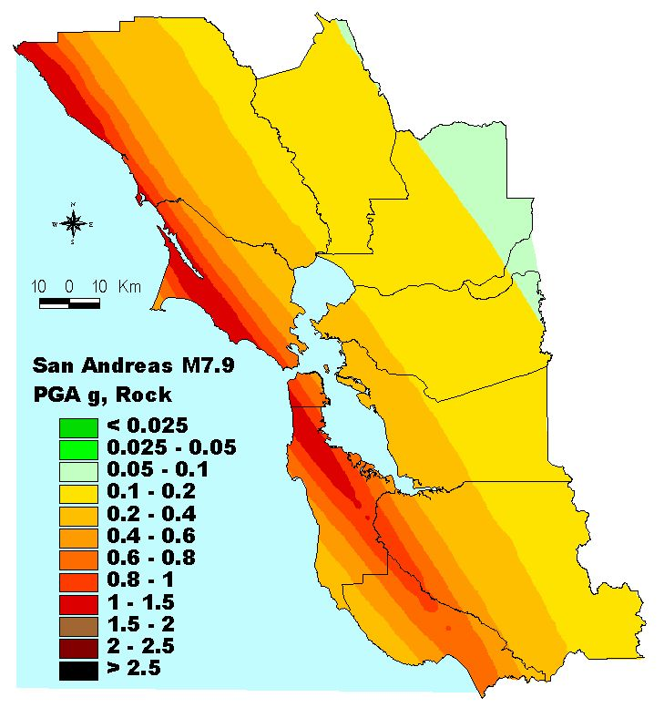

Figure 5.35. Hazard Map for San Andreas Fault M7.9, 5% Damped Spectral Acceleration: Median at 0 sec (PGA) on Rock

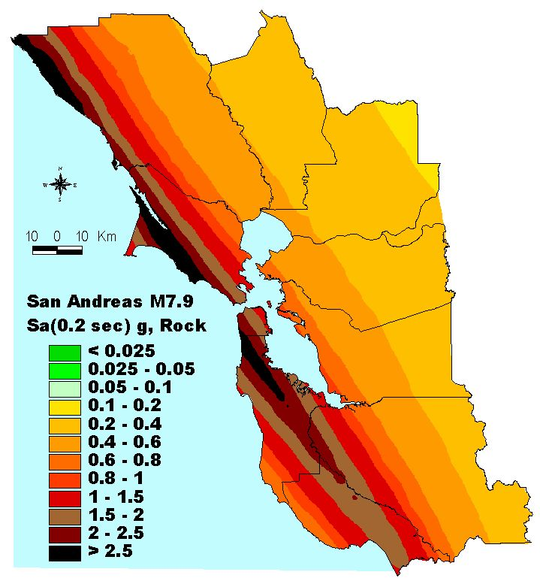

Figure 5.36. Hazard Map for San Andreas Fault M7.9, 5% Damped Spectral Acceleration: Median at 0.2 sec on Rock

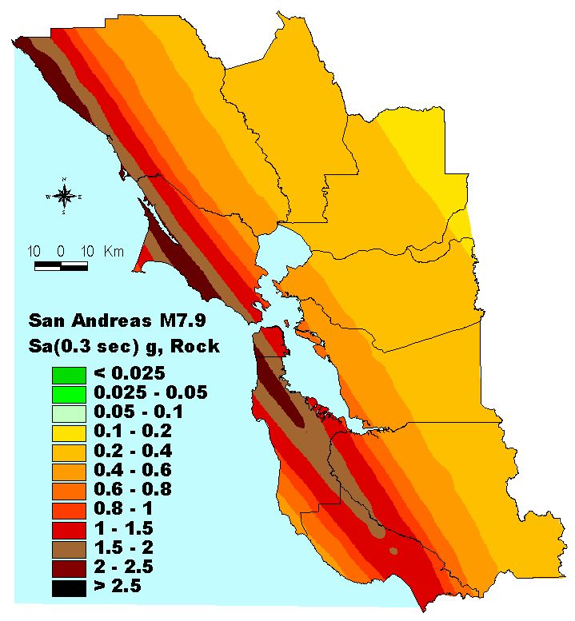

Figure 5.37. Hazard Map for San Andreas Fault M7.9, 5% Damped Spectral Acceleration: Median at 0.3 sec on Rock

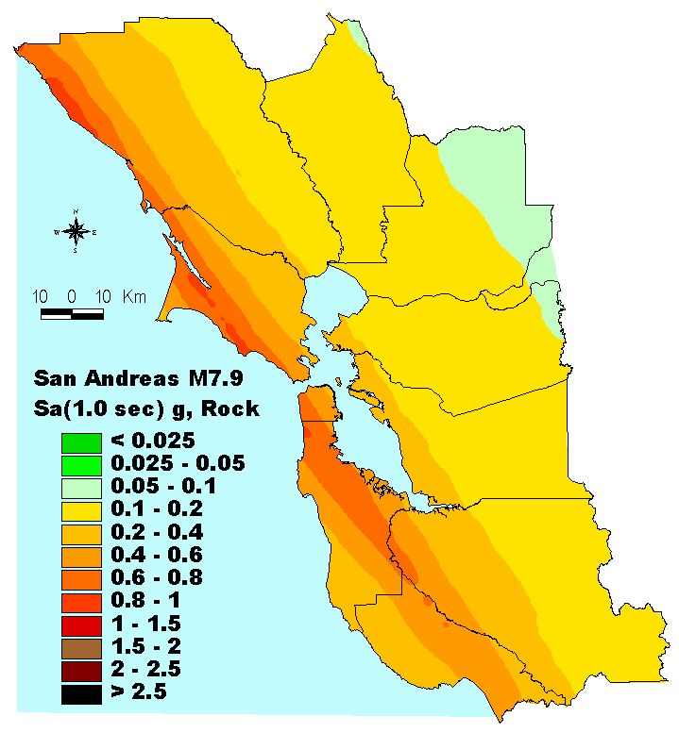

Figure 5.38. Hazard Map for San Andreas Fault M7.9, 5% Damped Spectral Acceleration: Median at 1.0 sec on Rock

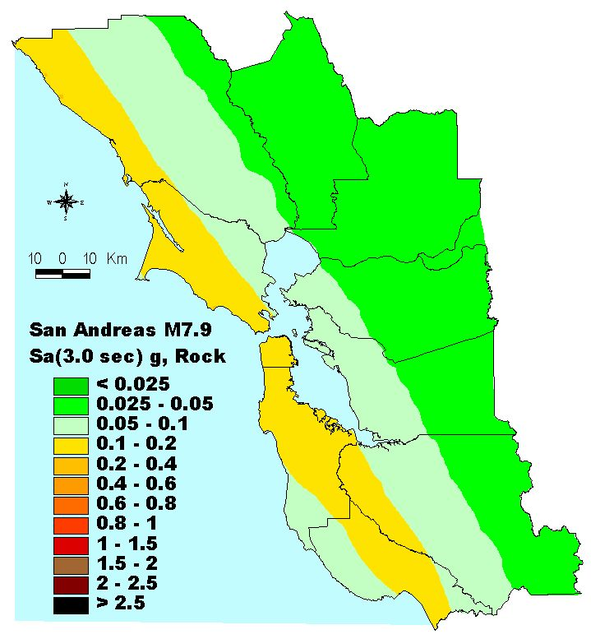

Figure 5.39. Hazard Map for San Andreas Fault M7.9, 5% Damped Spectral Acceleration: Median at 3.0 sec on Rock

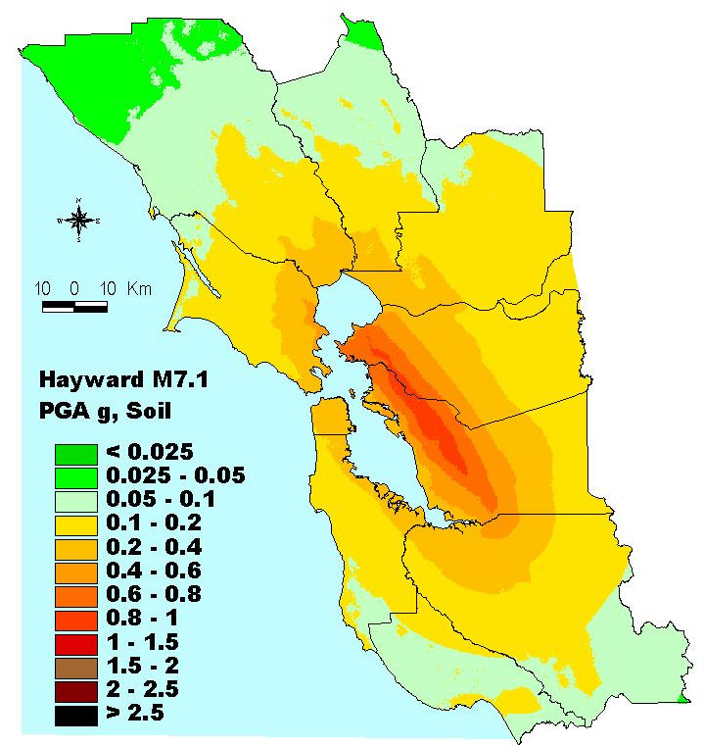
Figure 5.40. Hazard Map for Hayward Fault M7.1, 5% Damped Spectral Acceleration: Median at 0 sec (PGA) on Soil
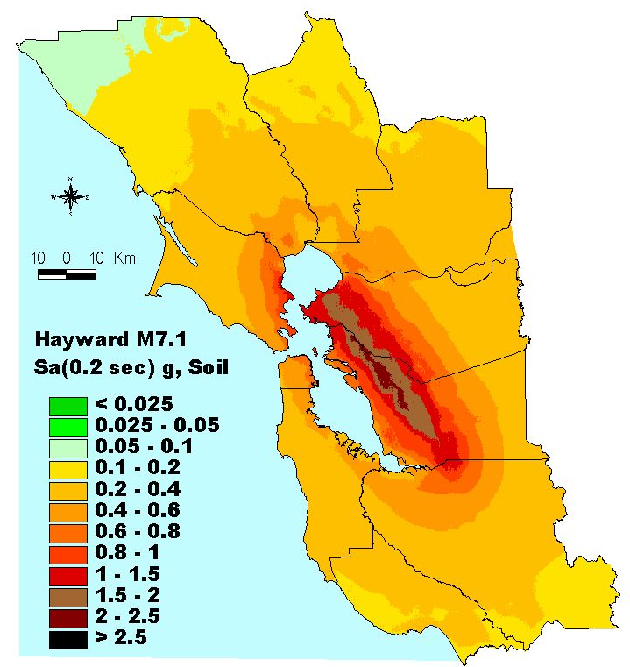

Figure 5.41. Hazard Map for Hayward Fault M7.1, 5% Damped Spectral Acceleration: Median at 0.2 sec on Soil

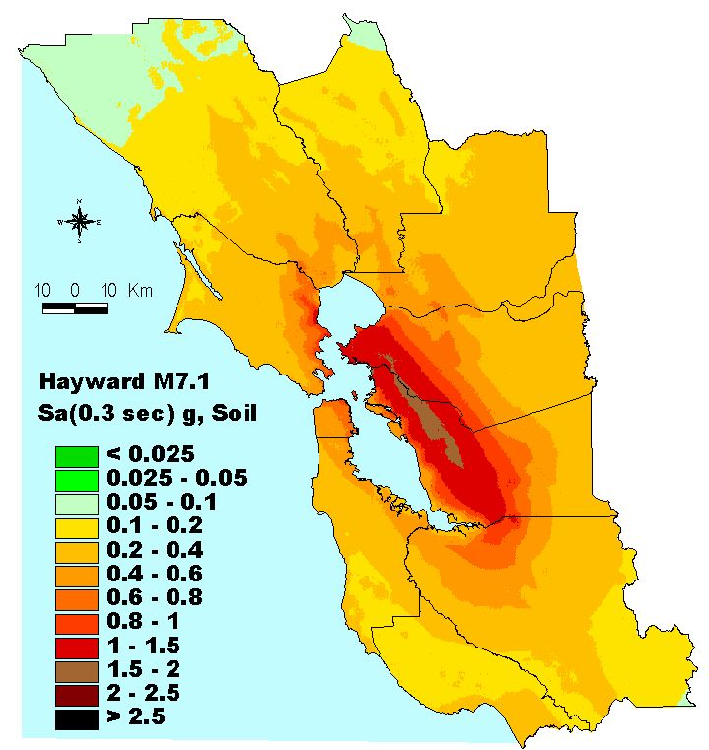

Figure 5.42. Hazard Map for Hayward Fault M7.1, 5% Damped Spectral Acceleration: Median at 0.3 sec on Soil

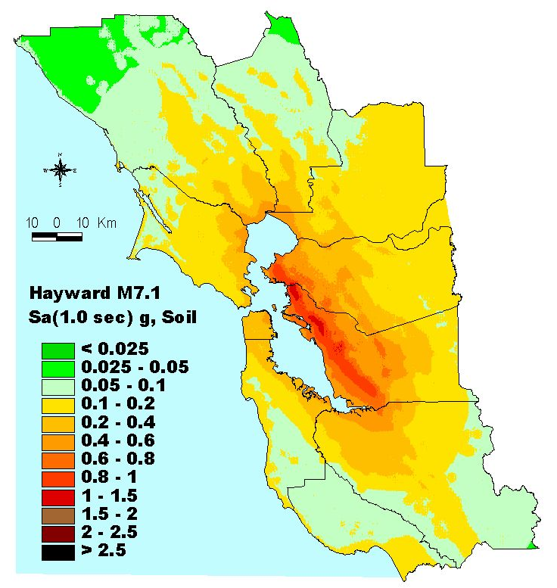

Figure 5.43. Hazard Map for Hayward Fault M7.1, 5% Damped Spectral Acceleration: Median at 1.0 sec on Soil

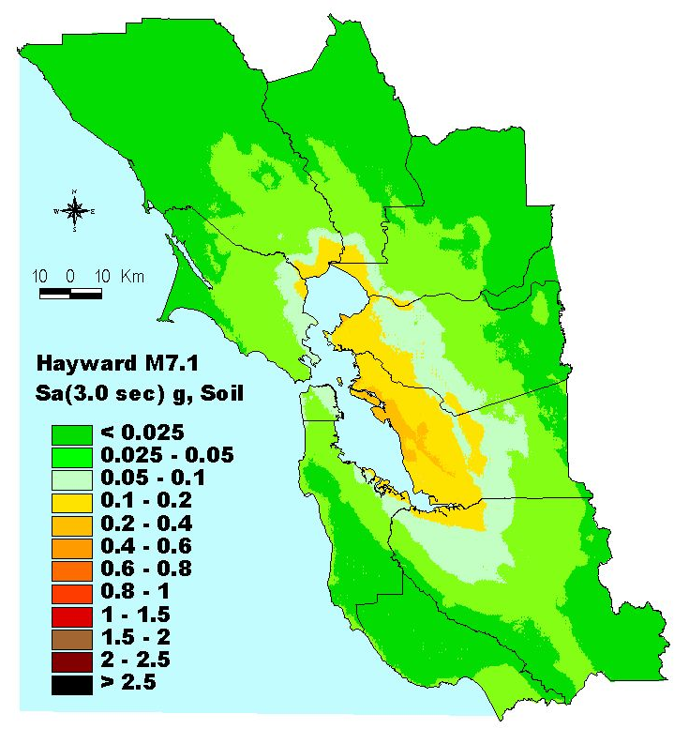

Figure 5.44. Hazard Map for Hayward Fault M7.1, 5% Damped Spectral Acceleration: Median at 3.0 sec on Soil

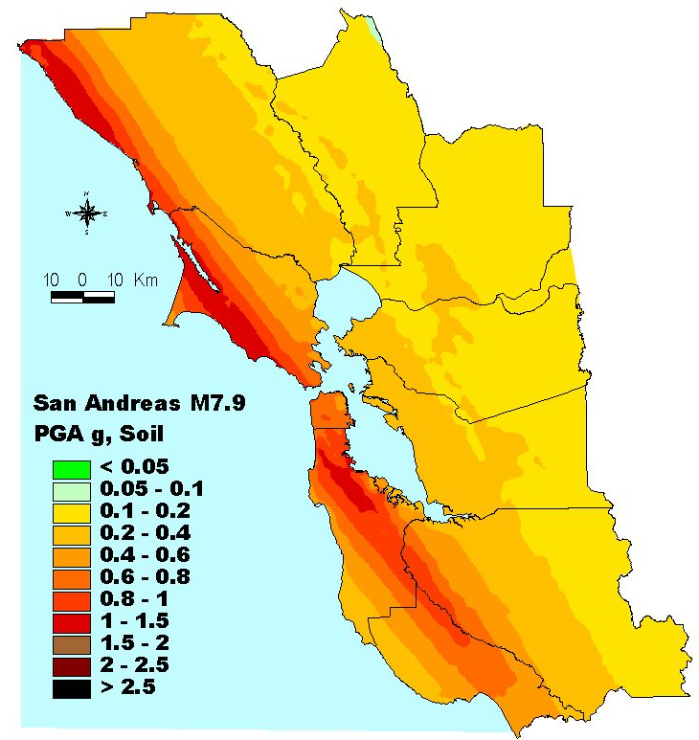

Figure 5.45. Hazard Map for San Andreas Fault M7.9, 5% Damped Spectral Acceleration: Median at 0 sec (PGA) on Soil

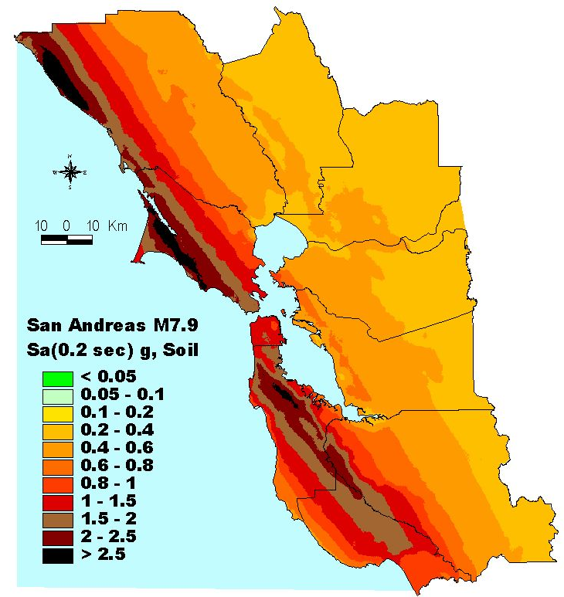

Figure 5.46. Hazard Map for San Andreas Fault M7.9, 5% Damped Spectral Acceleration: Median at 0.2 sec on Soil

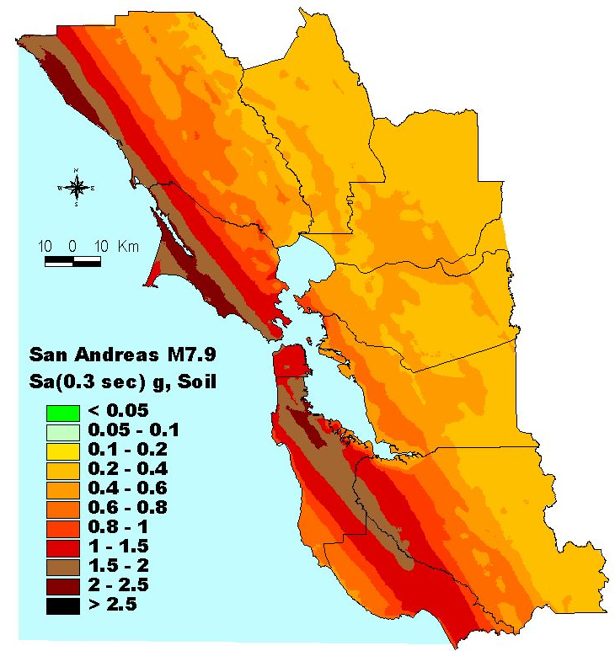

Figure 5.47. Hazard Map for San Andreas Fault M7.9, 5% Damped Spectral Acceleration: Median at 0.3 sec on Soil

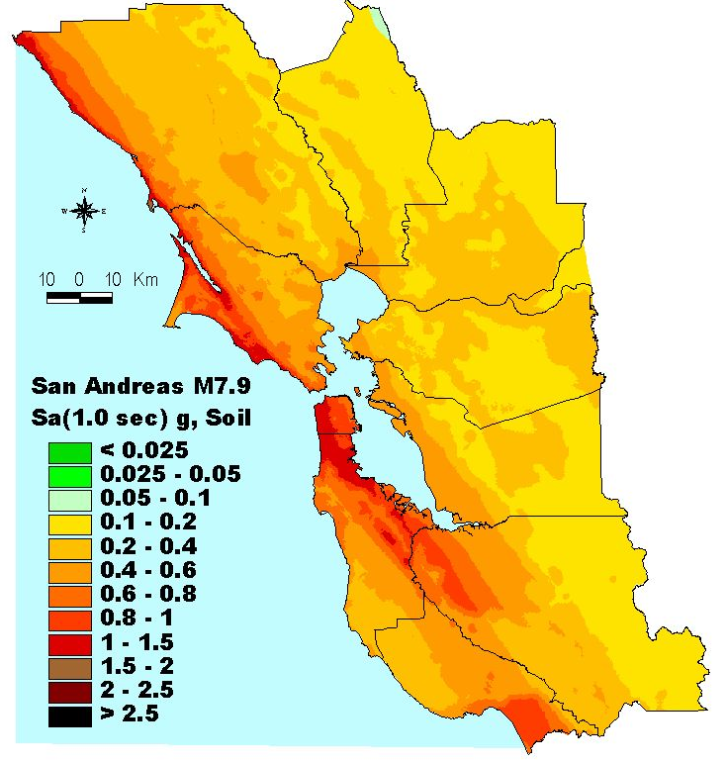

Figure 5.48. Hazard Map for San Andreas Fault M7.9, 5% Damped Spectral Acceleration: Median at 1.0 sec on Soil

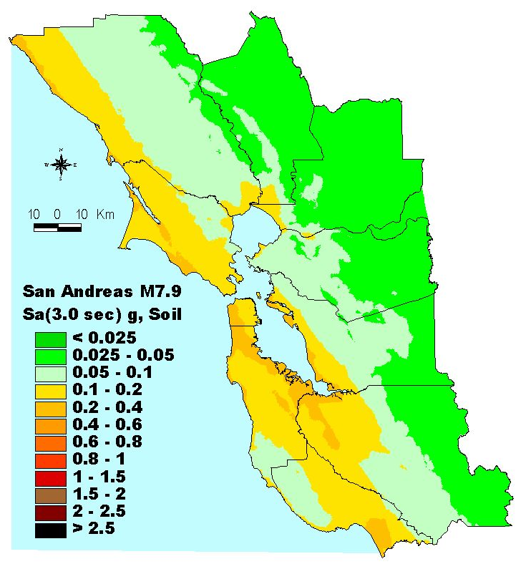

Figure 5.49. Hazard Map for San Andreas Fault M7.9, 5% Damped Spectral Acceleration: Median at 3.0 sec on Soil

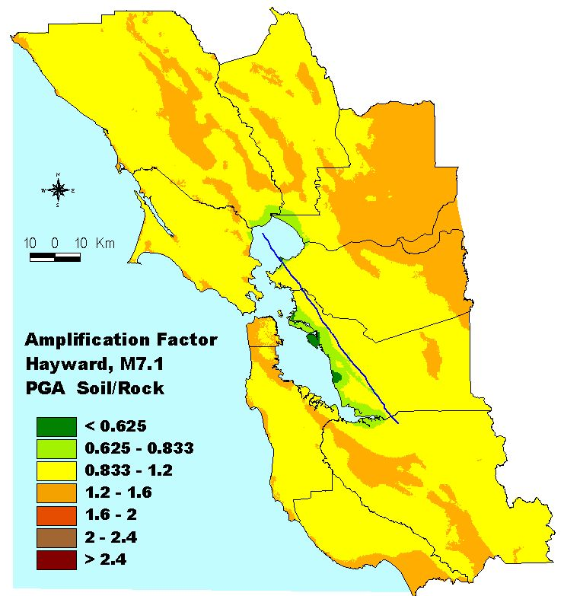

Figure 5.50. Hazard Map for Hayward Fault M7.1, 5% Damped Spectral Acceleration: Soil/Rock Amplification Factor at 0 sec (PGA)

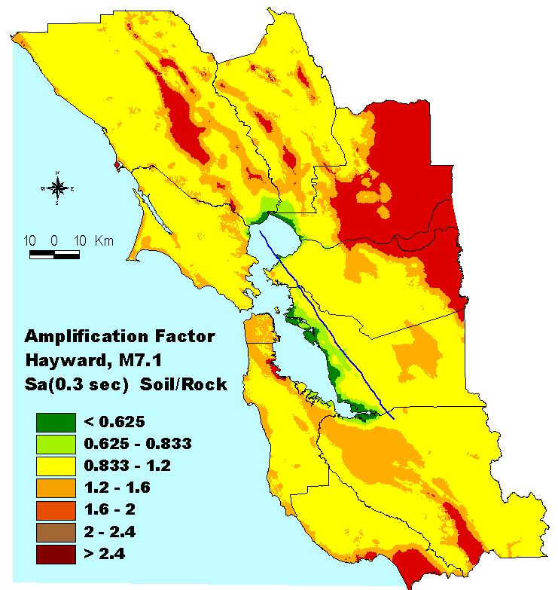

Figure 5.51. Hazard Map for Hayward Fault M7.1, 5% Damped Spectral Acceleration: Soil/Rock Amplification Factor at 0.3 sec

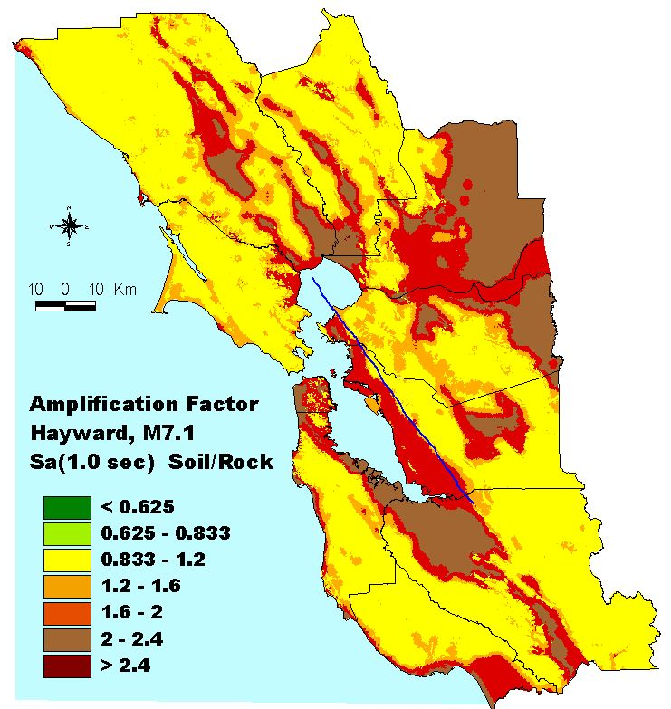

Figure 5.52. Hazard Map for Hayward Fault M7.1, 5% Damped Spectral Acceleration: Soil/Rock Amplification Factor at 1.0 sec

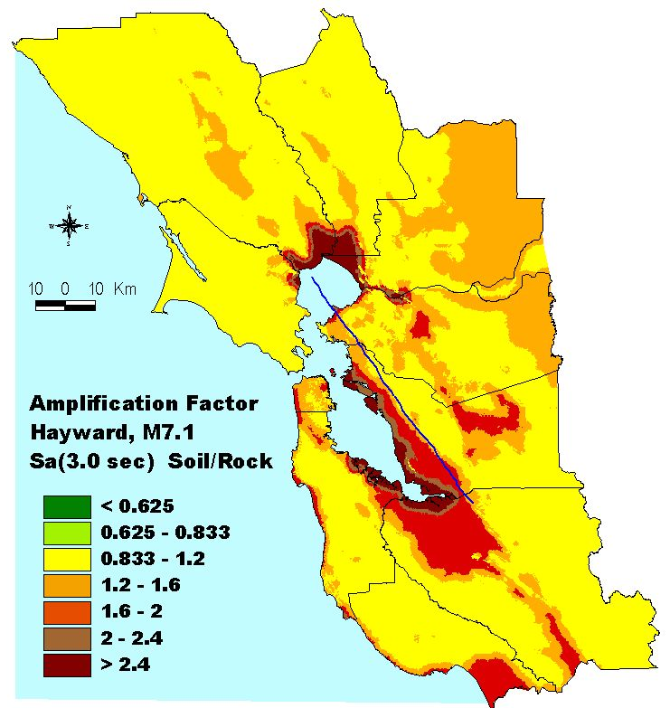

Figure 5.53. Hazard Map for Hayward Fault M7.1, 5% Damped Spectral Acceleration: Soil/Rock Amplification Factor at 3.0 sec

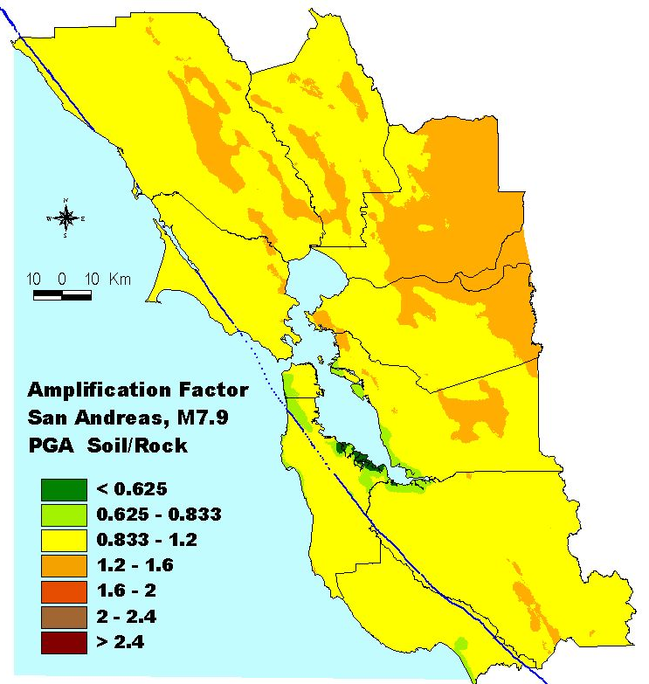

Figure 5.54. Hazard Map for San Andreas Fault M7.9, 5% Damped Spectral Acceleration: Soil/Rock Amplification Factor at 0 sec (PGA)

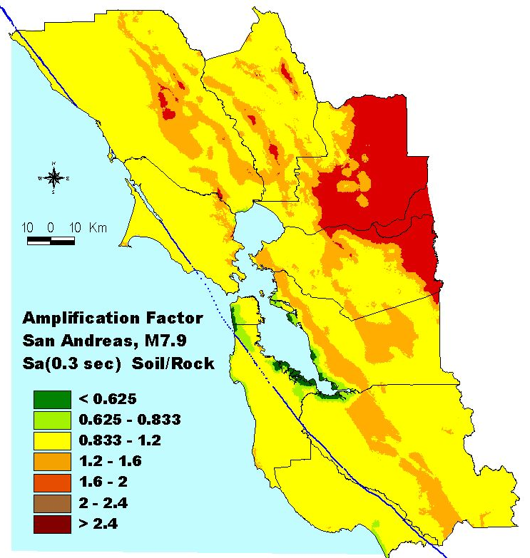

Figure 5.55. Hazard Map for San Andreas Fault M7.9, 5% Damped Spectral Acceleration: Soil/Rock Amplification Factor at 0.3 sec

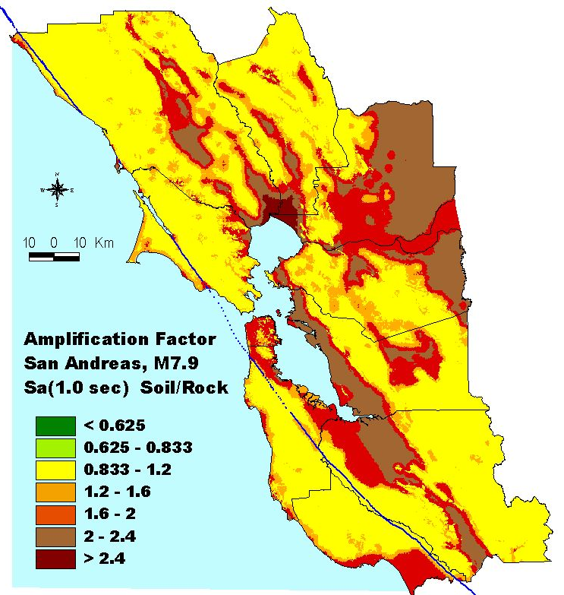

Figure 5.56. Hazard Map for San Andreas Fault M7.9, 5% Damped Spectral Acceleration: Soil/Rock Amplification Factor at 1.0 sec

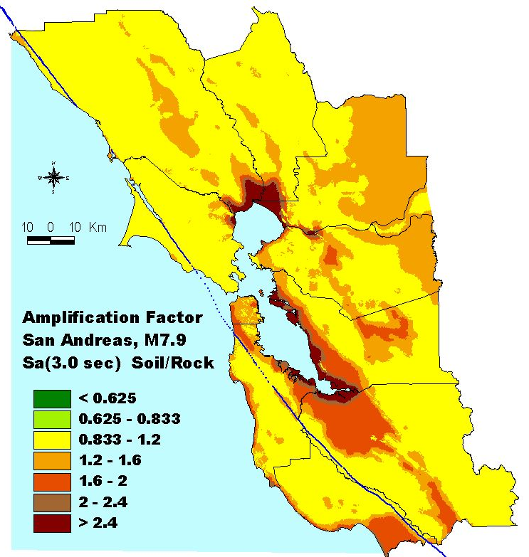

Figure 5.57. Hazard Map for San Andreas Fault M7.9, 5% Damped Spectral Acceleration: Soil/Rock Amplification Factor at 3.0 sec

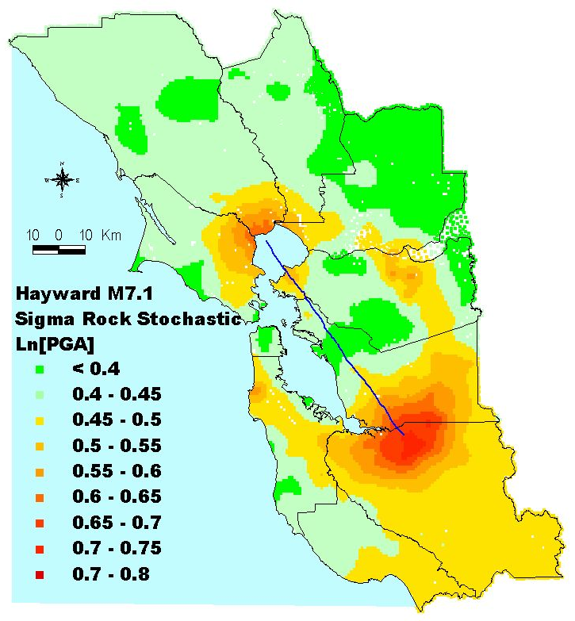

Figure 5.58. Hazard Map for Hayward Fault M7.1: Sigma of Natural Log Spectral Acceleration at 0 sec (PGA) on Rock for Stochastic Ground Motion Model

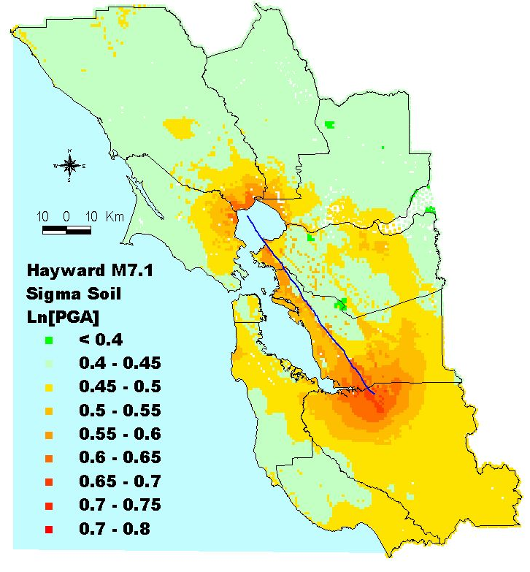

Figure 5.59. Hazard Map for Hayward Fault M7.1: Sigma of Natural Log Spectral Acceleration at 0 sec (PGA) on Soil (all models)

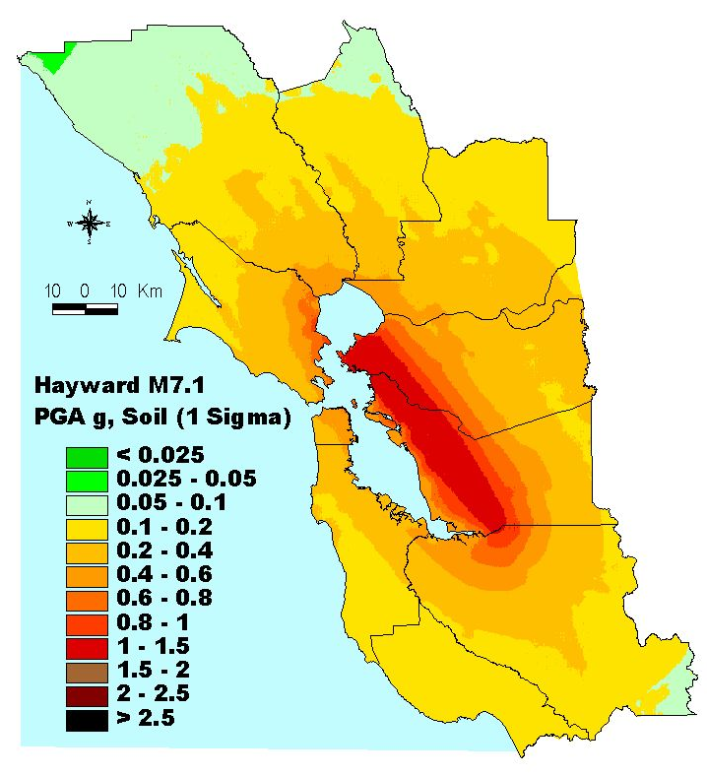

Figure 5.60. Hazard Map for Hayward Fault M7.1, 5% Damped Spectral Acceleration: 1 Sigma (84th Percentile) at 0 sec (PGA) on Soil (all models)

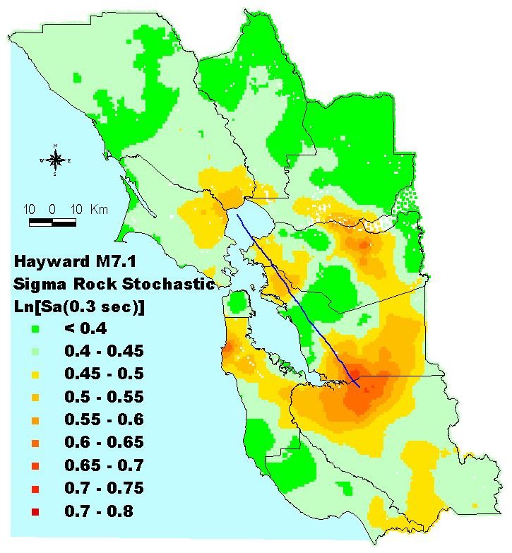

Figure 5.61. Hazard Map for Hayward Fault M7.1: Sigma of Natural Log Spectral Acceleration at 0.3 sec on Rock for Stochastic Ground Motion Model

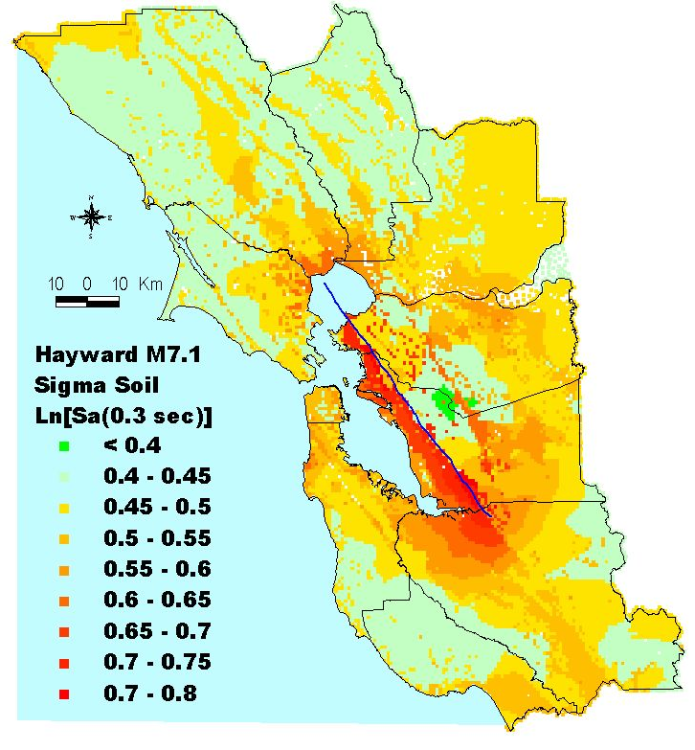

Figure 5.62. Hazard Map for Hayward Fault M7.1: Sigma of Natural Log Spectral Acceleration at 0.3 sec on Soil (all models)

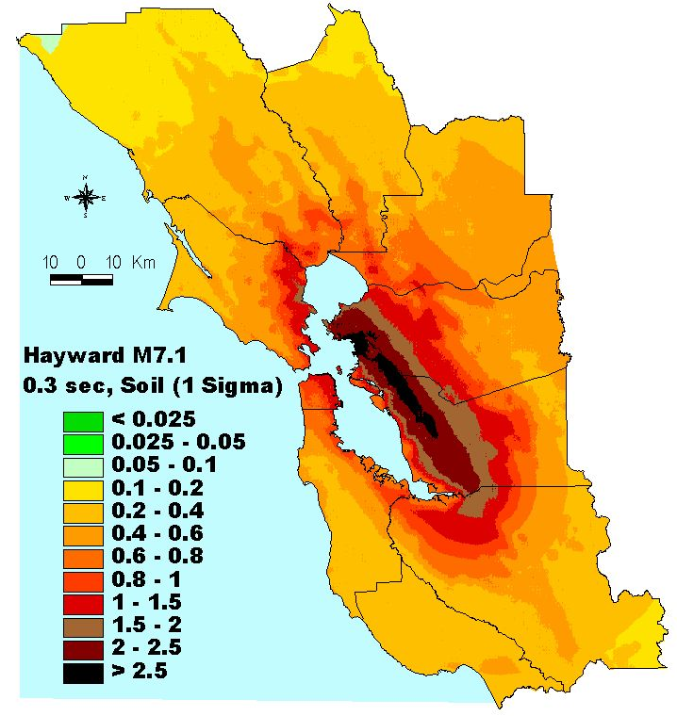

Figure 5.63. Hazard Map for Hayward Fault M7.1, 5% Damped Spectral Acceleration: 1 Sigma (84th Percentile) at 0.3 sec on Soil (all models)

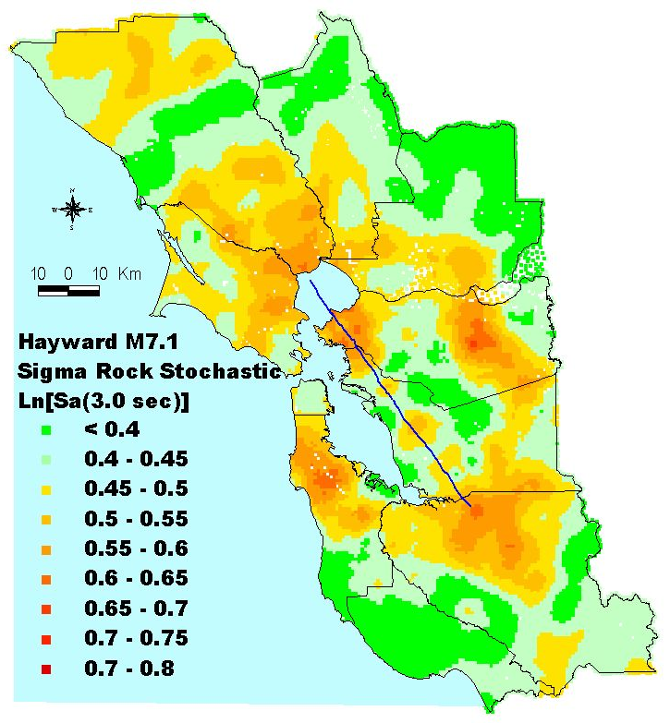

Figure 5.64. Hazard Map for Hayward Fault M7.1: Sigma of Natural Log Spectral Acceleration at 3.0 sec on Rock for Stochastic Ground Motion Model

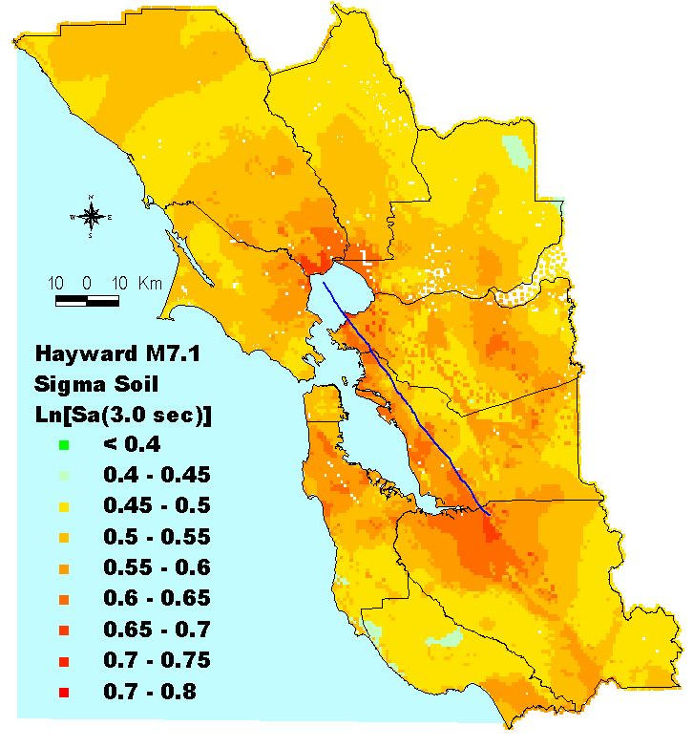

Figure 5.65. Hazard Map for Hayward Fault M7.1: Sigma of Natural Log Spectral Acceleration at 3.0 sec on Soil (all models)

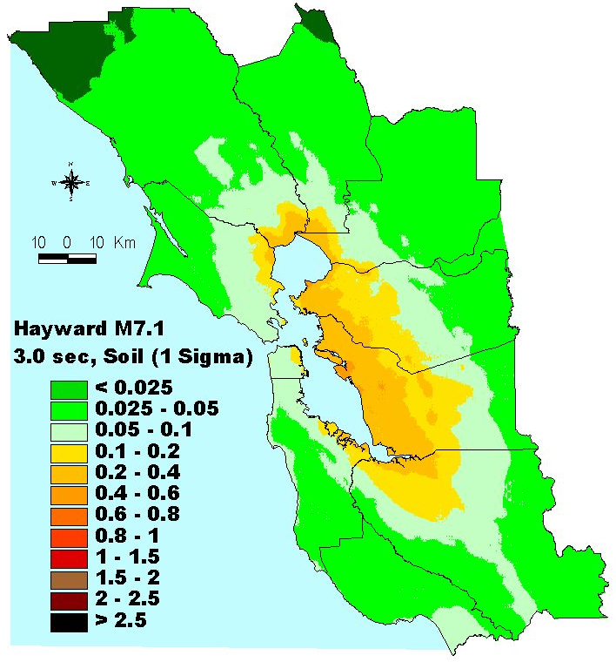

Figure 5.66. Hazard Map for Hayward Fault M7.1, 5% Damped Spectral Acceleration: 1 Sigma (84th Percentile) at 3.0 sec on Soil (all models)

Conclusions
The Hayward M 7.1 and San Andreas M 7.9 earthquakes have the highest probabilities of occurrence among characteristic earthquakes in the SFBR. The ground motions from these events also indicate that they have the most significant damage potential. Thus, the ground motion hazard maps developed in this study will be extremely useful for input to risk analyses for probabilistic maximum loss estimation, assessment of building codes, and urban/regional disaster planning.
Principal results of this study are as follows:
- While predicted ground motions are on average similar to those predicted by empirical relations alone, there is significantly more variability due to the combination of source, path and site effects modeled in this study.

- The largest median peak ground accelerations are nearly 1 g for the Hayward (fig. 5.11) scenario and ~1.2 g for the San Andreas (fig 5.16). 1 sigma motions range from 50% to 120% higher than median motions (e.g., Fig. 5.31).

- Median ground motions along the fault diminish near the ends, especially at short periods. The effect is more pronounced for the San Andreas scenario (e.g., Figures 5.16 and 5.18) than for the Hayward scenario (e.g., Figures 5.11 and 5.13). The greatest uncertainty (largest sigma) occurs at ends of the faults due to variations in rupture directivity (e.g., Figure 5.29).

- The general effects of attenuation with distance dominate variations in median ground motions (e.g., Figures 5.1-5.10 for rock and Figures 5.11-5.20 for soil) at all periods. Effects of post-critical reflections are not pronounced, but do increase median motions and sigma moderately at 50-80 km distance (e.g., Figure 5.29).

- Variations in soil amplification contribute significant variability in ground motions at all periods (e.g., Figures 5.21-5.24). Soft soils (especially Bay mud) show strong relative de-amplification at short periods and close distances (Fig. 5.21-5.22). Amplification for different soil depths is strongly period dependent. It is greatest for deep soils (> 200 m) at long period (3.0 sec) (e.g., in Santa Clara Valley near San Jose) (Fig. 5.24). It is also greatest for intermediate-depth soils (140-200 m) at intermediate periods (0.2 – 1 sec) (Figure 5.22).

References
Abrahamson, N.A and K.M. Shedlock (1997). “Overview.” Seis. Research Lett., 68(1), 9-23.
Abrahamson and Silva (1997). "Empirical response spectral attenuation relations." to appear in Seismological Research Letters.
Abrahamson, N.A, W. Silva, J. Schneider (1994). “Variability of strong ground motion due to the variability of the seismic slip distribution.” Seis. Research Lett., 65(1), 1484-1504.
Anderson, J. G. and S. E. Hough (1984). "A Model for the Shape of the Fourier Amplitude Spectrum of Acceleration at High Frequencies." Bull. Seism. So. Am., 74(5), 1969-1993.
Boatwright, J., and Astrue, M. (1983). "Analysis of the aftershocks of the New Brunswick earthquake." Workshop on Site-Specific Effects of Soil and Rock on Ground Motion and the Implications for Earthquake-Resistant Design. USGS Open-File Rept. 83-245.
Boore, D.M., Joyner, W.B. and Fumal, T.E. (1997). "Equations for estimating horizontal
response spectra and peak acceleration from Western North American earthquakes: A
summary of recent work." Seism. Res. Lett. 68(1), 128_153.

Boore, D.M., and Atkinson, G.M. (1987). "Stochastic prediction of ground motion and spectral response parameters at hard-rock sites in eastern North America." Bull. Seism. Soc. Am., 77(2), 440-467.
Boore, D.M. (1983). "Stochastic simulation of high-frequency ground motions based on seismological models of the radiated spectra." Bull. Seism. Soc. Am., 73, 1865-1894.
Boore, D.M., W.B. Joyner, and T.E. Fumal (1994). "Estimation of response spectra and peak accelerations from western North American earthquakes: and interim report. Part 2. U.S. Geological Survey Open-File Rept. 94-127.
Borcherdt, R. D. and Glassmoyer, G. (1992). "On the characteristics of local geology and their influence on ground motions generated by the Loma Prieta Earthquake in the San Francisco Bay region, California." Bull. Seism. Soc. Am., 82(2), 603-641.
Borcherdt, R.D. (1970). "Effects of local geology on ground motion near San Francisco Bay." Bull. Seism. Soc. Am., 60:29-61.
Campbell, K W. (1997). "Empirical near-source attenuation relationships for horizontal and
vertical components of peak ground acceleration, peak ground velocity, and pseudo_absolute
acceleration response spectra." Seism. Soc. Am., 68(1), 154_179.

Campbell, K.W. (1988). "Predicting strong ground motion in Utah." Evaluation of Regional and Urban Earthquake Hazards and Risk in Utah, edited by W.W. Hays and P.L. Gori, USGS Prof. Paper.
Campbell, K.W. (1985). "Near-source estimation of strong ground motion for the Eastern United States: second quarter progress report - FY 1985." Submitted to Nuclear Regulatory Commission, 14 pages.
Campbell, K.W. (1981). "Near-source attenuation of peak horizontal acceleration." Bull. Seism. Soc. Am., 71(6), 2039-2070.
Cranswick, E., Wetmiller, R., and Boatwright, J. (1985). "High-frequency observations and source parameters of microearthquakes recorded at hard-rock sites." Bull. Seism. Soc. Am., 75(6), 1535-1567.
Electric Power Research Institute (1993). "Guidelines for determining design basis ground motions." Palo Alto, Calif: Electric Power Research Institute, vol. 1-5, EPRI TR-102293.
vol. 1: Methodology and guidelines for estimating earthquake ground motion in eastern North America.
vol. 2: Appendices for ground motion estimation.
vol. 3: Appendices for field investigations.
vol. 4: Appendices for laboratory investigations.
vol. 5: Quantification of seismic source effects.
Fumal, T.E. (1991). A compilation of the geology and measured and estimated shear-wave velocity profiles at strong-motion stations that recorded the Loma Prieta, California, earthquake, US Geological Survey Open-File Report 91-311, 108 pp.
Gibbs, J.F., T.F. Fumal, D.M. Boore, and W.B. Joyner (1992). Seismic velocities and geologic logs from borehole measurements at seven strong-motion stations that recorded the Loma Prieta earthquake, US Geological Survey Open-File Report 92-287,139 pp.
Gutenberg, B. (1927). Grundlagen der Erdlebenkunde. Berlin.
Gutenberg, B. (1957). "Effects of ground on earthquake motion." Bull. Seism. Soc. Am., 47(1), 221-250.
Hartzell, S., S. Harmsen, A. Frankel, and S. Larsen (1999). “Calculation of broadband time histories of ground motion: comparison of methods and validation using strong-ground motion from the 1994 Northridge earthquake.” Bull. Seism. Soc. Am., 89(6), 1484-1504.
Hartzell, S.H. (1978). "Earthquake aftershocks as Green's functions." Geophys. Res. Letters,
5, 1-4.
Hayashi, S., H. Tsuchida, and E. Kurata (1971). "Average response spectra for various subsoil conditions." Third Joint Meeting, US-Japan Panel on Wind and Seismic Effects, UJNR, Tokyo.
Helley, E.J. and K.R. Lajoie (1979). Flatland deposits of the San Francisco Bay Region, California – their geology and engineering properties, and their importance to comprehensive planning, US Geological Survey Professional Paper 943, 88 pp.
Hensolt, W.H. and E.E. Brabb (1990). Maps showing elevation of bedrock and implications for design of engineered structures to withstand earthquake shaking in San Mateo County, USGS Report OFR 90-496.
Idriss, I.M. (1985). "Evaluating seismic risk in engineering practice." Proc. Eleventh Internat. Conf. on Soil Mech. and Foundation Eng., San Francisco, edited by A.A. Balkema, Rotterdam, 1, 255-320.
Irikura, K. (1983). "Semi_empirical estimation of strong ground motions during large
earthquakes." Bull. Disaster Prevention Res. Inst., Kyoto Univ., 33, 63_104.

Iwan, W.D. (1967). "On a class of models for the yielding behavior of continuous and composite systems." J. Appl. Mech., 34, 612-617.
Joyner, W.B., and Fumal, T.E. (1984). "Use of measured shear-wave velocity for predicting geologic site effects on strong ground motion." Proc. Eighth World Conf. on Earthq. Engin., San Francisco, 2, 777-783.
Joyner, H.B. and D.M. Boore (1982) "Prediction of earthquake response spectra." USGS, Open-File Rept. 82-977.
Mohraz, B. (1976). "A study of earthquake response spectra for different geological conditions." Bull. Seism. Soc. Am., 66(3) 915-935.
Reid, H.F. (1910). "The California earthquake of April 18, 1907." The Mechanics of the Earthquake, Carnegie Inst. of Washington, Publ. 87, 21.
Rogers, D.J. and S. Figuers (1991). Engineering geologic site characterization of the greater Oakland-Alameda area, Alameda and San Francisco Counties, California, Final Report to NSF, Grant No. BCS-9003785.
Sadigh, C._Y. Chang, J.A. Egan, F. Makdisi, and R.R. Youngs (1997). "Attenuation
relationships for shallow crustal earthquakes based on California strong motion data." Seism.
Soc. Am., 68(1), 180_189.

Schnabel, P.B., Lysmer, J., and Seed, H.B. (1972). SHAKE: a Computer Program for Earthquake Response Analysis of Horizontally Layered Sites. Earthq. Engin. Res. Center, Univ. of Calif. at Berkeley, EERC 72-12.
Schneider, J.F., W.J. Silva, and C.L. Stark (1993). Ground motion model for the 1989M 6.9 Loma Prieta ea rthquake including effects of source, path and site. Earthquake Spectra, 9(2), 251-287.
Seed, H.B., C. Ugas and J. Lysmer. (1976). "Site-dependent spectra for earthquake resistant design." Bull. Seism. Soc. Am., 66(1), 221-243.
Seed, H.B. and I.M. Idriss (1970). "Soil moduli and damping factors for dynamic response analyses." Earthq. Eng. Res. Center, Univ. of Calif. at Berkeley, Report No. UCB/EERC-70/10.
Silva, W.J., S. Li, R. Darragh, and N. Gregor (1999). Surface geology based strong motion amplification factors for the San Francisco Bay and Los Angeles areas, Final Report to Pacific Earthquake Engineering Research Center, University of California, Berkeley.
Silva, W.J., N. Abrahamson, G. Toro and C. Costantino. (1997). "Description and validation of the stochastic ground motion model." Report Submitted to Brookhaven National Laboratory, Associated Universities, Inc. Upton, New York 11973, Contract No. 770573
Silva, W.J. and R. Darragh (1995). "Engineering characterization of earthquake strong ground motion recorded at rock sites." Palo Alto, Calif:Electric Power Research Institute, TR-102261.
Silva, W.J. and C.L. Stark (1993) "Source, path, and site ground motion model for the
1989 M 6.9 Loma Prieta earthquake." CDMG draft final report.

Silva, W.J., Darragh, R.B., and Wong, I.G. (1990). "Engineering characterization of earthquake strong ground motions with applications to the Pacific Northwest." in Hays, W.W., ed., Proceedings of the Third NEHRP Workshop on earthquake Hazards in the Puget sound/Portland region, U.S. Geological Survey Open-File report (in press).
Silva, W.J., and Green, R.K. (1989). "Magnitude and distance scaling of response spectral shapes for rock sites with applications to North American tectonic environment." Earthquake Spectra, 5(3), 591-62 4.
Silva, W. J.; Turcotte, T.; Moriwaki, Y. (1988). "Soil Response to Earthquake Ground Motion”, Electric Power Research Institute, Walnut Creek, California, Report No. NP-5747.
Silva, W.J., and Lee, K. (1987). "WES RASCAL code for synthesizing earthquake ground motions." State-of-the-Art for Assessing Earthquake Hazards in the United States, Report 24, U.S. Army Engineers Waterways Experiment Station, Misc. Paper S-73-1.
Silva, W.J. (1976). "Body Waves in a Layered Anelastic soilid." Bull. Seis. Soc. Am., vol. 66(5), 1539-1554.
Thiel, C.C., and J.F. Schneider (1993). Investigations of Thirty-Three Loma Prieta Earthquake Strong Motion Recording Sites, United States/Japan Loma Prieta Earthquake Project for California Universities for Research in Earthquake Engineering and Building Contractors Society of Japan.
Toro, G.R., Silva, W.J., McGuire, R.K., and Herrmann, R.B. (1992). "Probabilistic seismic hazard mapping of the Mississippi embayment." Seism. Res. Letters, 63(3), 449-??.
Toro, G.R., and McGuire, R.K. (1987). "An investigation into earthquake ground motion characteristics in eastern North America." Bull. Seism. Soc. Am., 77, 468-489.
Vucetic, M.; Dobry, R. (1991). "Effects of Soil Plasticity on Cyclic Response," Journal of Geotechnical Engineering, ASCE, 117(1), 89-107.
Wentworth, C.M. (1997). General distribution of geologic materials in the San Francisco Bay Region, California: A digital map database, US Geological Survey Open-File Report 97-744.
Wells, D.L., Coppersmith, K.J. (1994). "New empirical relationships among magnitude,
rupture length, rupture width, rupture area, and surface displacement." Bull. Seism. Soc. Am.
84(4), 974_1002.

Wills, C.J, and W.J. Silva (1998). Shear-wave velocity characteristics of geologic units in California, Earthquake Spectra, 14:3, 533-556.
Wood, H.O. (1908). "Distribution of apparent intensity in San Francisco, in the California earthquake of April 18, 1906." Report of the State Earthquake Investigation Commission, Wash., D.C.: Carnegie Institute, 1, 220-245.

*Range of profile depth over which category applies as well as range of depth randomization for each category. Profile depth is defined as depth to basement material: top of Wald et al. (1991; 1996) crusts (Table 5.4).

